Hasan Suleman (20232766)

STUDENT SOCIAL MEDIA WEBSITE

A LEVEL NEA COMPUTER SCIENCE PROJECT

Contents

ANALYSIS: 3

PROBLEM DEFINITION AND STAKEHOLDERS: 3

COMPUTATIONAL METHODS: 4

RESEARCH: 6

FEATURES OF SOLUTION: 19

REQUIREMENTS: 20

LIMITATIONS: 21

SUCCESS CRITERIA: 22

DESIGN: 24

LAYOUT OF WEBSITE: 24

VISUALISATION OF WEBSITE: 26

DESIGNING THE AUTHENTICATION SYSTEM: 27

DESIGNING THE INTERESTS PAGE: 34

DESIGNING THE HOME PAGE: 38

DESIGNING THE CHATS PAGE: 40

DESIGNING THE PROFILE PAGE: 45

DESIGNING THE GROUP CHATS PAGE: 53

DESIGNING THE FLASHCARD PAGE: 57

DEVELOPMENT TEST PLAN: 63

POST DEVELOPMENT TEST PLAN: 70

DEVELOPMENT AND TESTING: 72

STAGE 1: PREPARING AN ENVIRONMENT: 72

REVIEW 1: 74

STAGE 2 : CREATING A HTML WEBPAGE: 75

CLIENT FEEDBACK 1: 95

REVIEW 2: 96

STAGE 3 : CREATING THE AUTHENTICATION SYSTEM: 97

CLIENT FEEDBACK 2: 105

REVIEW 3: 106

STAGE 4 : IMPLEMENTING THE INTERESTS PAGE: 107

CLIENT FEEDBACK 3: 111

REVIEW 4: 112

STAGE 5 : IMPLEMENTING THE HOME PAGE: 113

CLIENT FEEDBACK 4: 119

REVIEW 5: 119

STAGE 6 : CREATING THE PRIVATE MESSAGING SYSTEM: 120

CLIENT FEEDBACK 5: 131

REVIEW 6: 132

STAGE 7 : CREATING THE GROUP CHATS MESSAGING SYSTEM: 133

CLIENT FEEDBACK 6: 145

REVIEW 7: 145

STAGE 8: CREATING THE FLASHCARDS SYSTEM: 146

CLIENT FEEDBACK 7: 155

REVIEW 8: 156

STAGE 9 : CREATING THE PROFILE PAGE: 157

CLIENT FEEDBACK 8: 171

REVIEW 7: 171

EVALUATION: 172

POST DEVELOPMENT TESTING: 172

STAKEHOLDER SURVEY FOR TESTING USABILTY: 188

EVALUATION OF SOLUTION FROM THE SUCCESS CRITERIA: 191

USABILITY FEATURES: 192

UNSUCCESSFUL CRITERIA/USABILITY FEATURES: 197

LIMITATIONS OF THE SOLUTION 199

AND HOW THE PROGRAM CAN BE DEVELOPED TO DEAL WITH THEM: 199

MAINTENANCE ISSUES 200

AND HOW THE PROGRAM CAN BE DEVELOPED IN THE FUTURE: 200

# ANALYSIS:

## PROBLEM DEFINITION AND STAKEHOLDERS:

I will be making a student social media website for my client Jack who is responsible for student services support at an international college based in the UK. The college has a great reputation and attracts students from around the world such as China, India and Saudi Arabia. There is a total of 2,000+ students who attend this college every year. Jack is aware that many students find it hard to make new friends in college especially if they are coming from a different country. Furthermore, finding students with similar interests in such a populous college can sometimes be challenging. Even if a friend group is established many have different timetables and breaks meaning it is difficult for them to meet up. This may influence their studies as their mind is occupied on the social challenges they are facing. Jack would like me to create a social networking website that would allow students to find friends with similar interests. There are many existing social media apps however Jack wants a system that is private to the college and tailored to the social challenges specific to the college.

My stakeholders in this project will be students aged 16-19 at the college. They will use it to make new friends with similar interests helping them settle down into the college community. Staff will also benefit from the new system as the system will improve well-being hence tutors will have less concerns.

Matching students manually will require a lot of effort therefore I will create an algorithm to match students with similar breaks, interests and subjects. Chat rooms will have real-time messaging and will be student-only so students can talk openly without the overlying insecurity of teachers reading their messages. The new system will require students to register their details to have a login system which would require a dedicated database to store such large amounts of data. To secure such confidential data an encryption system will be in place. Furthermore, I will create surveys to question my client and stakeholders as to what features they would like to create an effective social networking website.

## COMPUTATIONAL METHODS:

**Why computational methods are suitable:**

Computational methods are suitable for my website as they allow efficient handling of large amounts of student data and automate processes such as my friend suggestion algorithm which if it were to be performed manually would be labour intensive. Furthermore, computational methods enable confidential student data to be secure through encryption. This reduces the administrative workload on Jack ensuring that the system runs smoothly without constant oversight.

**Thinking abstractly:**

As I program my social media website, I will be focusing on the necessary features before adding other details. My login system for the website will require details such as name. school email for student verification and subjects, hobbies, etc. to create an algorithm aimed at connecting students with similar interests. However, details such as address and the country you are coming from will be ignored as the objective is to bring together students regardless of their background. Furthermore, instead of giving a list of students to the student, which is inconvenient, I will use an algorithm to simplify this and give friend suggestions to the user based on similar interests and subjects.

**Thinking ahead:**

Jack has requested alongside with creating a website to form friendships, it should not be a distraction to the main priority of studying and therefore should include some educational features. In order to do so, I will create chat rooms for each class so they can help each other with homework projects etc. This will require class details from the school. Furthermore, I will create a daily flashcard system customised for the student in order to help the student’s revision. Jack has also said that the students are very competitive studying at such a prestige college hence, I will also create a flashcard leaderboard to encourage students to revise more. This will require a leaderboard for individual classes, different subjects and a whole school leaderboard as well. Furthermore, I will include a weekly leaderboard, a monthly leaderboard and an all-time leaderboard.

**Thinking procedurally with decomposition:**

Using decomposition, I will split my program into 5 parts. This consists of a login system, chat rooms, flashcard system, user profile and a user interface to display them all. The login system will be decomposed into a database using SQLite and an Django’s encryption system to ensure data is secured. The flashcard system will be decomposed into the leaderboards and the actual flashcards. Decomposition methods will make each part more manageable; a top-down diagram can be used to simplify larger problems into smaller components and modular / object orientated programming methods will enforce re-usability of code.

**Thinking logically:**

To develop a solution, I will need to use logic to plan a structured approach for each section of my program. The layout of my program will need to provide easy navigation and databases will need to be organised to prevent confusion and errors during testing and development. Since my website is targeted towards teenagers it would make sense to keep the content on the user interface simple and visually appealing. Teenagers expect quick responsive interactions and may dislike it if the program is too slow or visually complex. Once my website is developed, I will test it with Jack to make sure there are no errors and to get feedback.

**Thinking concurrently:**

An example of concurrency existing in my program is the flashcard system where the user’s score needs to be stored along with an email of the score to the student. This calls multiple functions within the program and can only run efficiently if concurrent functions are refined thoroughly thus enforcing that concurrency is crucial for the development of this system.

## RESEARCH:

**Client interview:**

I prepared an interview with Jack to determine the features and requirements of the program.

**1) What are the main challenges students face when trying to make friends at the college?**

“*Many students come from different countries and backgrounds making it difficult to make new friends. And even if friend groups are established, they have different timetables so often they cannot meet up”*

**2) How do you think this website will help students overcome those challenges?**

“*I want a website where students can find other students with similar interest or have the same free periods. It should make it easier for students to connect with others especially students that come from abroad”*

**3) How do you deal with social challenges currently?**

*“If students have reported that they have anxiety, they are invited to a separate induction day, during which they are put into smaller groups, with specialist staff to support them”*

**4) What specific features would you like to see on the website?**

*“Real-time messaging so students can talk to each other would be important. Also, a friend suggestion system based on similar interest and subjects would be great to create new friends. Also, if student’s timetables could be viewed on their profiles would be great to plan meetups”*

**5) What app do you currently use to communicate and give homework to students with?**

*“We currently use teams where we upload homework to students and use it to give any important notices”*

**6) Are there any other concerns that you want me to keep in mind?**

*“Yes, I want to ensure that the system prevents people who are not at the college from using the website.* *There must also be a way of blocking users who don't use the system properly”*

**7) Are there any features you would like me to not include?**

*“I don’t want it to feel like a traditional social media app with features that aren’t really necessary for this environment, like ‘likes’ or follower counts. The focus should be on making genuine connections, not creating competition or distractions”*

**8) Do you think this may be a distraction for students.**

*"Yes, it could possibly be a distraction, that’s why I would like you to add an educational feature to the website. Also, an educational feature with a leaderboard system would be great as our students are very competitive"*

**9) How will we measure the success of this social media website after it has been implemented?**

*“Success would mean seeing students actively using the platform to make new friends and feel more integrated into the college community. We could also track engagement levels, such as the number of users, messages exchanged, and friendships formed through the system”*

**Analysis of responses:**

|  |  |  |
| --- | --- | --- |
| Q | Response | Analysis |
| 1 | “*Many students come from different countries and backgrounds making it difficult to make new friends. And even if friend groups are established, they have different timetables so often they cannot meet up”* | The main focus of this website is to overcome the social challenges of students and create a platform where students can make new friends. |
| 2 | “*I want a website where students can find other students with similar interest or have the same free periods. It should make it easier for students to connect with others especially students that come from abroad”* | In order to overcome these challenges, I will create a friend suggestion algorithm by matching students with similar interests and subjects. |
| 3 | *“If students have reported that they have anxiety, they are invited to a separate induction day, during which they are put into smaller groups, with specialist staff to support them”* | We can see this process is time consuming and inefficient therefore a website will be a better solution to the social challenges. |
| 4 | *“Real-time messaging so students can talk to each other would be important. Also, a friend suggestion system based on similar interest and subjects would be great to create new friends. Also, if students’ timetables could be viewed on their profiles would be great to plan meetups”* | Real-time messaging will be included using python Django channels however one thing I overlooked is keeping timetables in student profiles which would be a good addition for meetups. |
| 5 | *“We currently use teams where we upload homework to students and use it to give any important notices”.* | When doing our existing solutions research, we will look at teams and see what we like and what we can improve in our website. |
| 6 | *“Yes, I want to ensure that the system prevents people who are not at the college from using the website.* *There must also be a way of blocking users who don't use the system properly”* | In order to do so a login system with school email address and password verification will be in place. An administrative authority will be given to Jack for those who break guidelines shall be blocked which is another thing I overlooked. |
| 7 | *“I don’t want it to feel like a traditional social media app with features that aren’t really necessary for this environment, like ‘likes’ or follower counts. The focus should be on making genuine connections, not creating competition or distractions”* | Initially, I was going to include likes and follower counts however Jack is right it would create insecurities among some students which opposes the objective of this website. |
| 8 | *"Yes, it could possibly be a distraction, that’s why I would like you to add an educational feature to the website. Also, an educational feature with a leaderboard system would be great as our students are very competitive"* | We will create a flashcard system with leaderboards to maintain the competitive spirit within the student to ensure they are not to distracted by this website |
| 9 | *“Success would mean seeing students actively using the platform to make new friends and feel more integrated into the college community. We could also track engagement levels, such as the number of users, messages exchanged, and friendships formed through the system”* | This is something we will definitely consider in the future by tracking number of times students use the app, the number of friendships formed, how many flashcards are done etc. |

**Stakeholder survey:**

I have carried out a survey on my stakeholders, the colleges students, to see what features might be of interest to them in order to implement it into my program.

**Question 1: What social media apps do you use the most?**

**Conclusion:** Students prefer Snapchat, Instagram and Twitter hence I need to research these websites to see what makes them so appealing.

**Question 2: What device would you prefer the social media platform?**

**Conclusion:** Majority students would prefer the social media platform to be on a laptop hence a website would be fitting.

**Question 3: What do you think is the most important feature?**

**Conclusion:** Students wanted most of the possible features that I had thought of, but pop-up notifications and status updates were not considered very important and hence will not be included.

**Question 4: What style of design would you prefer the website to be?**

**Conclusion:** As I mentioned in thinking logically students did not prefer a vibrant design neither a professional design hence, I will try to create a user-friendly, minimalistic and modern user interface.

**Question 5: How important is it for the website to include educational gamification elements (e.g., rewards, leaderboards)?**

**Conclusion:** Many students agree with me and Jacks proposal to include some form of educational competitiveness which we will create in the form of flashcards and leaderboards for whoever completes the most flashcards.

**Question 6: How should the website handle user feedback and suggestions?**

**Conclusion:** Since majority would like to give feedback through direct messages a system will be in place to send direct messages to me which I will use to improve the website.

**Existing solutions:**

The main social media platforms that were used by students who responded to the survey were snapchat, Instagram. Furthermore, teams is also currently used by the school to communicate with students. I will evaluate what makes these social media platforms so appealing to the students and what I dislike about them as well.

**Website 1:** [**https://www.snapchat.com**](https://www.snapchat.com)

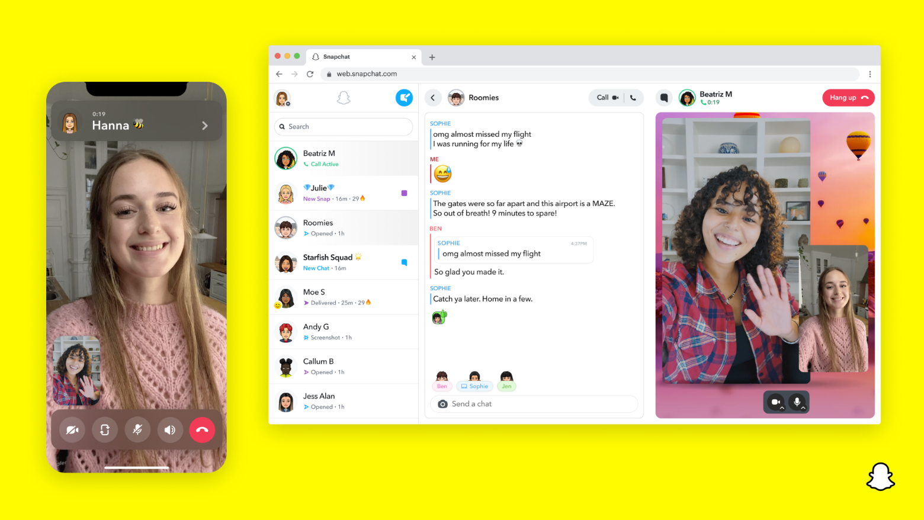

This social media website contains a menu displaying all of the users friends. It also provides private messaging, group messaging and a real-time calling service.

The websites design is minimalistic and visually appealing matching our student preferences. There is also a dark theme design option.

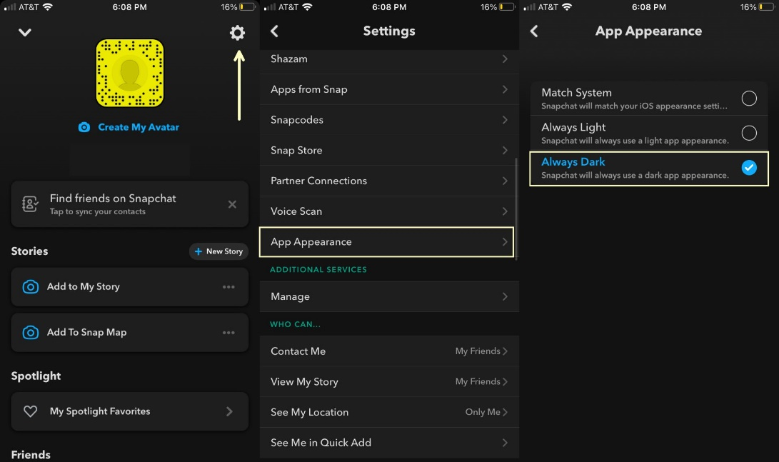

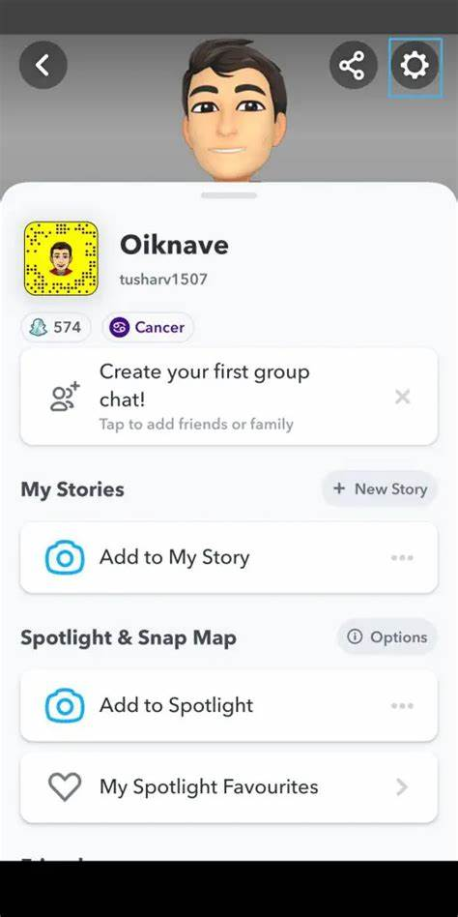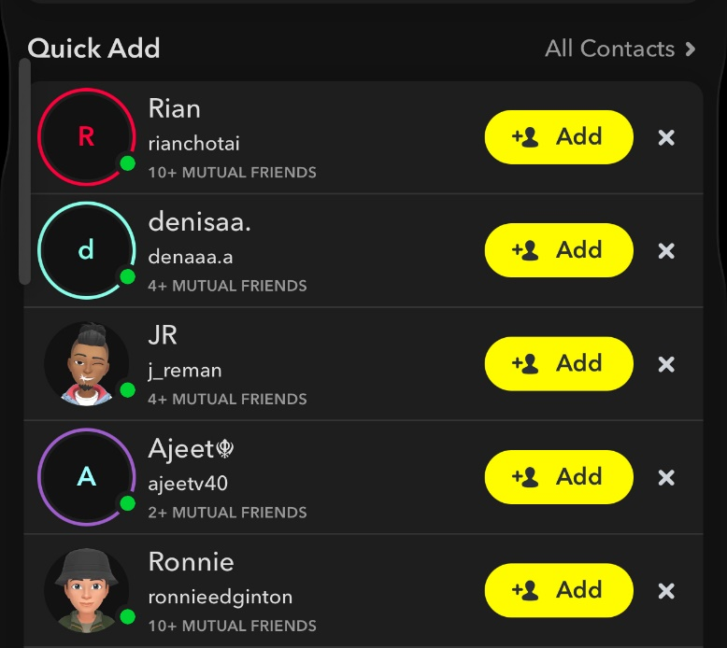Furthermore, there is a friend suggestion feature which gives you suggestions based on mutual connection of friendship.

There is also a user profile page with the name a virtual avatar and a snapscore with an option to mention your star sign as well.

|  |  |
| --- | --- |
| Things we like / might include | Things we don’t like / won’t include |
| The user interface design is minimalistic matching our student preferences and the fonts used with the layout is pretty pleasing. One aspect which I overlooked would be giving the option of a dark theme mode or possibly other themes of customization which would be a good addition. | We may not include the yellow colour scheme of the logo and certain elements of the website as it comes across as vibrant which the students did not prefer. |
| Mutual friend connections may be a good addition to our algorithm alongside using interests and hobbies so the students can make more friends easily and perhaps establish friend groups. | We will not include the snapscore as it is similar to likes and follower counts and may create insecurities among some students opposing the objective of this website. |
| Private messaging, group messaging will be included within our website. |  |

**Website 2:** [**https://www.instagram.com**](https://www.instagram.com/)

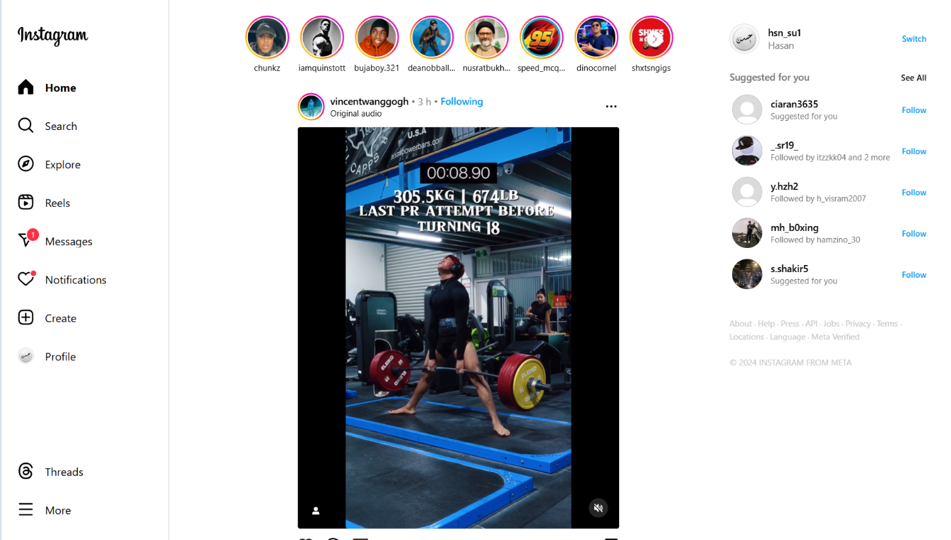



The interface contains a menu tab with several pages with the home page displaying a feed and friend suggestions. There is also a messages tab, a profile tab and a tab to explore more videos and photos uploaded by other individuals. At the top there is also the stories of the people you follow.

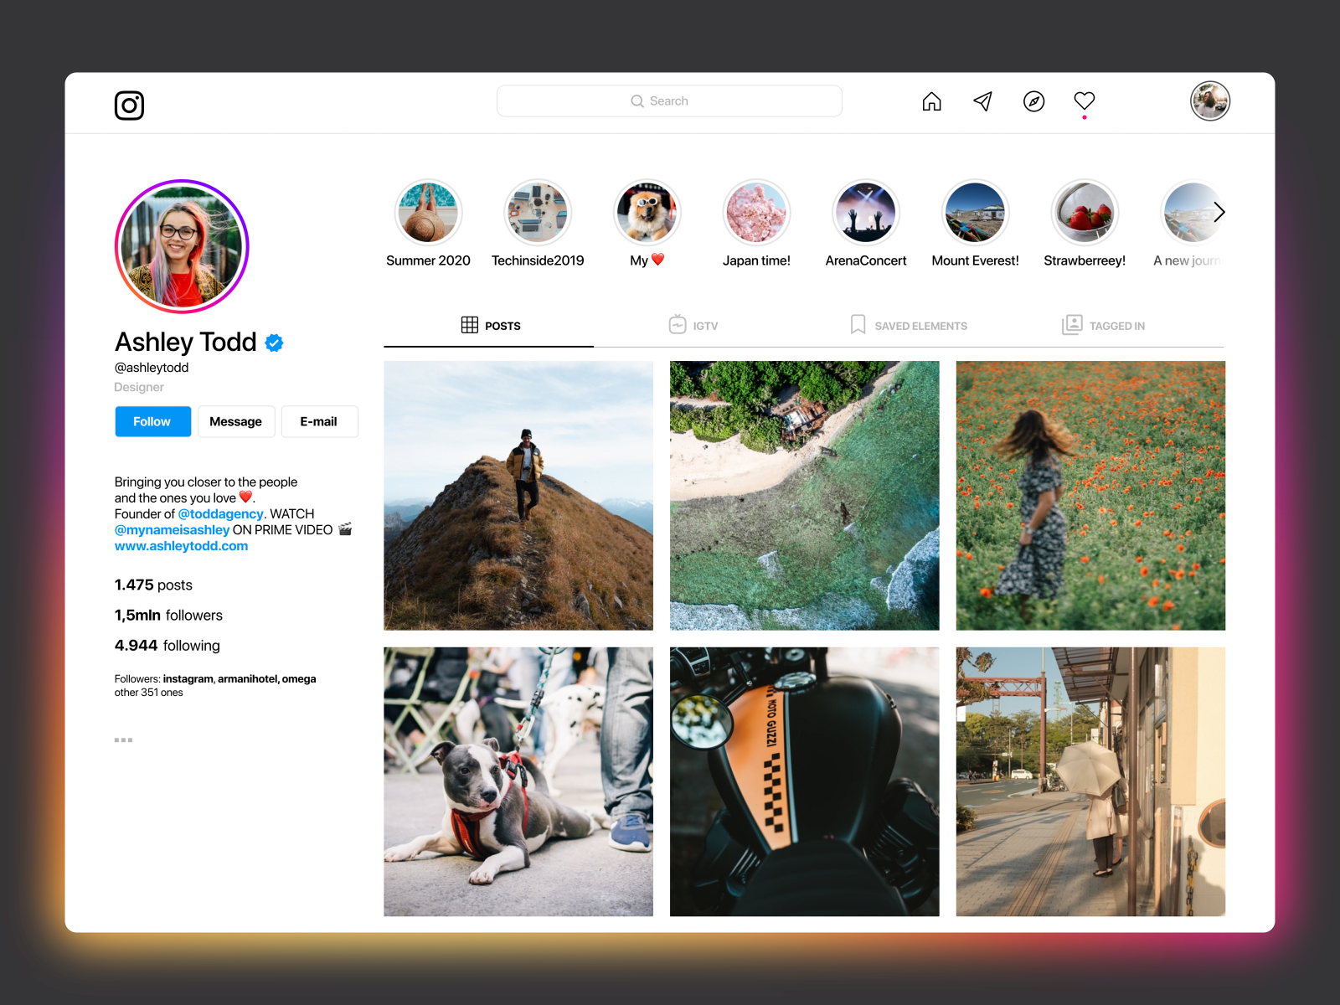

The profile consists of follower counts and your own photos and videos that you have uploaded with the profile picture.

|  |  |
| --- | --- |
| Things we like / might include | Things we don’t like / won’t include |
| The common thing in both Instagram and snapchat was its minimalistic user-friendly design which makes it so appealing to students at the teenage age which we will ensure to include in our website. | Coming from the feedback with our client Jack we won’t include followers and likes as they have in Instagram to prevent any insecurities and distractive competitiveness. |
| Private messaging and group chats are also available in Instagram which we will enable in our website. | The user has no control over the feed and many times inappropriate content to some extent can be displayed without viewer discretion. |
| Even though we won’t include the video feeds and reels as it does not align with our objective, we may use a feed system similar to that of Instagram to make the flashcard system in order to engage the students. | We will not include stories as this will be too similar to a traditional social media website and will remove the element of being customized to the school. Furthermore, the purpose of this website is to connect and make friends while still keeping that educational element which stories will be a distraction to. |
| Similar to snapchat we can see there are friend suggestions based on mutual connection which we will include in our website. |  |

**Website 3:** [**Microsoft Teams**](https://www.microsoft.com/en-gb/microsoft-teams/group-chat-software?ms.url=teamscom)

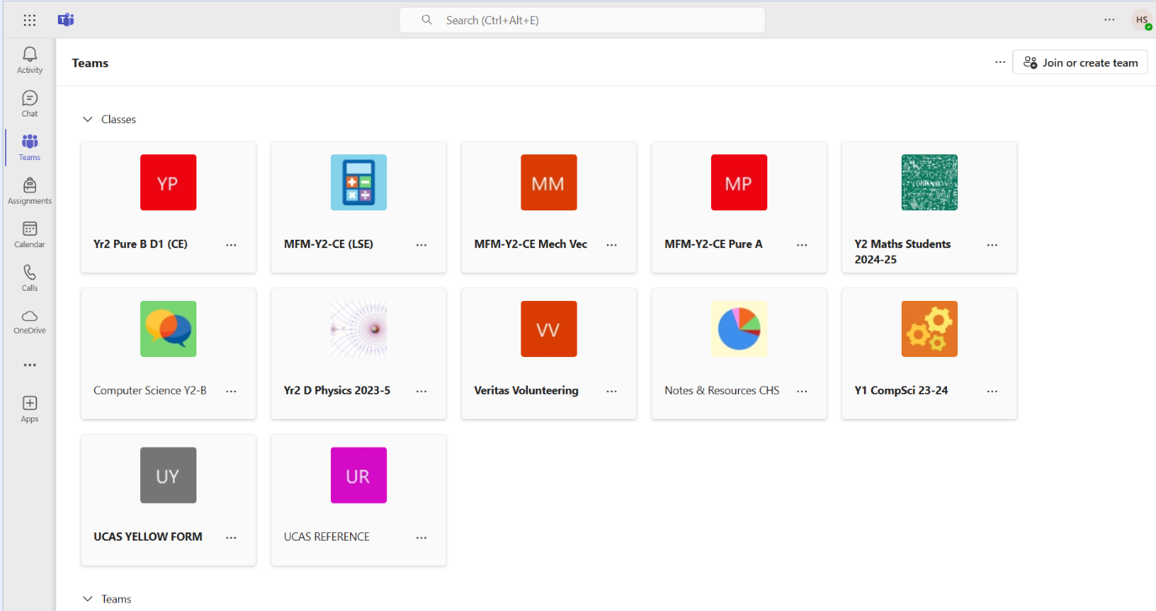

There is a menu bar containing classes, calls, assignments for each student. In the teams bar is a list of all the students classes.

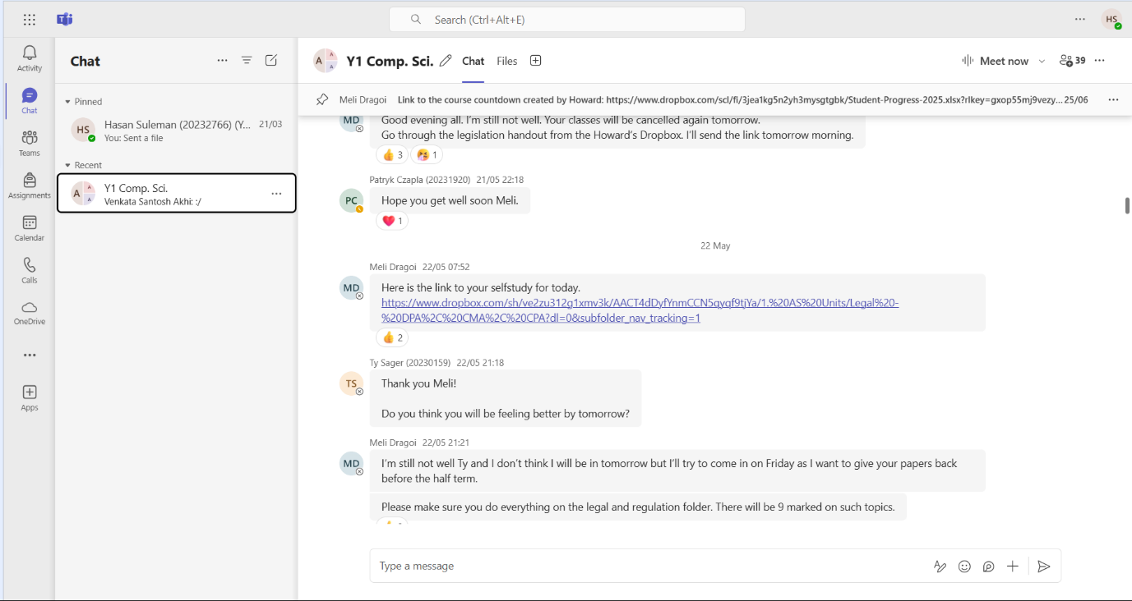

There is also a chat room for each class where along with real-time messaging you can upload files.

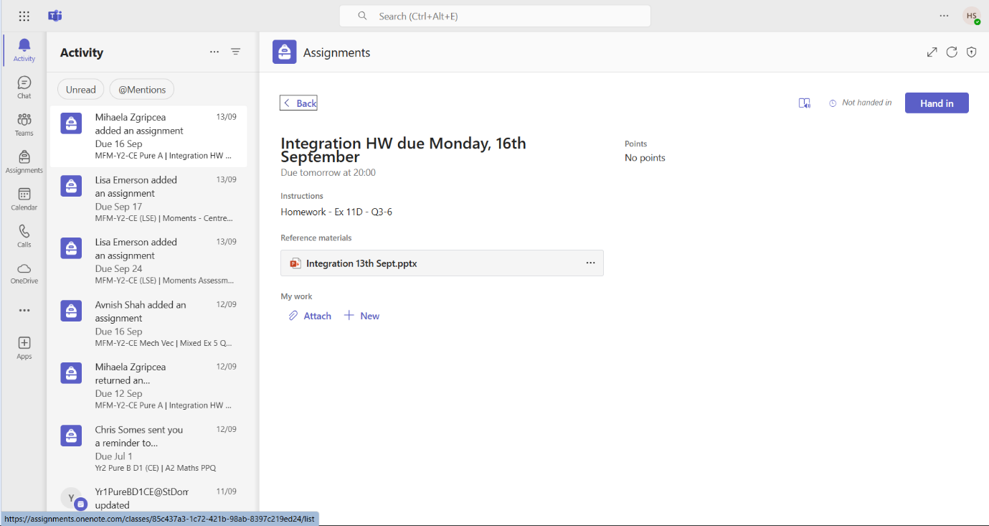

There is also an activity page to upload assignments or to make any announcements.

|  |  |
| --- | --- |
| Things we like / might include | Things we don’t like / won’t include |
| I like the separate classes displayed in the teams option and will create separate class chats in my website. | The presence of teachers is not needed in the group chats as conveyed by Jack. It would make students uncomfortable, and they will not talk freely making it harder to make new friends. |
| Along with private messaging and group chats I will also include the option to upload files like in teams as it would be helpful in sharing resources and helping fellow students in homework and studies. | Even though the design is minimalistic it feels a bit too professional and simplistic. I will try to enable some colour scheme to make it visually appealing to the students. |

## FEATURES OF SOLUTION:

|  |  |  |  |
| --- | --- | --- | --- |
| **#** | **Feature** | **Source** | **Notes** |
| **1** | A secure login system | Client interview | The login system will require school email address and password which will be stored in a database using SQLite from django. |
| **2** | A friend-suggestion algorithm | Client interview  Website analysis | Will use interests, subjects, timetable and mutual connections to suggest friends. |
| **3** | Flashcard game system | Client interview  Stakeholder survey | Will create a flashcard game system with an interface similar to Instagram reels. |
| **4** | User feedback through direct messages | Stakeholder survey | There will be a page on the website where users can give direct feedback |
| **5** | User-friendly, minimalistic and modern user interface. | Stakeholder survey  Website analysis | The interface will be easy to navigate and visually appealing. This will be done via html, CSS and JavaScript. |
| **6** | Flashcard leaderboard system | Stakeholder survey  Client interview | There will be a weekly, monthly, all-time leaderboard and a separate one for individual classes. |
| **7** | Private direct real-time messaging | Stakeholder survey  Website analysis | Real-time messaging will be created using Django channels. Also, an Django’s encryption system will be in place to secure confidential data. |
| **8** | Group chat messaging | Website analysis | Will be created using Django channels as well. |
| **9** | Subject class group chat | Website analysis | Will be created using Django channels as well. |
| **10** | Uploading files in chats | Website analysis | Students will be able to share resources. |
| **11** | Menu bar to navigate between chats and flashcards | Website analysis | This will be done via html, CSS and JavaScript on the interface |
| **12** | Ability to change profile image | Stakeholder survey | Will be integrated in the profile page. |
| **13** | Timetable of student viewed on profile | Client interview | Will need to contact Jack to get timetable details of students matching with their email address |

## REQUIREMENTS:

**User requirements:**

With the stakeholder survey data, I can conclude that most users would prefer to use a laptop, hence the minimum hardware specifications required would be:

* Operating system: windows 7 or greater
* Memory: 4 GB of RAM
* Storage: Minimum of 1 GB free disk space
* Monitor resolution: 1024x768
* Internet connection: minimum speed of 1 Mbps
* Processor clock speed: 2-4 GHz
* Peripherals: Keyboard, mouse, and monitor

Users will not require any software apart from a web browser.

**Developer requirements:**

I will be coding this program on my laptop and will require no hardware requirements.

Software requirements:

* IDE - Visual studios
* Python
* Django module
* Html
* CSS
* JavaScript

The IDE Visual studios will be helpful in storing multiple programming files into one folder and integrating multiple languages such as html, JavaScript and CSS which will be used for the user interface and python specifically the Django module to create real-time messaging channels. Furthermore, SQLite will be used to store the large amount of data in a database. (Will make this explanation better once I complete my code and understand it.)

## LIMITATIONS:

There are several limitations that I will face in the design and production of this project.

This project will need to be completed in a short time frame; this limitation will have to be tackled through simplifying certain features in the program and focus mainly on developing the main features that my client wants. An example includes customizable flashcards and multiple flashcard types in my flashcard system etc. which may improve user learning however will be time-consuming to implement. Furthermore, this will deviate from the main objective of the client, a social media platform for students to male new friends. Rather I will create a straightforward flashcard game with a limited pool of questions.

The program will also only be able to run on the web as support for apps will require more frameworks and extra modules where more knowledge, time and testing is required. Since I am not a highly experienced programmer, making this program usable for other devices will not be possible.

Reducing the complexity of user profiles like that of Instagram’s and snapchats will speed up development and ensure core objectives are reached. For example, rather than options for themes, background image, photos and video uploads, just a profile image, bio, name and timetable will be sufficient.

I will be creating this program on my laptop and due to the large amounts of students there will be a large amount of data that will need to be stored. Storing all of this data on my laptop will be impractical so for the starting phase I will only store a limited amount of student’s data and in the future if the school provide me with a dedicated database server, I will be able to store the rest of the students data.

Django’s encryption and decryption operations can be computationally expensive, especially for large datasets or messages. This might impact the performance of my website hence for the starting phase I will only use a small amount of student data and in the future if the school provides me with the required hardware, I will be able to use more student data.

## SUCCESS CRITERIA:

|  | **#** | Success Criteria | Description | Source |
| --- | --- | --- | --- | --- |
| **LOGIN** | 1 | Student can register with their school email address. | This must be verified by getting the details of user email address from Jack and storing them in a database. | Client interview    Myself |
| 2 | Student can create a username | The username must have between 3-15 characters | Client interview  Myself |
| 3 | Student can create a password | The password must have at least 5 characters and contain a number for privacy and security reasons. | Client interview  Myself |
| 4 | Student will fill out a multiple choice of interests and hobbies | This will cover a broad aspect of interests and hobbies and if a new hobby is entered it becomes another option for a future student. This will be used in the friend suggestion algorithm. | Client interview  Myself |
| 5 | Student will enter their subjects | This will be in the form of a multiple choice and will be used in the friend-suggestion algorithm. | Client interview  Myself |
| 6 | Student can login | After three unsuccessful login attempts, the user must be locked out of the system. They must then contact the administrator to get the account unlocked. | Client interview  Myself |
| **USER PROFILE PAGE** | 7 | Student can change their profile image. | Profile image can be viewed by other students in the shape of a circle with the image inside on the profile page. | Stakeholder survey  Website analysis |
| 8 | Student can change biography | Students will be able to write a small biography summarising themselves. | Website analysis  Myself |
| 9 | Student interests will be displayed | This will be displayed on their profile page. | Myself |
| 10 | Other students can view name, timetable and profile image on a student’s profile | Name and timetable along with subjects and timing of subjects will be on display on a student’s profile page. | Client interview |
| 11 | Student can view friend suggestions on their profile and add friends | Using the friend suggestion algorithm which will take into account mutual connection, interests and subjects. | Client interview  Myself  Website analysis |
| **CHAT ROOMS** | 12 | Student can message in real time directly to another student | This will be done using python Django channels. | Client interview  Myself  Website analysis |
| 13 | Student can create and edit a group chat and send messages in real-time | This will be done using python Django channels as well. | Website analysis  Myself |
| 14 | Student can upload files and images in chats. | This will help in sharing resources and helping other students. | Website analysis |
| 15 | Each class will have its own group chat. | Will contact Jack and he will assign emails to classes which they will automatically join. | Myself |
| **FLASHCARD SYSTEM** | 16 | Student can use flashcards based on each subject and topic | Student flashcard interface will be similar to Instagram to make it engaging. | Client interview |
| 17 | Student will get points on each flashcard they complete | Each student’s flashcard points will be kept track of. | Client interview |
| 18 | Student will be able to see points on a flashcard leaderboard | Flashcard leaderboards such as all-time, monthly, weekly and subject wise leaderboards will be displayed. | Client interview |
| **USER INTERFACE** | 19 | Students have a menu tab to navigate between areas of the website | There will be a profile tab, a flashcard tab and a chat rooms tab. | Website analysis |
| 20 | Log-out button | Students can log out if they wish. | Website analysis |

# DESIGN:

## LAYOUT OF WEBSITE:

I can decompose the website into its main views. I can develop these sections separately and then link them together to make a fully functioning solution. The parts of the website will include the following:

1. **Authentication system:**

* Breaking this system down, this will include:
  + A sign-up page, which will have inputs to create a username, password and email address, ensuring that the username is unique. Also email address and password will be validated to ensure they are college email addresses and passwords. These details will be stored in the default SQLite database provided by Django. Furthermore users will be asked their interests through multiple-choice questions to display on their profile page later.
  + A login page, which will have an input for email address/username and password as well as a link to the register page. The inputs will be validated by checking the details entered in the SQLite database using Django’s authentication system.
* Justification: Taking feedback from the client interview #6 I have provided students the facilities to create their own accounts and ensured that the system prevents people who are not at the college from using the website.

1. **Header:**

* Breaking this system down, this will include:
  + A link to the profile page.
  + A link to the private messages page.
  + A link to the classes and group chats page.
  + A link to the flashcards page.
* Justification: Through feedback from stakeholder survey, client interview and website analysis I have included the above features making the website a lot easier to navigate.

1. **Flashcards system:**

* Breaking this system down, this will include:
  + Page where student can use flashcards based on each subject.
  + A page where student will be able to see points on a flashcard leaderboard based on subject, classes and time (e.g.: all time, monthly).
* Justification: The client has requested an educational feature in response 8 along with the stakeholder survey Q5 to limit the distraction this app can cause and engage students in learning.

1. **Profile page**:

* Breaking this system down, this will include:
  + Option to change username and password.
  + Option to write and change biography.
  + Interests asked in multiple choice questions will be displayed.
  + A friend suggestion section which will be given through a friend suggestion algorithm which will use details provided by the school (Subjects they study, free periods, mutual connection etc.)
  + A timetable section where the student’s timetable can be viewed, which will be provided by the school and stored in the SQLite database using Django.
  + Button to log out.
  + Button to delete account.
  + A profile picture which can be changed and deleted.
  + A search bar to search for other users and add them as friends.
  + Subjects will be displayed.
* Justification: According to the data protection act, the user should be able to erase personal data of themselves which I have provided. Furthermore, feedback from the client interview, I have provided a friend suggestion section and a section where the students timetable can be viewed.

1. **Private messages and group chats page:**

* Breaking this system down into two pages will include:
* Private messaging page:
  + The option to privately message other students that are your friends.
* Group chats page
  + The option to create group chats with other students.
  + There will be a group chat for every class which will be done by contacting Jack and he will assign emails to classes which they will automatically join.
* Justification: Using feedback from client interview and website analysis I have included messaging features so students can talk and get to know one another.

## VISUALISATION OF WEBSITE:

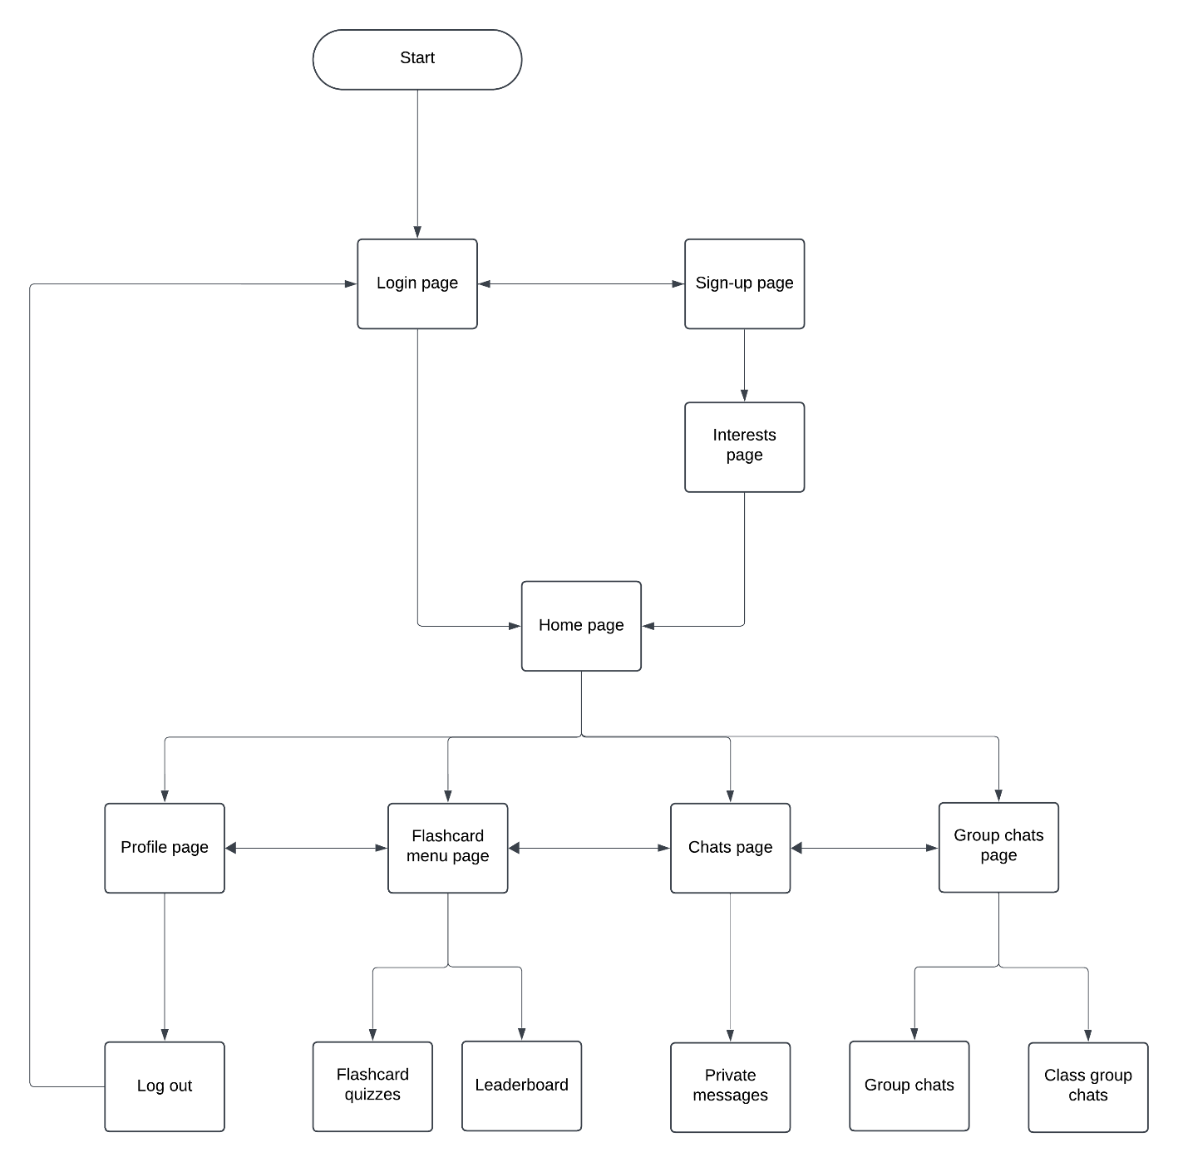I can use a flowchart to visualise the flow of the website and its layout to help decompose the problem.

When the user enters the website it will bring it to the login page where the user can login if they have an account. If the user doesn’t have an account they can create an account and after authentication they will be directed to the interests page where they select interests to display on their accounts page. Once logged in they will be directed to the home page where they will be able to navigate throughout the rest of the website and on each page there will be a header allowing the user to navigate throughout the rest of the website as well.

## DESIGNING THE AUTHENTICATION SYSTEM:

The authentication system will consist of two pages: the login and the sign-up pages. When a user attempts to login an algorithm will check that both username and password entered matches details stored in the database. This ensures a level of security preventing unauthorized users from using the website as requested by the client in the client interview. Furthermore, if users don’t have an account they are given the option to create and account. When registration details are validated, if they meet the requirements, they are added to the database.

**View of the login page:**

Usability feature: large title which is displayed on every page. This helps the user easily identify the website they are on and gives the website a more professional and neat look.

Website Title

Username:

Password:

Login

Usability feature: Text boxes to allow the user to input their username and password. The text boxes are labelled making sure the user knows what to enter.

New to this app? Register

Error message

Usability feature: There will be an error label if the user has entered invalid inputs to help identify their mistakes and what to do to fix them.

Usability feature: A button which links to the register page where the user is able to create an account if they don’t have one.

Usability feature: Login button to allow the user to login if details entered are valid as per the #6 success criteria. Once the user is logged in they will be directed to the home page.

**View of the Sign-up page:**

Usability Feature: the same website title as before to make the website look neat and professional.

Website Title

Enter college email address and password

Username:

Usability Feature: text specifying user must register with college email address and password to allow only members of the college to use this website by request from the client interview #6.

Email address:

Password:

Register

Already have an account? Login

Error message

Usability Feature: There will be an error label if the user inputs do not match school email addresses and passwords and an error label if the username is already taken or too long. This helps the user identify their mistakes and help them fix it.

Usability Feature: A button which links to the login page. This will allow the user to login if they already have an account.

Usability Feature: Button to create an account if the email address and password match one of the school email addresses and passwords sent by my client. Also the username must not be taken and fits the criteria.

|  |
| --- |
| **Table name: Users** |
| id (primary key) |
| username |
| email |
| first_name |
| last_name |
| password |

**Structure of the User table:**

This table in the database has 6 columns including an id column which acts as the primary key linking to other tables. Also, the first name and last name will be fetched by matching the email address to the student in the excel sheet provided by the client.

**Authentication system variables:**

**Authentication system variables:**

| Variable name | Data type | Description and justification | Validation and justification |
| --- | --- | --- | --- |
| new_user | record | Stores the full record (username, id, email, first_name, last_name and password) of the entered details during the registration process and once details are validated will be entered into the database. This is needed to authenticate users, manage user accounts, and ensure each user has a unique and identifiable record for access control. | None |
| user | record | This variable stores the record of a user that is retrieved from the database during login. It stores the information associated with the username entered, and it is checked to see if the password entered matches the stored password for that user. Once validated, this record allows the system to authenticate the user and provide a personalized experience. | None |
| id | integer | Using Django’s default User model, the auto incrementing id field is automatically created as a primary key for each user record. The id field is essential for maintaining the entity integrity of the database by ensuring that each user has a unique identifier. It simplifies operations like querying, updating, and deleting user records, | None |
| username | string | This variable will be used to store the username input from the form on the frontend once it has been validated. This will be useful in distinguishing between users in for example the user profile page. | -Must be less than 20 characters and longer than 6 characters to ensure ease of readability and usability.  -Must not be already in use to allow a user to be uniquely identified. |
| email | string | This variable will be used to store the email input from the form on the frontend once it has been validated. Will be used to identify the student and match them to their subjects and timetable in the excel sheet provided by the client. | -Must contain an “@” in the string as every email does.  -Must match one of the student emails from the excel sheet allowing only the colleges students to access the website as per the client interview #6.  -Must not be already in use to allow only one account per student. |
| first_name | string | This variable will be used to store the first name which will be retrieved from the excel sheet by referencing the user's email address. This will be displayed on their profile page as a part of the user’s details. | None |
| last_name | string | This variable will be used to store the last name which will be retrieved from the excel sheet by referencing the user's email address. This will be displayed on their profile page as a part of the user’s details. | None |
| password | string | This variable will be used to store the password input from the form on the frontend. If the entered password is validated, it will be hashed and added to a user record in the database. The password will also be used to login to an account. | -Must match the password corresponding with the students email address from the excel sheet allowing only the colleges students to access the website as per the client interview. |
| data | dictionary | This variable will store the POST request data which contains the details entered by the user in the login and registration forms. This variable will be used to check if the user has entered valid details. | None |
| correct_email | boolean | Boolean variable to check if the email matches one of the school emails. Initially set to False and turns True if email is a school email. If it remains False, an error message will be displayed and the rest of the function will be discontinued.  This ensures we meet the client interview requirements of giving only school students access to the website. | None |
| emails | list | A list of school emails extracted from the excel sheet provided by the client. This will be used to check if email entered matches one of the emails in this list. | None |
| passwords | list | A list of school passwords extracted from the excel sheet provided by the client. This will be used to check if password entered matches one of the passwords corresponding to the email in this list. | None |
| student_  index | integer | The index of the email address entered which will be used to find the corresponding password and validate if the password entered is correct or not. | -only created if the email matches one of the school emails otherwise an error message will be returned before this variable is created. |
| student_  password | string | The student_password will be access using the student_index and will be used to validate if the password entered is correct to the corresponding email. | -only created if the email matches one of the school emails otherwise an error message will be returned before this variable is created. |

**How the authentication system will work:**

Below is a basic flowchart which represents how the authentication system will work. It will start on the login page and end when the user has either been validated and logged in and has been redirected to the home page or when the user has registered their account to the database with valid inputs and has been redirected to the interest page. The input validations allow for the system to be secure. Furthermore, school email addresses and passwords are used to prevent people not from the school from accessing the website as per the clients request in the client interview.

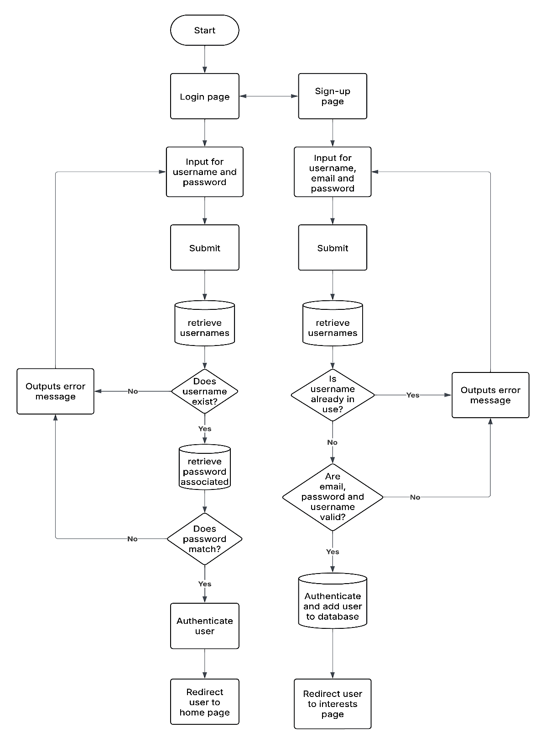

**Authentication system validation pseudocode:**

Below is the pseudocode for the validation I will do for the variables username, password and email when an account is being created in the registration page:

**Username:**

**FUNCTION validate_username:**

**IF LENGTH(username) > 20 THEN**

**RETURN error message: “Username is too long; it needs to be less than 20 characters”**

**ElSE IF LENGTH(username) < 6 THEN**

**RETURN error message “Username is to short; it needs to be longer than 6 characters”**

**ELSE IF username IN users.username THEN**

**RETURN error message “Username is already in use”**

**Email:**

**FUNCTION validate_email:**

**correct_email = False**

**FOR student_email IN emails**

**IF email = student_email THEN**

**SET correct_email = True**

**BREAK**

**IF not correct_email THEN**

**RETURN error message ”You have to use school email”**

**Password:**

**FUNCTION validate_password:**

**SET student_index = emails.index(email)**

**SET student_password = passwords[student_index]**

**IF password ≠ student_password THEN**

**RETURN error message “Incorrect password”**

## DESIGNING THE INTERESTS PAGE:

If a user has just registered an account, they will be redirected to the interests page which contains a dropdown list of different interests and hobbies from which the user can select to display on their profile page. The interests will also be used to create the friend suggestion algorithm to match students with similar interests as requested in the client interview #4. Once the user has selected their interests they will be directed to the home page where they will be able to access the rest of the website. I will give an example of how the page will look below (There will be more interests options in the actual website)

**View of the interests page:**

Usability feature: clear bold title indicating to the user what page he is on and instructions telling him: he has to select his interests and he can only select up to four interests.

**Select Your Top 4 Interests**

football

Sports

Usability Feature: Specific interests for example if you want to select a specific sport as your interest it will be viewable in a dropdown menu ensuring the user has a clear view on all the possible interests to select from.

Pop

Music

Gaming

Travel

Art

Other:

Usability Feature: All interest options are clearly listed ensuring the user has a clear view on all the possible interests to choose from.

SUBMIT

Usability Feature: An option to enter an interest not already in the list to allow users to express themselves however unique their interests are and if we have missed them out.

Usability Feature: Checkbox allowing users to select the interest corresponding with the name written next to it which will be displayed in the accounts page once added to the UserProfile table.

Usability Feature: Button to submit the interests once the user has selected them and storing them to the UserProfile table to be used later to display in the accounts page.

**UserProfile table:**

This table in the database has 6 columns including a user column which acts as the primary key linking to other tables and is a record containing the data of the user from the User table. The interests field is a list containing all of the interests selected by the user and the bio, friends and subjects will be used later on in the website.

|  |
| --- |
| **Table name: UserProfile** |
| user (primary key) |
| interests |
| bio |
| subjects |
| friends |
| profile_picture |

**Interests page variables:**

|  |  |  |  |
| --- | --- | --- | --- |
| Variable name | Data type | Description and justification | Validation and justification |
| interests | list | This variable stores a list of the interests that the user has selected and will be displayed on the user account page allowing other users to make friend requests based on similar interests. It will also be used in the friend suggestion algorithm to give suggestions based on interests as per client interview. | -Must not have more than 4 interests selected. Limiting interests makes the users account page more readable and ensures that their interest choices are meaningful. |
| other_interests | string | This variable stores the interests that have not been provided in the original interests options to allow user hobby inclusivity and diversity. This variable will be added to the interests list. | -Must be less than 20 characters. Restricting character length prevents the user from entering unnecessarily long inputs which could disrupt system behaviour and affect readability. |
| current_user | record | This variable stores the record of a user that is created and stored in the database during registration. It is the primary key allowing each user_profile to be associated to a specific user making it easier to access. | None |
| user_profile | record | This variable stores the record of a user using the UserProfile table and will be created upon submission of the interests. | None |

**How the interests page will work:**

Below is a basic flowchart which represents how the interests page will work once the user has registered their account and has been redirected to this page. Once interests have been submitted, they will be added to the newly created user_profile record to use later on in the accounts page and other various aspects of the program.

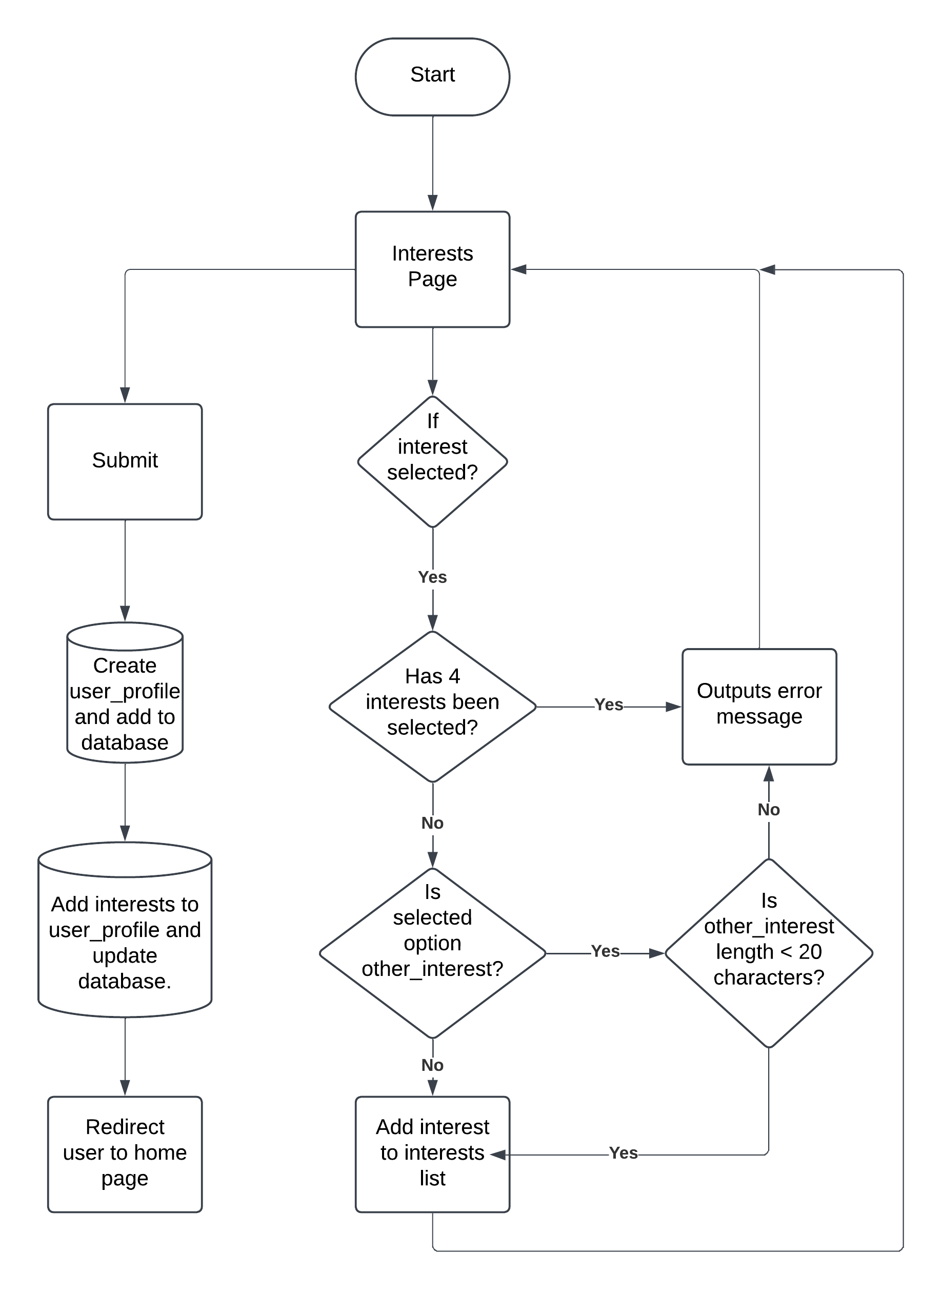

**Interests page pseudocode:**

Below is the pseudocode for the validation I am going to do on the interests list when the user is selecting their interests and the pseudocode showing how I will create a user_profile along with the interests within it and how I will add it to the database:

**FUNCTION Validate_interests:**

**IF interest IS SELECTED THEN**

**IF interest IS EQUAL TO other_interest THEN**

**IF LENGTH(other_interest) > 20:**

**RETURN error message “Other interest length has to be less than 20 characters “**

**IF LENGTH(interests) < 4 THEN**

**AddItem(interests, interest)**

**ELSE:**

**RETURN error message “You have already selected 4 interests”**

**FUNCTION Interests:**

**SET interests = GetListFromPOST("interests")**

**SET other_interest = GetFromPOST("other_interest").strip()**

**SET current_user = GetCurrentUser()**

**SET user_profile = CreateUserProfile(user=current_user)**

**IF other_interest IS NOT EMPTY THEN**

**RemoveFromList(interests, 'other')**

**AppendToList(interests, other_interest)**

**Validate_interests()**

**SET user_profile.interests = interests**

**SaveToDatabase(user_profile)**

## DESIGNING THE HOME PAGE:

The home page will be a welcome page that provides the users with a friendly engaging starting point featuring a navbar allowing the user to navigate throughout the rest of the website (chats page, group chats page, profile page, flashcard page).

**View of the Home page:**

Usability feature: the navbar will be available on every page of the website for consistency and allows the user to navigate through the rest of the parts of the website. Consistency of the navbar is important as helps the user get familiar with using it.

Usability feature: this will be the websites name and will be on every page for consistency and ensuring the website looks more professional and cleaner. If the user is on a different page and clicks on the name, it will direct them back to this home page.



Group Chats

Flashcards

Chats

**UniVerse**

Welcome to UniVerse

Usability feature: this will be a welcome message to the user and lets the user know this is the home page and hence the user can navigate through the rest of the website using the navbar. I may also personalise the welcome message with the user’s name to make the experience more engaging and tailored.

Usability feature: this will display the profile picture of the user and if clicked will lead the user to the profile page. Also, if a user hovers over the profile picture the profile picture will react by slightly increasing in size allowing the user to know that this links to somewhere.

**How the home page will work:**

|  |  |  |
| --- | --- | --- |
| Variable name | Data type | Description and justification |
| profile_picture | Binary data type | This variable will stores the image to use as the profile picture. The data type is binary data type as images are stored in binary in SQLite. This enhances user experience by personalising interactions and giving the user a sense of identity. |

The home page only links to other pages and does not require any validation or variables apart from the profile picture which is unique to each user:

Below is the pseudocode showing how the user will be able to navigate throughout the rest of the website using the home page specifically the navbar:

**FUNCTION Home:**

**DISPLAY NavigationBar:**

**DISPLAY Link to "Chats" WITH href "/chats"**

**DISPLAY Link to "Flashcard" WITH href "/flashcard"**

**DISPLAY Link to "Group Chats" href "/group_chats"**

**DISPLAY ProfileSection:**

**DISPLAY Image WITH source profile_picture**

**ON CLICK redirect to "/account"**

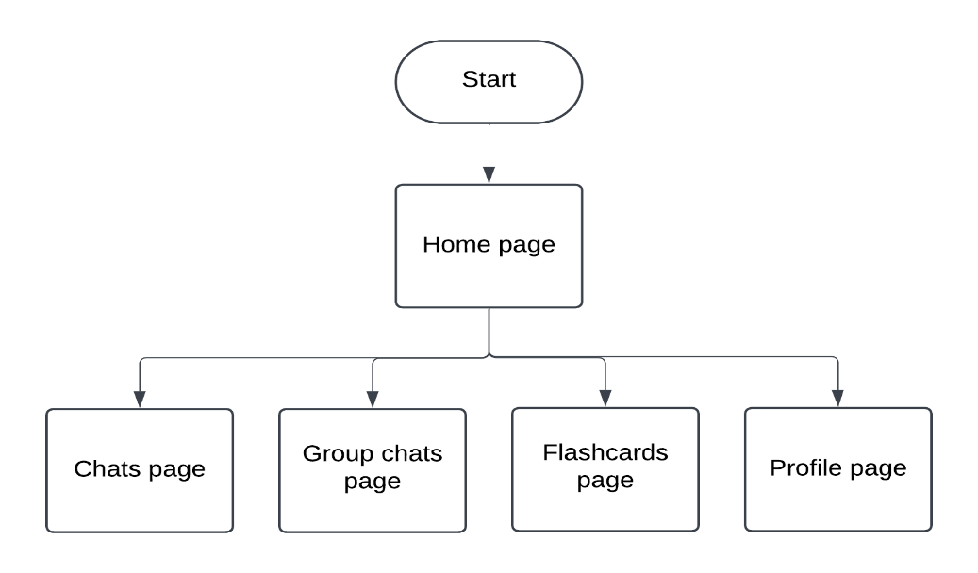Below is a visual representation of the structure of the website:

## DESIGNING THE CHATS PAGE:

The chats page will allow the user to privately message his friends that he has added using the accounts page in real time as per the client interview #4. On this page the user will also be able to view the list of his friends and any incoming friend requests. All messages from the user will be saved unless he deletes them to adhere to the data protection act which includes that the user should be able to erase personal data of themselves.

**View of the chats page:**

Usability feature: a dropdown menu allowing the user to view and manage friend request statuses as per success criteria #11 and website analysis #1. Once users become friends they will be able to message each other.

Usability feature: the page the user is on will be highlighted in the nav bar reminding the user what page they are on.

Usability feature: when the circles are coloured blue it indicates your friend has seen the message and when the colour is filled white it indicates the user has not seen your message helping the users communicate.



Group Chats

Chats

Flashcards

**UniVerse**

Friend requests



Date

message

Friends

Date

message

Friend 1



Date

message

Friend 2

Friend 3

Send a chat

Send

Friend 4

Friend 3

Usability feature: messages sent by the user will be displayed in a distinct colour from those sent by their friend, ensuring ease of readability. Additionally, the date will be displayed alongside each message for better context.

Usability feature: this is an expandable input box where the user can enter messages to send by clicking on the send button accompanied with it. This allows for real time messaging as per client interview #4.

Usability feature: a scrollable friend list will display all the user's friends, providing easy access. Additionally, if the user is actively chatting with a friend, that friend's section will be highlighted, making it easier to locate and manage active conversations.

|  |
| --- |
| **Table name : Message** |
| from_whom |
| to_whom |
| message |
| date |
| time |
| has_been_seen |

**Chats page tables:**

Message table:

This table in the database has 6 columns containing the necessary fields to store and manage messages, including the sender, recipient, message content, date, time, and whether the message has been seen, ensuring efficient message tracking and delivery.

|  |
| --- |
| **Table name : UserChannel** |
| user (primary key) |
| channel_name |

UserChannel table:

This table in the database has 2 columns including a user column which acts as the primary key linking to other tables and is a record containing the data of the user from the User table. The UserChannel table will be used to create a channel between two users to allow real time messaging.

FriendRequest table:

This table in the database has 3 columns and contains the fields necessary to send, accept, reject and receive from requests from one user to another. This structure ensures smooth handling of user interactions within the system.

|  |
| --- |
| **Table name : FriendRequest** |
| from_user |
| to_user |
| status |

**Chats page validation and justification:**

We will only need to validate the message variable (will go to more detail about it in the variables section) to limit its length to prevent excessively long messages that could impact performance or cause issues with storage. We will do this by limiting the text box area and preventing the user to enter more characters once the size limit has been reached in the front end using JavaScript. Below is the pseudocode representing the validation:

**FUNCTION messageValidation:**

**SET max_length = 200**

**IF user TYPING IN text box THEN**

**IF current_length > max_length THEN**

**DISABLE TYPING IN text box**

**RETURN error message “Max message length reached”**

**Chat page variables:**

| Variable name | Data type | Description and justification |
| --- | --- | --- |
| from_whom | record | This variable holds the user record (from the user table) containing the details of the person that sent the message. This will be used to create a channel between the user and the friend allowing them to send messages between each other. |
| to_whom | record | This variable holds the user record (from the user table) containing the details of the person that the message has been sent to. This will be used to create a channel between the user and the friend allowing them to send messages between each other. |
| message | string | This variable holds the message that the user wants to send to the other user allowing the user to communicate in real time as per client interview #4. |
| date | string | This variable holds the date a particular message was sent using the datetime module and will be displayed next to each message. This allows the users to track their messaging history for better context. |
| time | string | This variable holds the time a particular message was sent using the datetime module and will be displayed next to each message. This allows the users to track their messaging history for better context. |
| has_been_seen | boolean | This variable holds the boolean value for whether a message has been seen or not: TRUE means the message has been seen , FALSE mean the message has not been seen. This variable will be used to update the viewed status next to the message. This feature enhances the user experience by providing real-time communication status between users. |
| channel_name | String | This variable holds the name of the channel created using django to allow real time messaging between two users. |
| request_to | record | This variable holds the user record (from the user table) containing the details of the person that the friend request has been sent to. Once the friend receives and accepts the request, the two will be able to message each other. Friend requests will be displayed on this page via a  dropdown menu. |

|  |  |  |
| --- | --- | --- |
| Variable name | Data type | Description and justification |
| request_from | record | This variable holds the user record (from the user table) containing the details of the person that sent the friend request. Once the friend receives and accepts the request, the two will be able to message each other. Friend requests will be displayed on this page via a dropdown menu. |
| status | record | This variable holds the status of the friend request that has been sent in the form: “ACCEPTED”, “REJECTED” or “PENDING”. It will be used in the friend request dropdown to update the status of requests and in the account page search bar for easy tracking. |
| my_profile | record | This variable holds the user_profile record (from the UserProfile table) containing the details of the user. This will be used in case a friend request is accepted to add that user to the friends list within this table. |
| friend_profile | record | This variable holds the user_profile record (from the UserProfile table) containing the details of the user whos friend request has been accepted. This will be used to add that user that accepted the friend request to the friends list within this table. |
| friends | list | This variable holds a list of all of a user's friends and is a bidirectional field, meaning if person1 is friends with person2, person2 is automatically friends with person1. This bidirectional setup simplifies the process of adding friends, as the relationship is automatically reflected on both user profiles with a single action. |
| response | boolean | This variable holds the boolean value of whether a user has accepted the friend request or rejected the friend request on the chats page: TRUE means the friend request has been accepted, FALSE means the friend request has been rejected. This will allow users to add friends. |
| accepted | list | This variable contains a list of all the users that have accepted the friend request and will be used to display the acceptance of the friend request in the friend request dropdown. |
| rejected | List | This variable contains a list of all the users that have rejected the friend request and will be used to display the rejection of the friend request in the friend request dropdown. |

**How the chats page will work:**

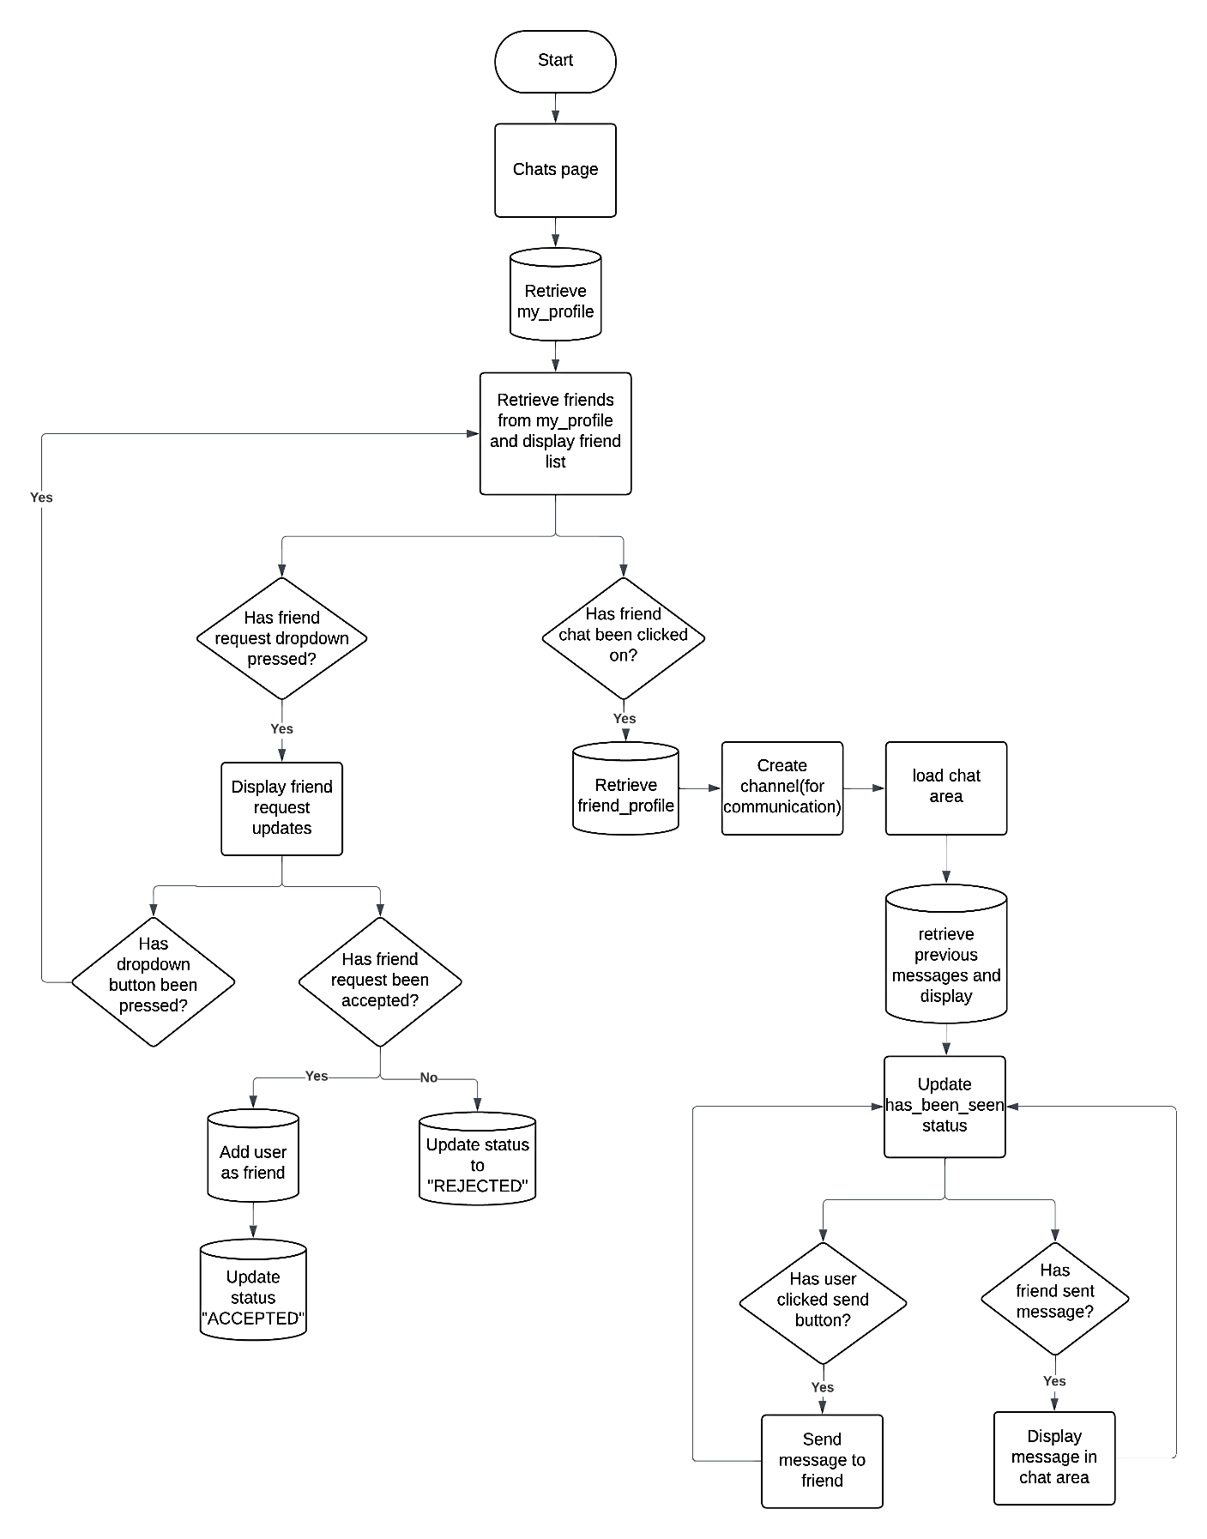The chats page will be designed with three main sections: a friend list displaying the user’s friends, a chat window for the selected conversation and the navbar. The chat window will display the full conversation with the selected user, along with an input field for sending new messages. Real-time updates, enabled through WebSocket will ensure that new messages appear instantly for a better user experience.

## DESIGNING THE PROFILE PAGE:

The profile page will serve as a personalised space where users can manage and display their information for other users to view such as subjects, interests, timetable etc. The profile page will also display friend suggestions and a search bar to search for other users. The view of the page will be split into 3: when the profile is open, when the search bar is open and when the change password section is open.

**View of the profile page – profile section:**

Usability feature: if this icon is clicked a timetable pop up will be displayed displaying the timetable of the user enhancing accessibility ensuring users can stay organised. Furthermore, if a user hovers over the icon the icon will expand slightly letting the user know that it is interactable.

Usability feature: options to edit username, bio and profile picture as outlined by the data protection act this page will allow users to update their personal details in real time. This feature enhances privacy and transparency by allowing quick and secure updates.



Chats

**UniVerse**

Flashcards

Group Chats

Profile

📅

Search users



Name:

✎Username

✎Bio:

Change password

Edit profile picture

Delete account

Subject 2

Subject 4

Subject 3

Subject 1

Logout

Interest 1

Interest 4

Interest 3

Interest 2

Suggestion 3

Suggestion 1

Suggestion 2

Usability feature: this will display user suggestions for the user to add. These suggestions will be generated using a friend suggestion algorithm which will take into account mutual connections, similar interest, similar subjects and same free periods using a point system. This will take into account the clients request from the client interview #4.

Usability feature: this will display a user’s interests and subjects, enabling others to find and connect with users who share similar interests. The subjects will be sourced from an excel sheet provided by the client, which contains each user's specific subjects, ensuring accurate and relevant information.

**Validation of username:**

The following validation will be used to ensure the username is eligible for readability and allows the user to remember it with ease:

-Must be less than 20 characters and longer than 6 characters to ensure ease of readability and usability.

-Must not be already in use to allow a user to be uniquely identified.

**PSUEDOCODE:**

**FUNCTION validate_username:**

**IF LENGTH(username) > 20 THEN**

**RETURN error message: “Username is too long; it needs to be less than 20 characters”**

**ElSE IF LENGTH(username) < 6 THEN**

**RETURN error message “Username is to short; it needs to be longer than 6 characters”**

**ELSE IF username IN users.username THEN**

**RETURN error message “Username is already in use”**

**Validation of biography:**

The following validation will be used to ensure the username is eligible for readability and an aesthetic structure of the page:

-Must be less than 200 characters for readability.

-Must not be empty.

**PSUEDOCODE:**

**FUNCTION validate_biography:**

**IF LENGTH(biography) > 200 THEN**

**RETURN error message: “Biography is too long; it needs to be less than 200 characters”**

**ElSE IF LENGTH(biography) = 0 THEN**

**RETURN error message “Biography cannot be empty”**

**View of the profile page – search bar:**

Usability feature: section which the user is on is highlighted for every section allowing the user to know which page he is on.

Usability feature: allows user to delete account and provides a confirmation pop-up in case of a mis click.

Usability feature: The search bar allows users to quickly find others by entering a username. It includes a search button to start the query. If no results are found, a clear message guides users to refine their search. This feature allows users to add new friends allowing them to connect with other people.



Chats

**UniVerse**

Flashcards

Group Chats

Profile



Search users

Search users

Username 1 +

Change password

Username 2 pending

Delete account

Logout

Username 3 ✅

Usability feature: allows user to logout and redirects them to the login page as per success criteria #20. Furthermore, if the user hovers over this button, it will be highlighted to indicate interactivity.

Usability feature: the dropdown menu makes it easy and quick to select and view users. If a username is clicked it will redirect the user to the selected user’s profile page. Furthermore, if the user hovers over this button, it will be highlighted to indicate interactivity.

Usability feature: the usernames will be displayed when the user searches the username. Next to the usernames there will be a symbol representing their relationship status: a “pending” label means the friend request is pending, a “+” symbol is a button allowing user to send a friend request, a ✅ will indicate user is already your friend.

**View of the profile page – change password:**

Usability feature: user must enter old password to confirm that he wants to change the password in order to maintain security. user can enter a new password and must confirm the password just in case of a miss type. The text boxes are labelled making sure the user knows what to enter.

Usability feature: an error message will pop up if the user types an invalid old password or does not meet the validation requirements for the new password.



Chats

**UniVerse**

Flashcards

Group Chats

Profile

Error message

Search users

Enter old password:

Change password

Enter new password:

Delete account

Confirm new password:

SUBMIT

**Validation of password:**

All this validation measures ensure security by making the password harder to guess. Below is the pseudocode representing the validations:

**FUNCTION Validate_Password:**

**IF LENGTH(password) < 7 THEN**

**RETURN error message “password is too short”**

**ELSE IF NOT (password CONTAINS digit) THEN**

**RETURN error message “password must contain a number”**

**ELSE IF NOT (password CONTAINS special character) THEN**

**RETURN error message “password must contain a special character”**

**Profile page variables:**

Some variables such as my_profile, user_profile, email user will be accesses again. Also, some new variables will need to be created to carry out the tasks required:

|  |  |  |
| --- | --- | --- |
| Variable name | Data type | Description and justification |
| subject_data | data frame | This variable accesses the excel sheet provided by the client and retrieves the subjects sheet which contains the subjects each user does. |
| subjects_unicode | dictionary | This variable contains all the subjects as the keys and its values as the unicode characters associated with it allowing it to be displayed on the profile page for an aesthetic look. |
| subjects_true | list | The excel sheet lists user emails alongside subjects. Each cell contains a Boolean value: "TRUE" indicates the student is enrolled in the subject, while "FALSE" indicates they are not. This variable appends all the subjects that represent “TRUE” from the subject_data data frame. |
| user_subjects | list | Once the subjects have been appended to subjects_true by checking the values in the data frame the subjects will be appended to the user subjects to be able to display on the profile page. |
| subject_instance | record | This holds the subject record of the subject from the subjects table that will be appended to the user_subjects list. |
| users | list | Holds the list of all the users registered on the website to be displayed in the dropdown menu when the user searches for other users. |
| new_pfp | Binary data type | This variable will store the newly uploaded profile picture allowing the user to change their profile picture. This enhances user experience by personalising interactions and giving the user a sense of identity. |
| new_username | string | This variable contains the newly entered username entered by the user and will be validated before saving it as the new username in the user record. |
| new_bio | string | This variable contains the newly entered biography entered by the user and will be validated before saving it as the new biography in the user record. |
| status | string | This variable is from the FriendRequest table mentioned previously and stored the current relationship status between two users in the form: “ACCEPTED”, “REJECTED”, “PENDING”. |

**How the profile page will work:**

The profile page will consist of many functions and therefore I will use multiple flowcharts to represent the logic behind this page: the search bar flowchart, the edit user information flowchart and account management flowchart.

Search bar flowchart:

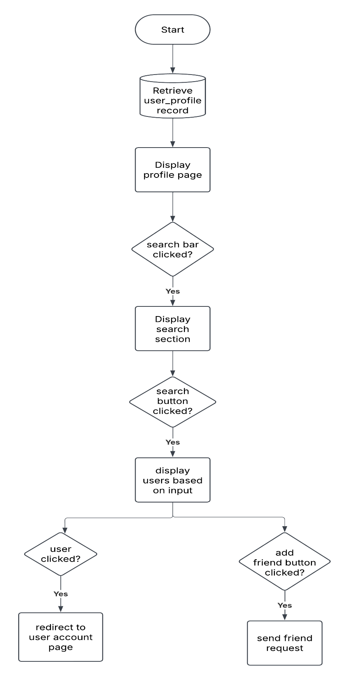

The search bar will allow the user to search for other users and allow them to view who is already their friend with a tick symbol. Furthermore, the user can add users by pressing the + symbol next to the user which will show the friend request status as pending after doing so. You will also be able to click on users to view their profile page.

Edit user information flowchart:

This section will allow the user to edit their username, biography and profile picture as long as the validation requirements are met. If these requirements are not met an error message will be displayed.

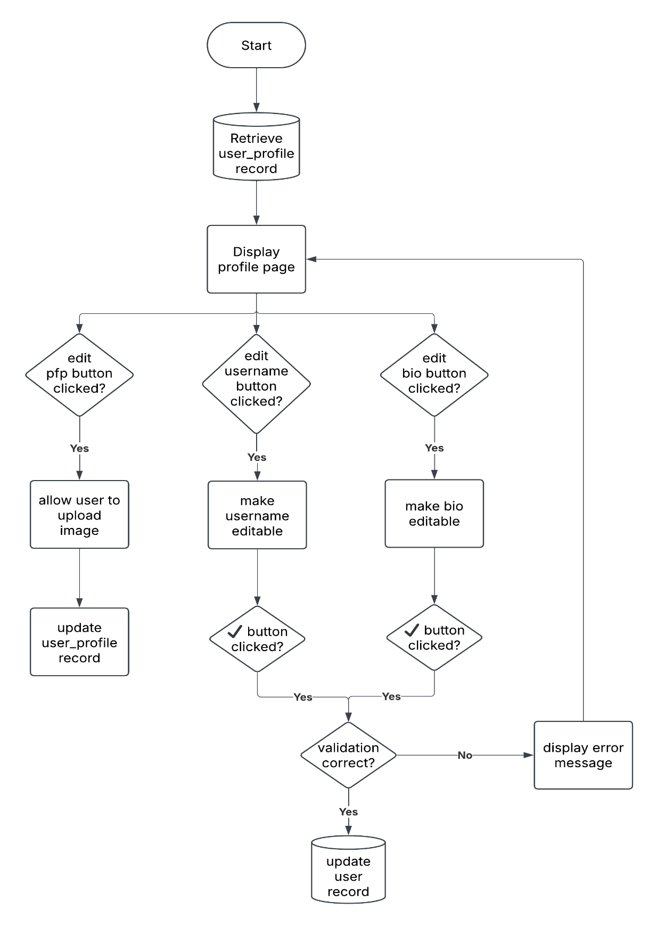

Account management flowchart:

Will allow the user to logout redirecting them to the login page. Furthermore it will allow the user to delete their account with a confirmation message in order to prevent an accidental deletion. The change password section will confirm the users identity and allow them to change their password.

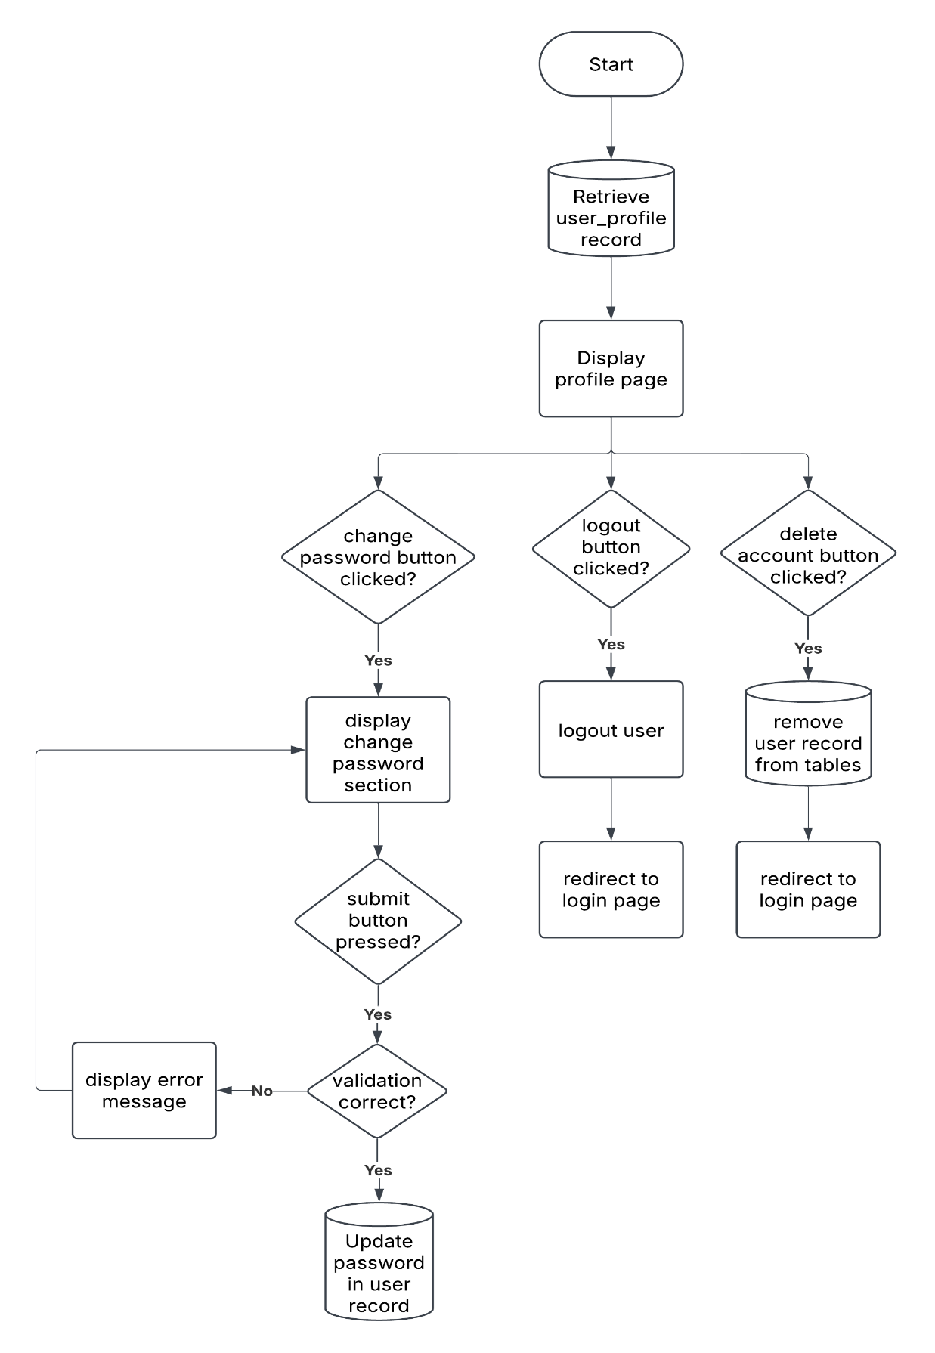

## DESIGNING THE GROUP CHATS PAGE:

The group chats page will allow the user to create, edit and message his friends in group chats as per the success criteria #13. On this page the user will also be automatically added to the a group chats of all the classes he attends using the excel sheet provided by the client.

**View of the group chats page:**

Usability feature: the page the user is on will be highlighted in the nav bar reminding the user what page they are on.

Usability feature: a scrollable classes list will display all the user's classes, providing easy access. Additionally, if the user is actively chatting in a class, that class section will be highlighted, making it easier to locate and manage active conversations.

Usability feature: user profile picture will be viewable next to each message to help the user identify who sent the messages.



Group chats

Flashcards

Chats

**UniVerse**

Classes



Class 1

Group Chats

Date

message

Class 2



Date

message



Group chats + +

Date

message

Group 1

Send a chat 🔗 🔗 🔗

Group 2

Send

Usability feature: this button once clicked will allow the user to create a new group chat by adding other friends. Furthermore considering the user may have multiple group chats there is also a dropdown button to open and close the view of all the group chats.

Usability feature: This button will allow the user to upload and share files and images with other users potentially helping each other with homework and revision as per the website analysis.

Usability feature: a scrollable group chats list will display all the user's group chats, providing easy access. Additionally, if the user is actively chatting in a group chat, that group chat section will be highlighted, making it easier to locate and manage active conversations.

**Group chats page tables:**

This database table has five columns that help store and manage messages. It includes fields for the sender, message content, date, and time. The sender field is important because messages are shown with the user’s profile picture, making it easy to see who sent each message. This setup keeps messages organized and easy to access.

|  |
| --- |
| Table name : GroupMessage |
| group |
| sender |
| message |
| date |
| time |

**Group chats page validation and justification:**

We will only need to validate the message variable (will go to more detail about it in the variables section) to limit its length to prevent excessively long messages that could impact performance or cause issues with storage. We will do this by limiting the text box area and preventing the user to enter more characters once the size limit has been reached in the front end using JavaScript. Below is the pseudocode representing the validation:

**FUNCTION messageValidation:**

**SET max_length = 200**

**IF user TYPING IN text box THEN**

**IF current_length > max_length THEN**

**DISABLE TYPING IN text box**

**RETURN error message “Max message length reached”**

**How the group chats page will work:**

The group chats page will have three main sections: a class list showing the user’s classes, a group chat window for the selected conversation, and a navbar for easy navigation. The group chat window will display the full conversation with the selected user, along with an input field for sending new messages. Users will be able to scroll through past messages to review previous discussions easily. Real-time updates, powered by WebSocket, will ensure new messages appear instantly without needing to refresh the page, making the chat experience smooth and interactive. Unread messages will be highlighted or marked with a notification until they are opened, ensuring users don’t miss important conversations. The next page will include a flowchart to visually represent how the page functions.

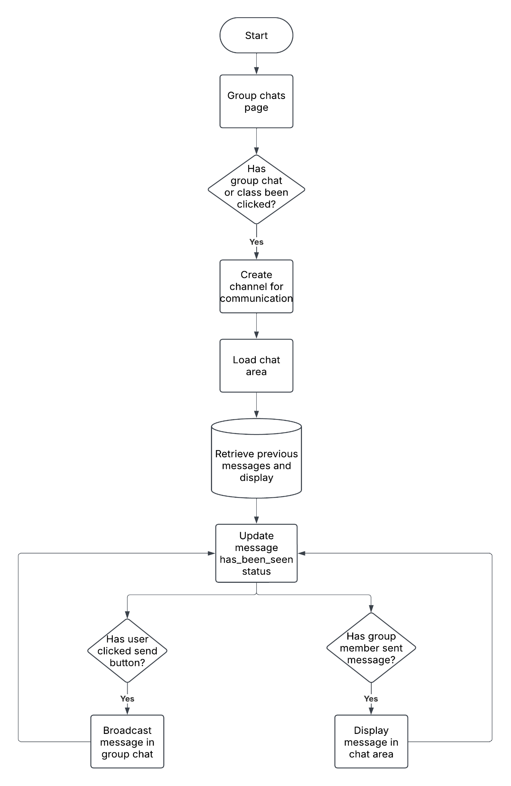**Group chats page variables:**

|  |  |  |
| --- | --- | --- |
| Variable name | Data type | Description and justification |
| groups | list | This holds all the group chats the user is a part of in the form of its GroupChat record. It helps in easily fetching and displaying the groups the user has access to, making navigation smoother. |
| group | record | Stores all the details of a specific group chat, including its name, members, messages, and other metadata. This is needed to properly manage and display group-related information. |
| messages | list | A list of all messages exchanged in a group chat. Each message contains details like the sender, timestamp, and content, ensuring that conversations are stored and displayed correctly. |
| group_id | integer | A unique identifier assigned to each group chat. It is used to differentiate between groups in the database, making searching and fetching data much more efficient. |
| admin | record | Stores details about the group admin, such as their username , firstname etc. from the user record. Admins have special permissions like adding/removing members, modifying group settings, and managing content within the group. |
| members | list | This contains all the users who are part of the group chat. It is essential for access control, ensuring that only members can view and participate in the chat. It also helps in displaying the participant list within the group. |
| date | string | Represents the date when a message was sent or when a group was created. This helps in organizing messages and events in a chronological order. |
| time | string | Stores the exact time a message was sent or an event occurred in the group. This ensures proper ordering of messages and helps users track conversations more easily. |
| sender | record | Holds details about the user who sent a message, including their user ID, display name, and profile information using the user record. This ensures messages are correctly attributed and displayed in the chat interface. |

## DESIGNING THE FLASHCARD PAGE:

The flashcard page will be where you can study and review flashcards organized by subject, allowing you to focus on specific topics. It will also include a Leaderboard that ranks users based on their progress adding a fun, competitive element to learning as per the stakeholder survey #5 and the client interview #8. The view of the page will be split into two sections: the flashcard quiz section and the leaderboard section.

**View of the flashcard page – quiz section:**

Usability feature: all time points of user for the current subject will be displayed here.

Usability feature: the page the user is on will be highlighted in the nav bar reminding the user what page they are on.

Usability feature: a scrollable flashcard subject list will display all the subjects from which the student can choose to do the flashcards. Additionally, if the user is actively using a subject flashcard , that subject section will be highlighted making it easier to locate and manage active flashcards.



Flashcards

Group chats

Chats

**UniVerse**

Flashcards

Points: 289

Physics

Group Chats

What is an enzyme?

Biology

Leaderboards

All time

This month

Flashcard mode

Quiz mode

This week

Usability feature: a dropdown leaderboard subject list will display all the different time period leaderboards. Additionally, if the user is actively using a leaderboard , that leaderboard section will be highlighted making it easier to track activities.

Usability feature: in this section in the flashcard mode the question will be displayed from which if the user clicks on it , it will reveal the answer of the question. Once the user has seen this the user can click on quiz mode which will question the user based on the flashcards he has done in a random order. For each correct quiz answer the user will gain a point.

**View of the flashcard page - leaderboard section:**



Flashcards

Group chats

Chats

**UniVerse**

Flashcards

Physics

Group Chats

**Weekly Leaderboard**

Biology

Name 1 80 points

Name 3 28 points

Name 2 70 points

Leaderboards

Name 4 22 points

All time

Name 5 21 points

This month

This week

Usability feature: Displaying points for each user encourages competition and motivation. Users can track their progress and aim to improve their ranking over time, which keeps them engaged with the flashcards.

Usability feature: The leaderboard section highlights the currently selected time period (e.g., "This week") to help users quickly identify which leaderboard they are viewing. This makes navigation easier and reduces confusion.

**Flashcard table:**

This table in the database has 5 columns including a user column which acts as the primary key linking to other tables and is a record containing the data of the user from the FlashcardPoints table. The FlashcardPoints table will be used in storing all time points, weekly points and monthly points of users to display on the leaderboards. The last_reset value will also be used to reset weekly and monthly points every week and every month.

|  |
| --- |
| **Table name : FlashcardPoints** |
| user (primary key) |
| all_time_points |
| weekly_points |
| monthly_points |
| last_reset |

**Flashcard page variables:**

|  |  |  |
| --- | --- | --- |
| Variable name | Data type | Description and justification |
| subject_data | data frame | This variable accesses the excel sheet provided by the client and retrieves the subjects sheet which contains all the subjects that will be used in the flashcards. |
| user_subjects | list | This variable contains all the subjects that the school provides which will be extracted from subject_data to be used to provide flashcards for all subjects. |
| users | list | This variable contains the user records of all the users to display on the leaderboards. This user record contains their profile details such as username, name etc. to identify the user on the leaderboard. |
| user_points | list | This variable contains the FlashcardPoints records of all the users to display their weekly, monthly and all time points on their according leaderboard. |
| leaderboard_data | list | This variable is an ordered list of dictionaries which are ordered depending based on which leaderboard the user requests ie: if the user requests a all time leaderboard this list will be ordered based on all time points. Within each dictionary will be the name of the user and their individual points. |
| flashcard_data | data frame | This variable contains the flashcards and answers in an excel sheet which have been extracted from public sources for the students educative flashcards. |
| current_subject | string | This contains the subject that the user is currently doing flashcards or quizzes on and helps identify which questions to give. |
| flashcards | list | Contains a list of flashcards each flashcard being a dictionary containing a question and an answer. These flashcards will be shuffled so the user will not have to repeat the same questions. |
| flashcard_points | record | Gets the FlashcardPoints record of each user which contains all time points, monthly points, weekly points, and last reset time. These will enable the program to display a leaderboard with all the separate time period points. Additionally, the system ensures that points are accurately tracked and reset for monthly and weekly periods. |

**How the flashcard page works:**

The flashcard page will consist of many functions and therefore I will use multiple flowcharts to represent the logic behind this page: the flashcard flowchart, the quiz mode flowchart and the leaderboards flowchart.

Leaderboards flowchart:

The leaderboards flowchart will display the all-time points , monthly points and weekly points of all the users to enable a competitive spirit between the students as per client interview #8.

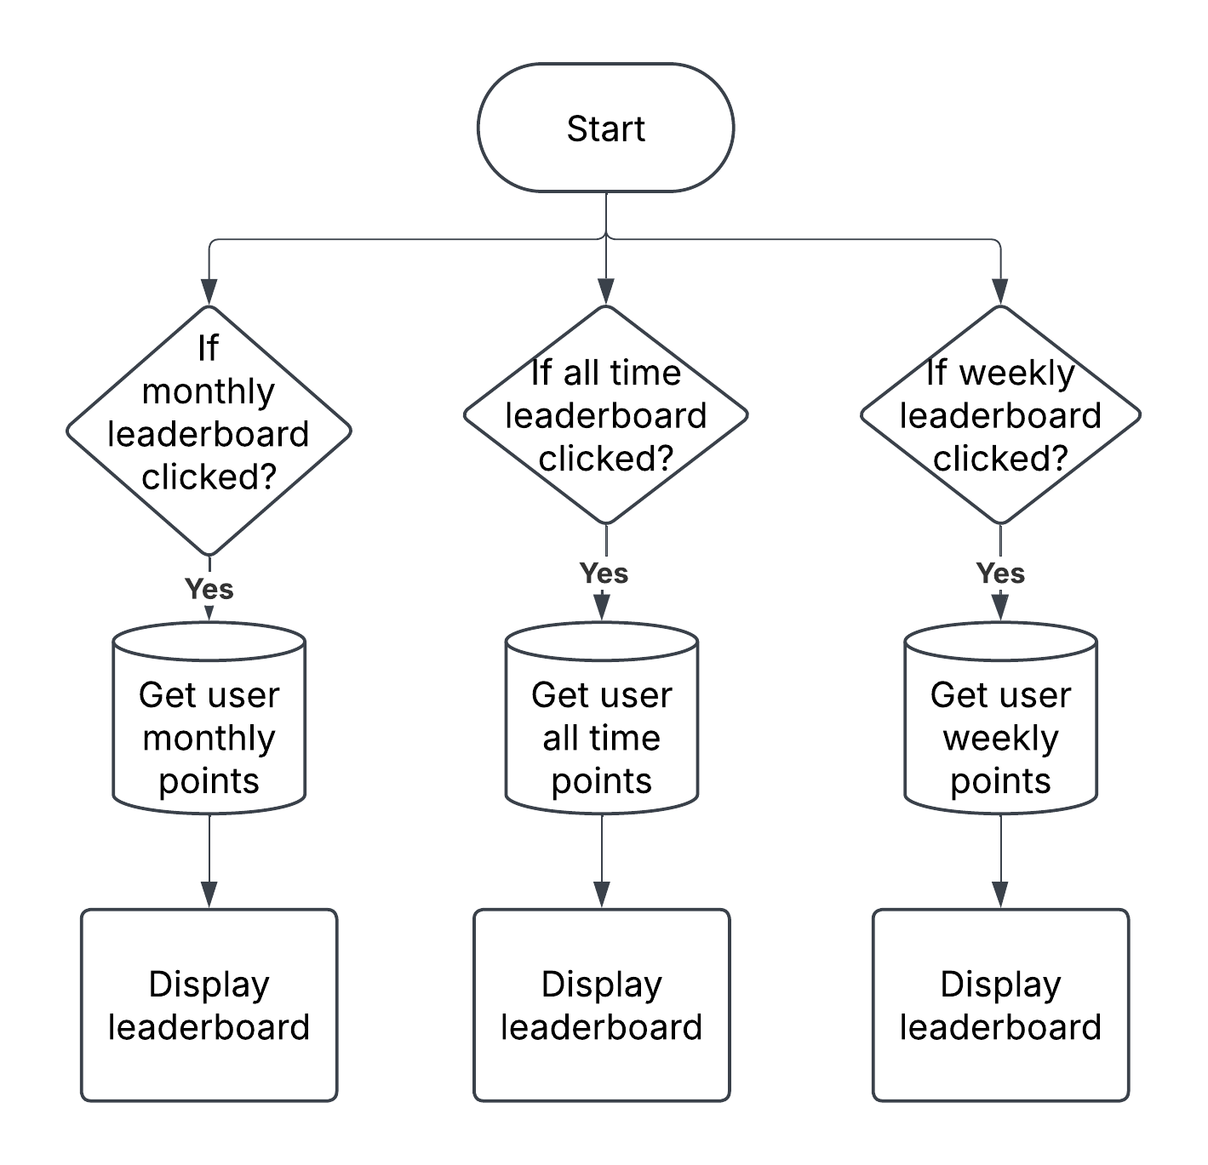

Flashcard flowchart:

Will allow the user to use interactive flowcharts which reveal their answer once clicked upon. Flashcards will be differentiated based on each subject for the students.

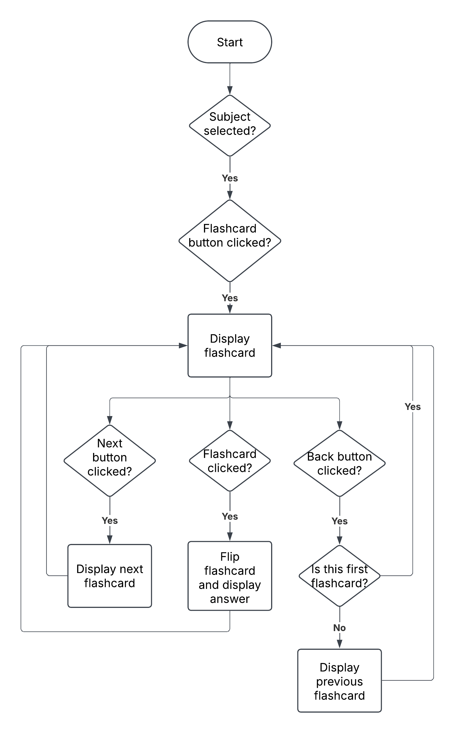

Quiz Mode flowchart:

The quiz mode sections will ask the user multiple questions based on their subject and will award points for the correct answer which will be displayed on the leaderboard.

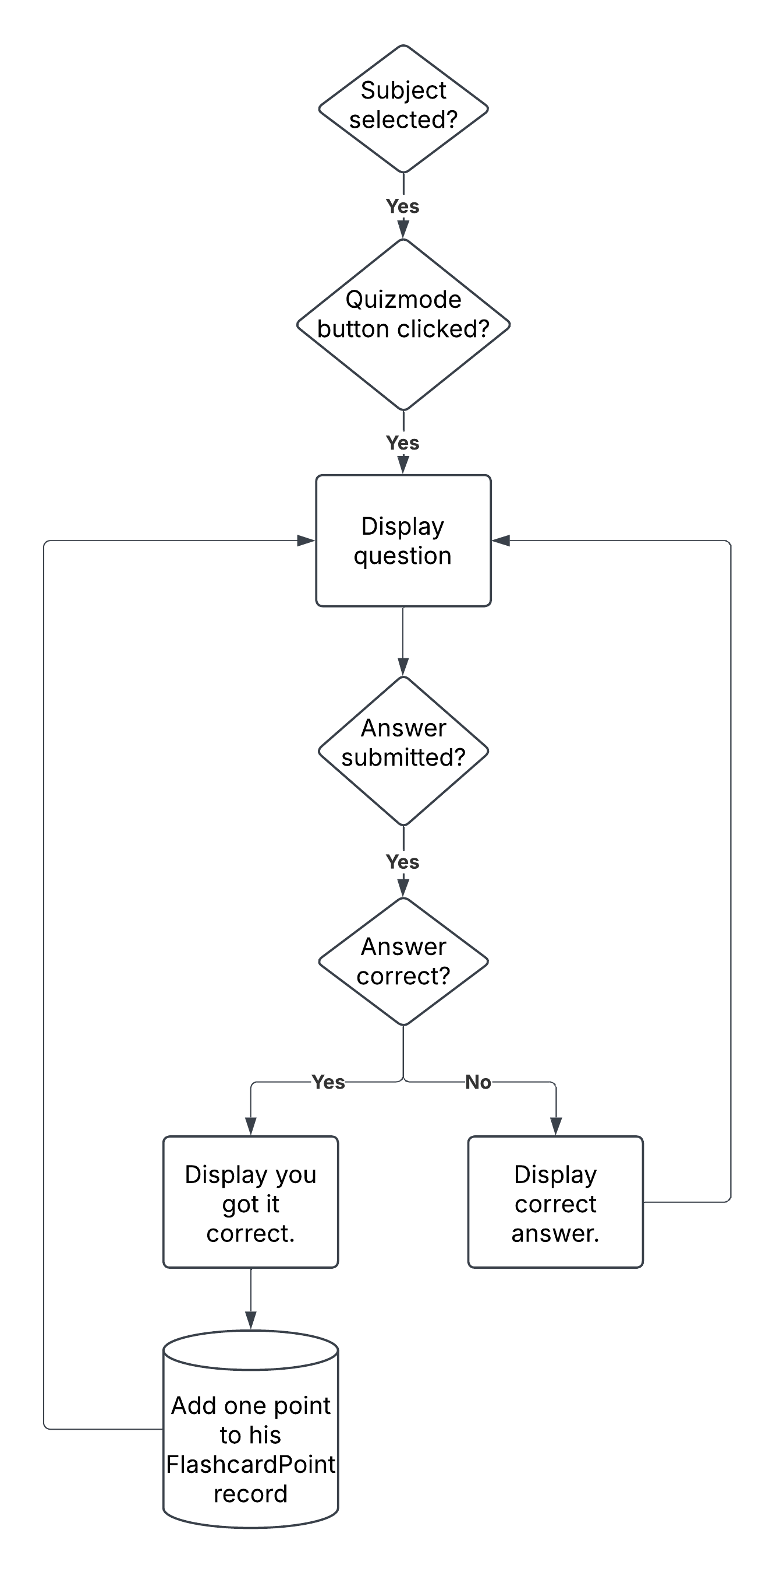

## DEVELOPMENT TEST PLAN:

Below are all the tests that I plan to do during development.

**Preparing the environment:**

| No. | Description | Justification | Input | Successful output |
| --- | --- | --- | --- | --- |
| 1 | Testing to see if project files successfully created. | I will be using these files to create the website and hence need to be in the correct directories. | No input.  Will only be viewing directory. | Front end html, static and backend folders created. |
| 2 | Testing if virtual environment created and running. | This ensures installed packages are stored in the correct folders and the package version matches with the logic of the code. | StudentChat\Scripts\activate in command terminal. | .venv folder created and terminal shows its activated. |
| 3 | Testing to ensure all packages are installed within the virtual environment. | I will be using the functions provided by the package in creating my website. | No input , confirmation will be received in terminal. | Successful installation method in terminal. |
| 4 | Testing to see if daphne server created at local host. | This ensures the server is running correctly and allows us to run and test our website. | python manage.py runserver to activate code. | No errors displayed and url for development server displayed. |

**Testing the HTML webpage:**

| 5 | Testing to see if HTML for login page works and looks as expected. | This will ensure the user has a smooth and secure experience when logging in, ensuring everything from the design to the functionality works. | No input.  This is just testing the html code. | Html page displayed as shown in the view of the page for the login page. |
| --- | --- | --- | --- | --- |
| 6 | Testing to see if HTML for sign-up page works and looks as expected. | This will ensure the user has a smooth and secure experience when logging in, ensuring everything from the design to the functionality works. | No input.  This is just testing the html code. | Html page displayed as shown in the view of the page for the sign-up page. |

| No. | Description | Justification | Input | Successful output |
| --- | --- | --- | --- | --- |
| 7 | Testing to see if HTML for interests page works and looks as expected. | This will ensure the user has a smooth experience when selecting his interests. | No input.  This is just testing the html code. | Html page displayed as shown in the view of the page for the interests page. |
| 8 | Testing to see if HTML for home page works and looks as expected. | This will ensure the user has a smooth experience when the user is navigating through the website. | No input.  This is just testing the html code. | Html page displayed as shown in the view of the page for the home page. |
| 9 | Testing to see if HTML for chats page works and looks as expected. | This will ensure the user has a smooth experience when the user is messaging. | No input.  This is just testing the html code. | Html page displayed as shown in the view of the page for the chats page. |
| 10 | Testing to see if HTML for flashcard page works and looks as expected. | This will ensure the user has a smooth experience when the user is using the flashcards. | No input.  This is just testing the html code. | Html page displayed as shown in the view of the page for the flashcard page. |
| 11 | Testing to see if HTML for group chats page works and looks as expected. | This will ensure the user has a smooth experience when the user is messaging. | No input.  This is just testing the html code. | Html page displayed as shown in the view of the page for the group chats page. |
| 12 | Testing to see if HTML for profile page works and looks as expected. | This will ensure the user has a smooth experience when the user is navigating through his account. | No input.  This is just testing the html code. | Html page displayed as shown in the view of the page for the profile page. |

**Testing the authentication system:**

| No. | Description | Justification | Input | Successful output |
| --- | --- | --- | --- | --- |
| 13 | Testing to see if database set up with default User model: | Confirms that the database exists and can be queried and accessed for our authentication system. | No input , will view the database using Django’s administration. | Database file contains User table with correct fields: username, first_name, last_name, email, password. |

| No. | Description | Justification | Input | Successful output |
| --- | --- | --- | --- | --- |
| 14 | Testing username validation during sign-up. | To ensure username is not too long or too short. | Normal: “testuser”  Erroneous: “aa”  Erroneous: “Thisusernameislongerthan20characters” | Error message displayed for erroneous data. |
| 15 | Testing email and password validation during sign-up. | To ensure email and password are from the school to prevent outsiders accessing the website. | Email: [nilastela4@stmary.com](mailto:nilastela4@stmary.com)  password:WhiteLion@34  Email: [123@gmail.com](mailto:123@gmail.com)  password:ting123 | First details will be accepted as school details however second details will raise an error message as not school details. |
| 16 | Testing to see if user details added to database on sign-up. | Checks to see if authenticated user is added to database. | Email: [nilastela4@stmary.com](mailto:nilastela4@stmary.com)  password:WhiteLion@34 | Database will have a record of the details. |
| 17 | Testing if username already in use cannot be used. | This will ensure each user can be identified by one unique username. | Erroneous data:  some username already in use. | Error message will be displayed for erroneous data. |
| 18 | Testing if user redirected to interests page after sign-up. | Ensures the user is redirected to the correct page if authenticated. | No input, looking at webpage and URL. | After registering the user is brought to the Interests page. |
| 19 | Testing if user login is authenticated. | Checks to see if the database is correctly queried and the user is authenticated. | username: nila2  password: WhiteLion@34  username: random3  password: redmonkey5 | User will be authenticated on the first test, error message displayed on second as user details don’t exist. |
| 20 | Testing if user redirected to home page login. | Ensures the user is redirected to the correct page if authenticated. | No input, looking at webpage and URL. | After logging in the user is brought to the home page. |

**Testing the interests page:**

| No. | Description | Justification | Input | Successful output |
| --- | --- | --- | --- | --- |
| 21 | Testing to see  to see if user is able to select interests and if interests added to the database. | Checks to see if user interests have been added to UserProfile table. | 4 interests selected eg: football, pop music, camping, reading. | Database will have a record of these details. |
| 22 | Testing if interests validation works. | This ensures that user can select up to 4 interests with an other interest option if his/her hobby is not displayed. | 4 interests selected eg: football, pop music, camping, reading.  erroneous: 5 interests selected. | Will redirect user to home page if under 4 interests selected. For erroneous error message displayed. |

**Testing the home page:**

| No. | Description | Justification | Input | Successful output |
| --- | --- | --- | --- | --- |
| 23 | Testing to see if friends list works. | All the user friends must be displayed in a list. | No input. | All users friends displayed in a scrollable list. |
| 24 | Testing if user can manage friend requests. | This will test if user receives friend requests and can accept and reject friend requests. | No input.  Accept or reject button clicked. | Friend requests displayed with tick and cross button next to it. |
| 25 | Testing to see if profile button displays users profile picture. | Ensure user is redirected to profile page but also personalises for user. | No inputs.  Profile picture button will be clicked. | User will be redirected to the profile page. |

**Testing the chats page:**

| No. | Description | Justification | Input | Successful output |
| --- | --- | --- | --- | --- |
| 26 | Testing to see if user can message friend. | This will test if send message button sends text to friend in textbox and displays message in chat area. | Input: “hello” | Test input will be displayed with date and time. |
| 27 | Testing if user can receive messages. | This will test if messages sent to user can be displayed in chat area. | Input from other account: “hello”. | Test input will be displayed with date and time. |

| No. | Description | Justification | Input | Successful output |
| --- | --- | --- | --- | --- |
| 28 | Testing if user message history is displayed in order. | This will test if all messages in the past will still be displayed in order in chat area even after reload. | No input.  Will refresh page. | Old messages still displayed in a scrollable chat area with date and time. |
| 29 | Testing if i_have_seen_message button works. | This will test whether the read message status updates once someone has read his message. | No input. | White when message hasn’t been read and light blue when message has been read. |

**Testing the group chats page:**

| No. | Description | Justification | Input | Successful output |
| --- | --- | --- | --- | --- |
| 30 | Testing to see if class list works. | All the classes the user is in must be displayed in a list. | No input. | All users classes displayed in a scrollable list. |
| 31 | Testing if create group chat button works. | This will test if user is able to create a new group chat and add members. | No input.  Create group chat button clicked. | Pop up with option to add members and name group chats. |
| 32 | Testing if edit group chat button works. | This will test if name and users of group chat is updated in database if changed. | No input.  Change group chat name button clicked. | Database record updated with new group chat name and users. |
| 33 | Testing to see if user can message in a group chat/class. | This will test if send message button sends text to users in textbox and displays message in chat area. | Input: “test input” | Test input will be displayed with date, time and user along with profile picture. |
| 34 | Testing if user can receive messages in a group chat. | This will test if messages sent to user can be displayed in chat area. | Input from other account: “test input”. | Test input will be displayed with date, time and username with profile picture. |
| 35 | Testing if user message history is displayed. | This will test if all messages in the past will still be displayed in chat area even after reload. | No input.  Will refresh page. | Old messages still displayed in a scrollable chat area with date, time and username with profile picture. |

| No. | Description | Justification | Input | Successful output |
| --- | --- | --- | --- | --- |
| 36 | Testing to see if user can send pictures in class/group. | This will test if user is able to upload and send and photos in chat area. | No input. | Image displayed in chat area. |

**Testing the flashcards page:**

|  |  |  |  |  |
| --- | --- | --- | --- | --- |
| No. | Description | Justification | Input | Successful output |
| 37 | Testing if user can select subject and view flashcard. | This will test that when a subject button is clicked the user can view the flashcard. | No input.  Subject button clicked. | Interactive flashcard displayed on screen. |
| 38 | Testing if user can answer the flashcard in quiz mode. | This will test that the user can input an answer to the question and the program checks the answer. | Normal input: Answer to question  Erroneous: “jdiwdw” | Normal input will display correct and add point to database while incorrect input will display incorrect and show answer. |
| 39 | Testing is user can view all-time leaderboard. | This will test if user can view leaderboard of users in order of all time points. | No input.  All time leaderboard button clicked. | Leaderboard displayed with username list alongside with points. |
| 40 | Testing is user can view  monthly leaderboard. | This will test if user can view leaderboard of users in order of current week points. | No input.  Weekly leaderboard button clicked. | Leaderboard displayed with username list alongside with points. |
| 41 | Testing is user can view weekly leaderboard. | This will test if user can view leaderboard of users in order of current month points. | No input.  Monthly leaderboard button clicked. | Leaderboard displayed with username list alongside with points. |

**Testing the profile page:**

| No. | Description | Justification | Input | Successful output |
| --- | --- | --- | --- | --- |
| 42 | Testing to see of user can view other users. | This tests that the user can view all users. | No input.  User button clicked. | Users displayed. |
| 43 | Testing to see if username can be updated. | This tests to see if the database is updated when the user attempts to change his username. | Same inputs as testing username validation. | Database record updated with correct username. |
| 44 | Testing to see if biography can be updated. | This tests to see if the database is updated when the user attempts to change his biography. | Same inputs as testing username validation.  Default value for biography will be Bio: | Database record updated with correct biography. |
| 45 | Testing change his profile picture button. | This tests if the database updates when the user changes his profile picture. | No input.  Change profile picture button clicked. | Database record is updated with new profile picture. |
| 46 | Testing timetable button | This tests to see when the user clicks the timetable button his timetable pops up. | No input.  Timetable button will be clicked. | Pop up displaying user timetable can be seen. |
| 47 | Testing change password button. | This tests to see if the database is updated when the user attempts to change the password. | Same inputs as testing password validation. | Database record updated with correct password. |
| 48 | Testing if user can send friend requests using add friends button. | This tests that when add friend button clicked in the search section a friend request is sent to the user. | No input.  Add friend button clicked. | Friend request sent and updated in database. |
| 49 | Testing to see if user friend suggestions displayed | This tests that friend suggestions which are ordered by using the friend suggestion algorithm is displayed. | No input.  Profile page viewed | Friend suggestions displayed. |
| 50 | Testing logout button | This tests to see if user is logged out and redirected to login page. | No input.  Log out button clicked. | User is redirected to login page and logged out. |
| 51 | Testing delete his account button. | This tests if delete account button clicked and confirmed is user account removed from database. | No input.  Delete account button clicked. | Database record updated by removing user account. |

## POST DEVELOPMENT TEST PLAN:

Once development is complete, below are the tests that I plan to carry out, to check that the program meets the success criteria.

| No. | Feature | Justification | Input/How to test | Result |
| --- | --- | --- | --- | --- |
| 1 | Allow user to login. | Client interview Q6  All website analysis | Email: [nilastela4@stmary.com](mailto:nilastela4@stmary.com)  password:WhiteLion@34  Email: [123@gmail.com](mailto:123@gmail.com)  password:ting123 | If the user enters the correct email and password, they will be redirected to the homepage |
| 2 | Allow user to create account. | Client interview Q6  All website analysis | Email: [nilastela4@stmary.com](mailto:nilastela4@stmary.com)  password:WhiteLion@34  Erroneous:  -enter non school email address and password | The user can create an account with their email, username and password and then will be redirected to the interests page after successful creation |
| 3 | Allow user to log out. | All Website analysis | Click logout button | User will be directed to login page and logged out. |
| 4 | Option to change details (username, biography, profile picture) | Website analysis 1 & 2  Stakeholder survey Q3 | username: “testuser”  Biography: “hi”  Change profile picture button clicked. | Details updated on profile page. |
| 5 | Option to delete account | Website analysis 1 & 2 | Delete account button clicked. | User will be redirected to register page and details will be removed from database. |
| 6 | Displays interactive flashcards for each subject. | Client interview Q8  Stakeholder survey Q5 | Click on interactive flashcards. | Notes will be displayed per subject. |
| 7 | Displays questions in quiz mode and allows user to answer them. | Client interview Q8  Stakeholder survey Q5 | Click on quiz and answer. | Response displayed on answer whether correct or not |
| 8 | Display flashcard points leaderboards | Client interview Q8  Stakeholder survey Q5 | Click on leaderboards | Leaderboards displayed with correct points. |
| 9 | Allow user to message friends | Stakeholder survey Q3  All website analysis | Enter text: “test text” | Message displayed in chat area and sent to user. |
| 10 | Allow user to create, manage and message in group chats. | All website analysis | Create group chat: “group1”  Add users.  Message in group. | Group chat created and message broadcasted to all users. |
| 11 | Displays friend suggestions to user. | Client interview Q4  Website analysis 1 & 2 | Friend suggestions should be displayed in order determined by friend suggestion algorithm. | Friend suggestions should be displayed in a horizontal list. |
| 12 | Displays timetable in user profile page. | Client interview Q4  Stakeholder survey Q3 | Click on timetable button | Pop up with user’s timetable displayed. |
| 13 | Allows user to change appearance themes. | Website analysis 1  Stakeholder survey Q4 | Change themes. | Colour scheme of website will change. |
| 14 | Navbar at the top of the page for navigation | All website analysis | Click on different navbar links. | User is redirected to corresponding pages. |
| 15 | Allow the user to add friends. | Website analysis 1 & 2  Client interview Q4 | Click add friend button in search bar next to username. | Once friend request accepted user shown in friend list. |
| 16 | Allow user to send files and images in class. | All website analysis | Click files and images button and upload. | Image or file displayed in chat area. |
| 17 | Message seen status updated. | Website analysis 1 & 2 | View message status button. | Should turn blue when friend has viewed your message. |

# DEVELOPMENT AND TESTING:

## STAGE 1: PREPARING AN ENVIRONMENT:

**Creating the project files:**

I will create a main directory along with subdirectories to organise my solution. The main directory will be called StudentChat which will contain Django configuration files in the subdirectory config and a subdirectory called UniVerse which will contain the logic code for the website along with a templates directory containing front end code.

**Test (1) : Testing to see if project files successfully created:**

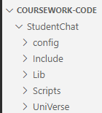

We can see the project files have been created so the **test has been passed.**

**Creating the virtual environment:**

I am choosing to use a virtual environment as it will allow me to easily install, upgrade and remove packages without affecting other projects.

This command will create a virtual environment named StudentChat in the coursework-code directory



**Test (2) : Testing to see if virtual environment created and running:**

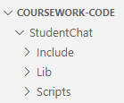

We can see the virtual environment has been created inside the correct directory. I have activated the virtual environment and we can see that it is running. Both requirements have been met so the **test has been passed.**

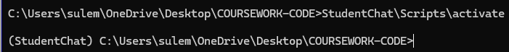

**Installing packages:**

The packages I will be installing will add extra functionality and save time as I will not have to manually code them myself. Each package will be installed within the virtual environment ensuring that they are isolated inside this project only.

**Test (3) : Testing if packages installed within virtual environment:**



The packages Django, channels and daphne have been installed within the virtual environment so the **test has been passed**.

**Initiating the daphne server:**

Daphne is the default ASGI (Asynchronous Server Gateway Interface) server for Django channels and allows Django applications to handle asynchronous communications which will be used in features such as real time messaging.

In order to run the daphne server we first need to create an “app”:



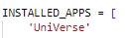

We also need to define this app in settings.py:

**Test (4) : Testing to see if we can run a daphne server at the local host:**

When I ran python manage.py runserver an error was displayed : **Test Failed**



**Correcting failed test (4):**

The problem was I missed a comma after UniVerse in the installed apps list.

FIXED CODE:

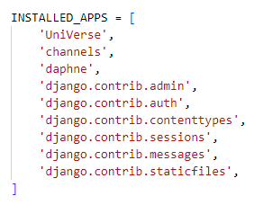

All the necessary preparations to run the daphne server has been completed and we will now test if it works and provides us with a development server.

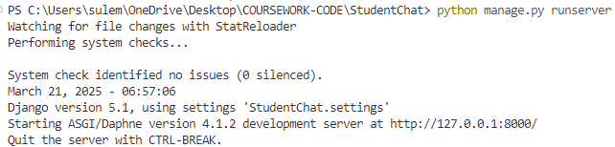

When we run the code we can see a development server has been created so the **test has been passed.**

### REVIEW 1:

Now that I have a structure for the project and have installed the necessary packages within my virtual environment to help me create a solution I can begin coding my solution. I will now make the html files which will contain:

* The general layout of the website
* Links to other parts of the website
* Using python with Django for the logic of the code
* Using CSS to design the appearance of the website
* As per the **website analysis and the stakeholder survey Q4** I will keep the colour scheme minimalistic and user friendly
* JavaScript will be shown when explaining the logic of the code and the backend later on in the coursework

## STAGE 2 : CREATING A HTML WEBPAGE:

I will start the frontend of the website with HTML, CSS and JavaScript.

**LOGIN PAGE:**

The login page is where the user can either select the register link if they don’t have an account or the login with their username and password if they have an account.

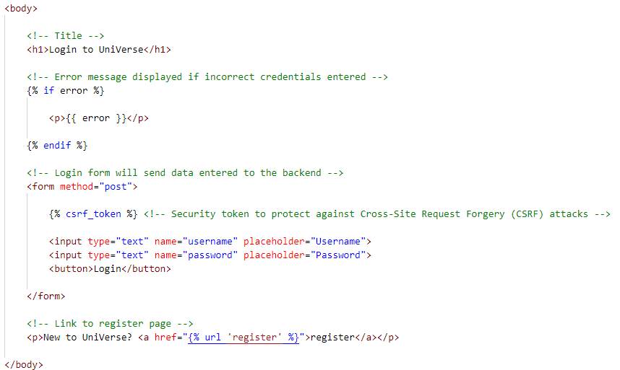**HTML:**

Link to register page

Input for username and password

Error message

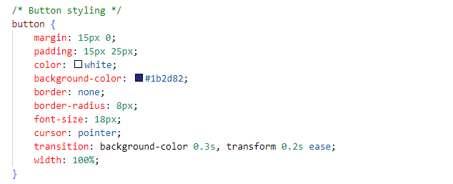**Example of CSS:**

**Setting up a URL path to Render the HTML login page in Django:**

Before we can test if the HTML of the login page works, in Django we need to create a URL path in urls.py file that maps a view to a specific URL and will return the rendered HTML page when the URL is accessed in the browser.

* path is imported from django.urls to define URL patterns.
* The views module is also imported so we can connect our URL paths to specific view functions or classes.
* The line above maps the /login URL to the Login view.
* 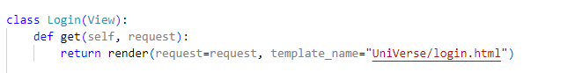The name="login" helps in referring to this URL elsewhere in Django.
* The Login class extends Django’s default View class, meaning it inherits properties and methods from View.
* The get() method handles GET requests (when a user accesses the page) while maintaining encapsulation by keeping request-handling logic within the class.
* The render() function is used to return the login.html template located inside the UniVerse/ directory.

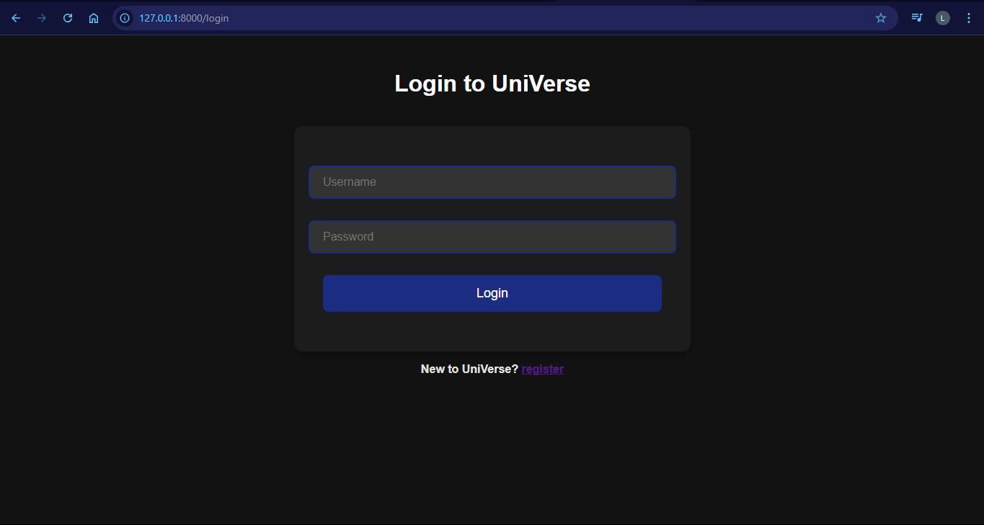**Test (5) : Testing to see if HTML for login page works:**

Title

The HTML contains inputs, submit button and link to registration page and looks as expected hence **the test has been passed.**

Input for details

Link to register page

Submit button

**SIGN-UP PAGE:**

The user can create an account by entering their school email address and password while creating a new username that meets the requirements.

**HTML:**

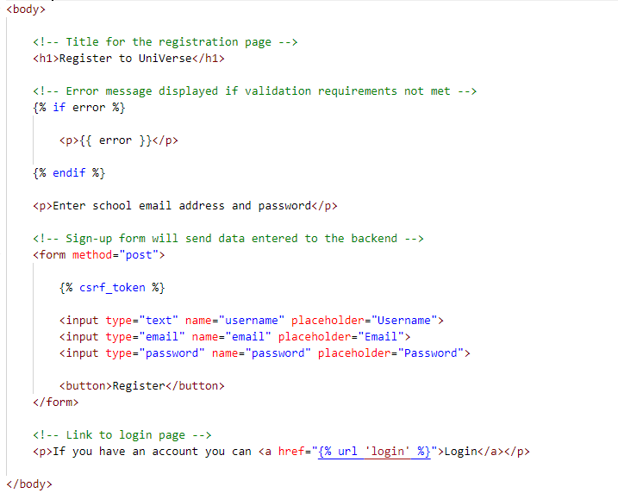

Error message

Input for username and password and email address

Link to login page

**Example of CSS:**

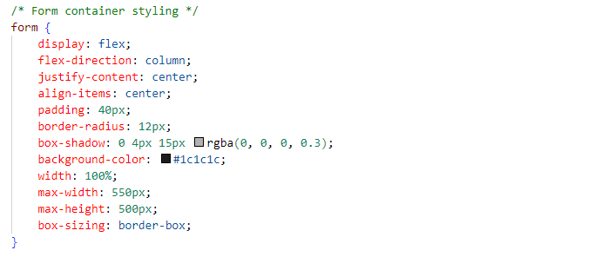

**Test (6) : Testing to see if HTML for sign-up page works:**

After creating the URL path in urls.py and the class for the sign-up page in views.py as shown before I will run the server and go to the URL of the sign-up page to see if it works.

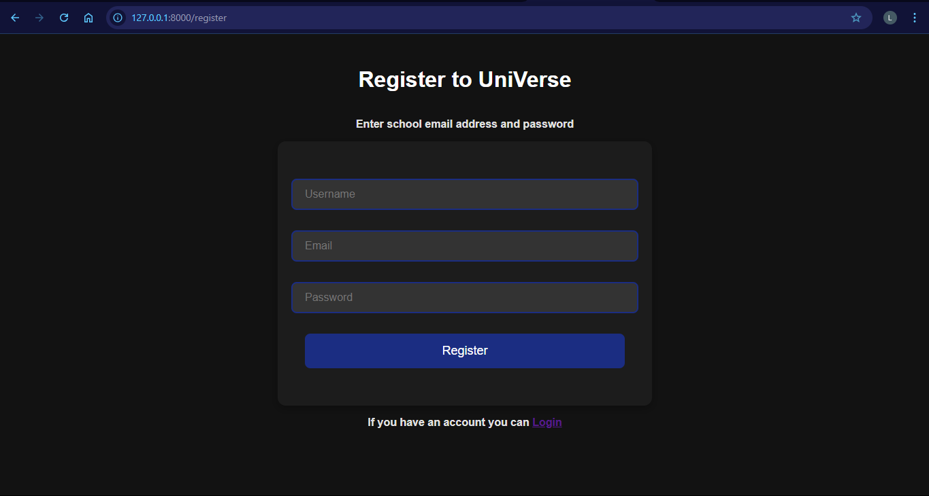

Title

Input for details

Link to login page

Submit button

The HTML contains inputs, submit button and link to login page and looks as expected hence **the test has been passed.**

**INTERESTS PAGE:**

Once the user has created an account they will be asked to select their interests which will be displayed on the profile page.

**Example of CSS:**

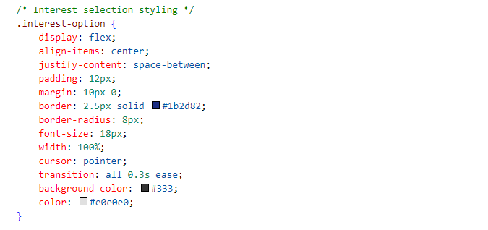

**HTML:**

The user will only be allowed to select four interests which will be carried out using JavaScript and will be shown later on in my coursework.

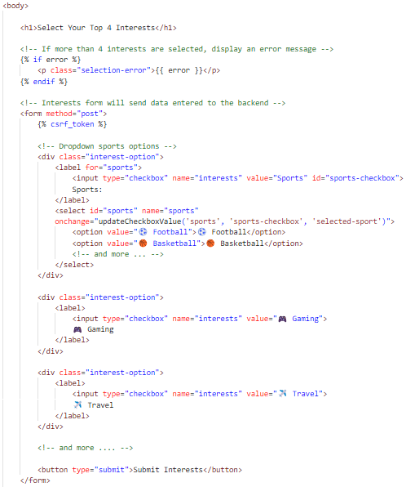

Error message

Dropdown interests options

More interest options

More interest options

Submit button

**Test (7) : Testing to see if HTML for interests page works:**

After creating the URL path in urls.py and the class for the interests page in views.py as shown before I will run the server and go to the URL of the interests page to see if it works.

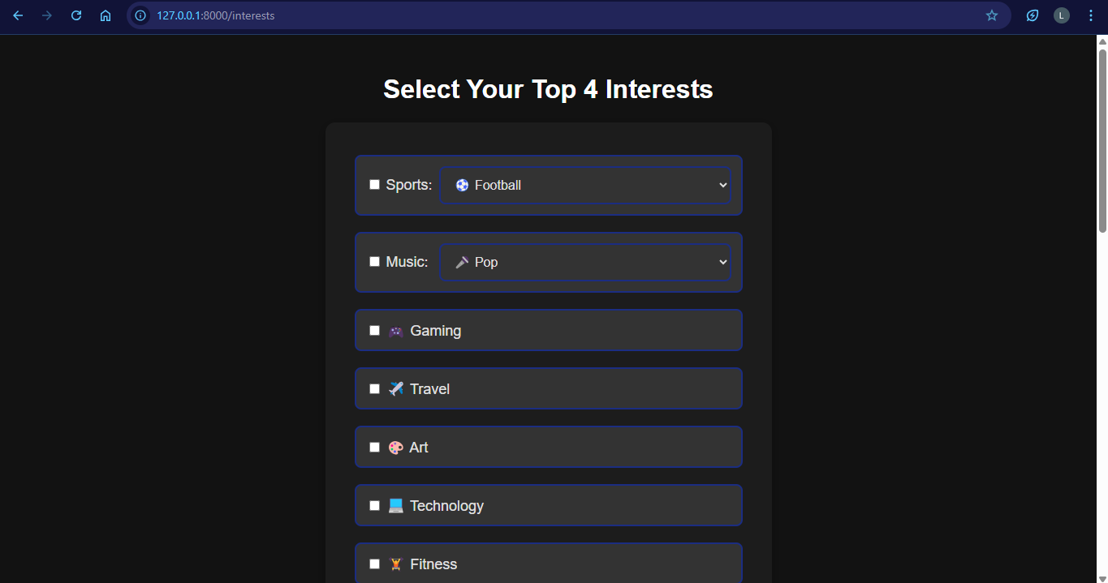

Title

Dropdown option

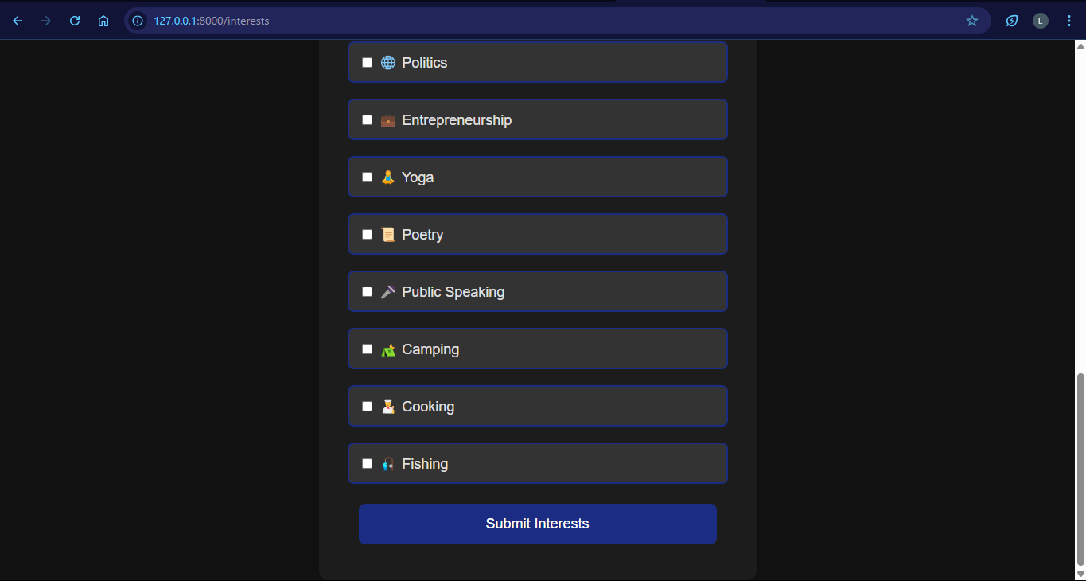

More options

Submit button

The HTML page contains options to select interests from along with a submit button and looks as expected hence **the test has been passed.**

**NAV BAR:**

The nav bar will be used to navigate throughout the rest of the website. The test for it will be done along with the home page.

**HTML:**

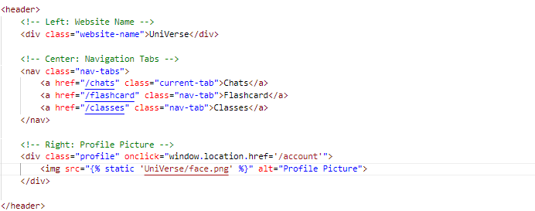

Website title “UniVerse”

Nav tabs

Profile picture linking to profile page

**Example of css:**

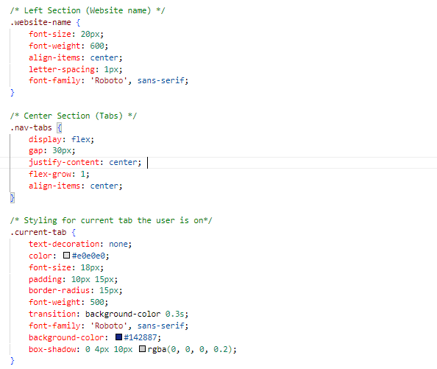

**THE HOME PAGE:**

After signing up or logging in the user will be redirected to the home page where they can navigate through the rest of the website.

**HTML:**

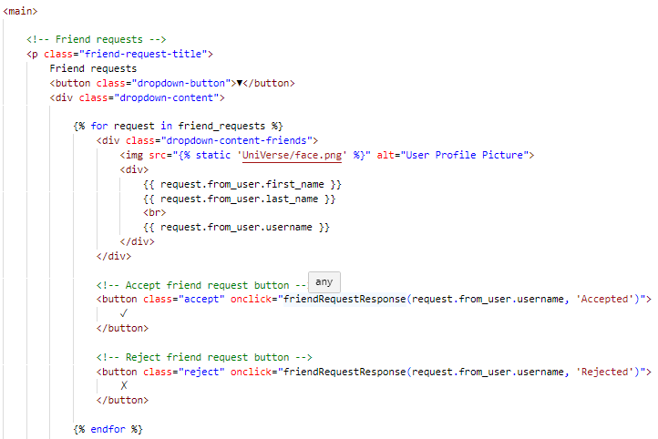

Friend requests dropdown

Accept or reject button

Accept or reject button

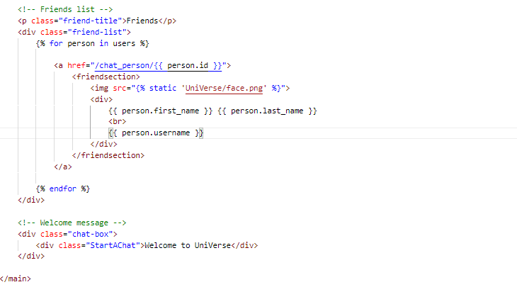

Friends list

Welcome message

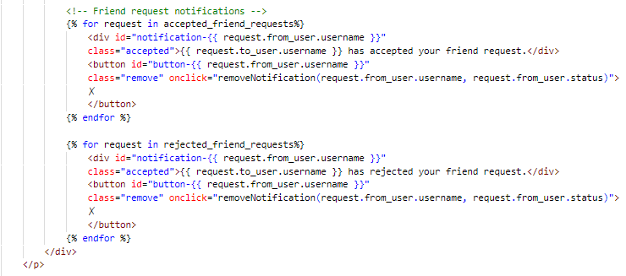

Friend request notifications

**Example of CSS:**

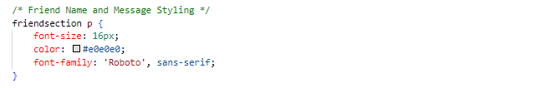

**Test (8) : Testing to see if HTML for home page works:**

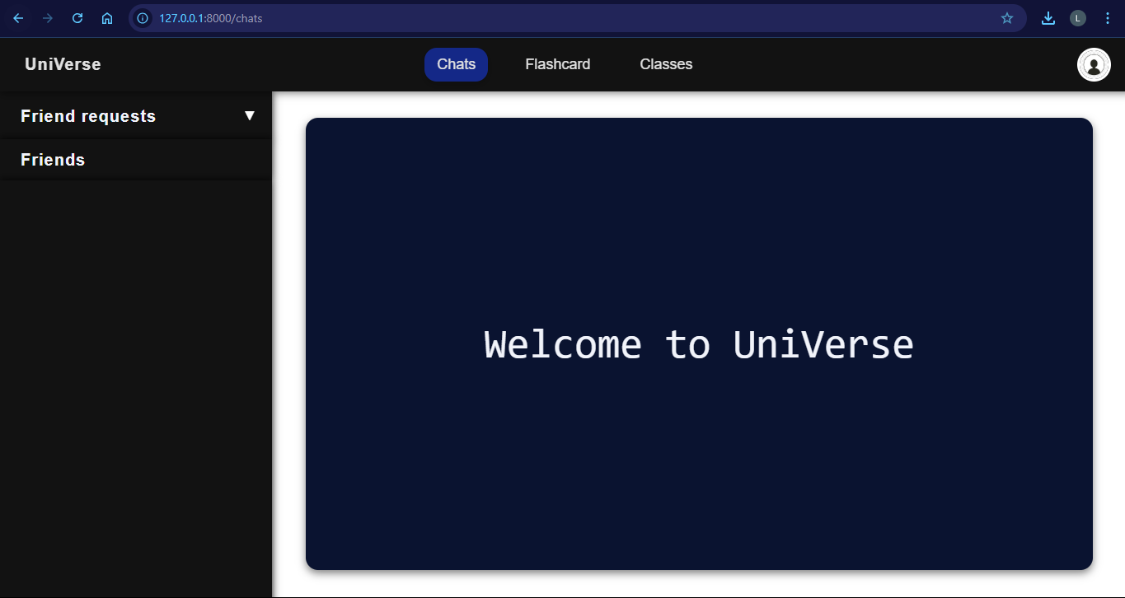After creating the URL path in urls.py and the class for the home page in views.py as shown before I will run the server and go to the URL of the home page to see if it works.

Nav bar

Friend request dropdown

Friend list

Welcome message

Currently the user has no friends or friend requests so friend list is empty. Apart from that the HTML page contains a navigation bar which displays links to other pages and looks as expected so **the test has been passed.**

**THE CHATS PAGE:**

The user can privately message his friends and will be able to accept and reject friend requests in the chats page for which the following is the code for the layout of it. I will be displaying the HTML specific to the chats page and not repeating for example the navigation bar HTML.

**HTML:**

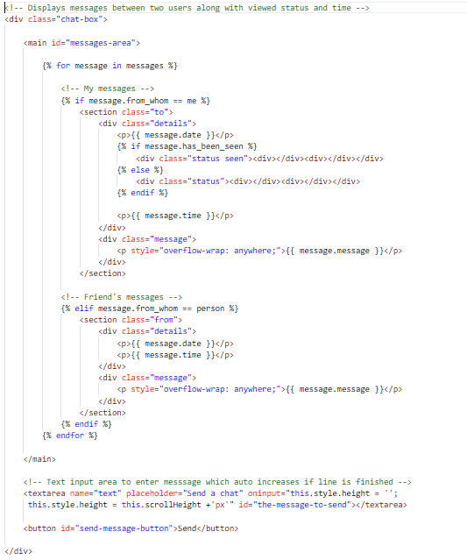

My messages

Friends messages

Input for message

Send button

**Example of CSS:**

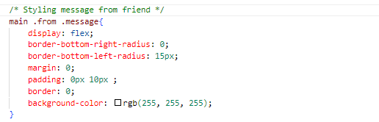

As mentioned previously the backend logic and JavaScript used to display these messages will be explained in later on.

**Test (9) : Testing to see if chats page HTML works:**

After creating the URL path in urls.py and the class for the chats page in views.py as shown before I will run the server and go to the URL of the chats page to see if it works.

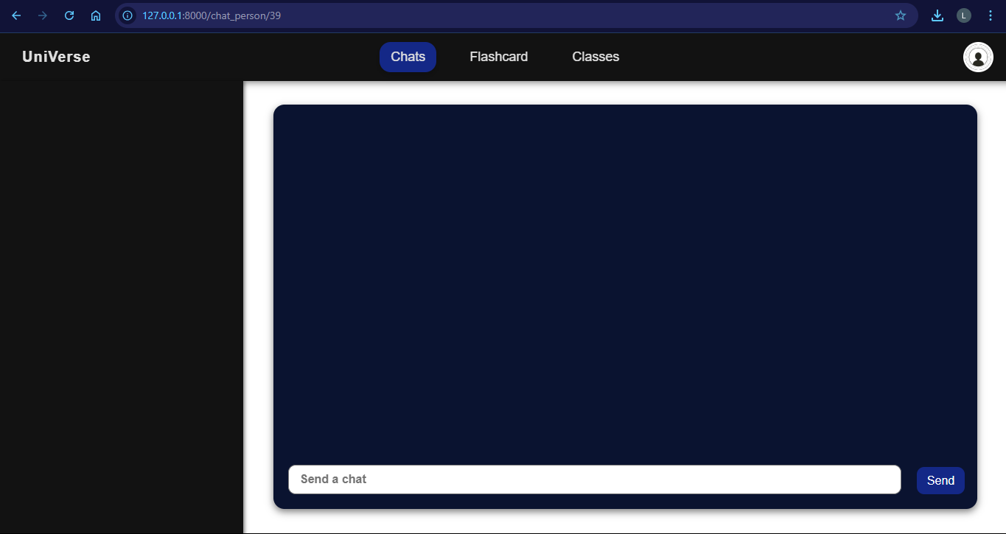

Messages will be displayed here

Submit button

Input message

The website does not display any messages as the user has no friends to message at the current stage without finishing the backend. Apart from that the HTML displays the text input area and a send message button and looks as expected **hence the test has been passed.**

**THE FLASHCARDS PAGE:**

The user will be able to learn content from flashcards then using the quiz mode earn points which will be displayed on a leaderboard. I will be displaying the HTML specific for each page without repeating e.g.: header. The flashcard page will be split into three sections; the home page, the flashcard page and the leaderboard page.

**Example of CSS:**

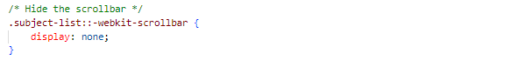

**HTML:**

HOME PAGE:

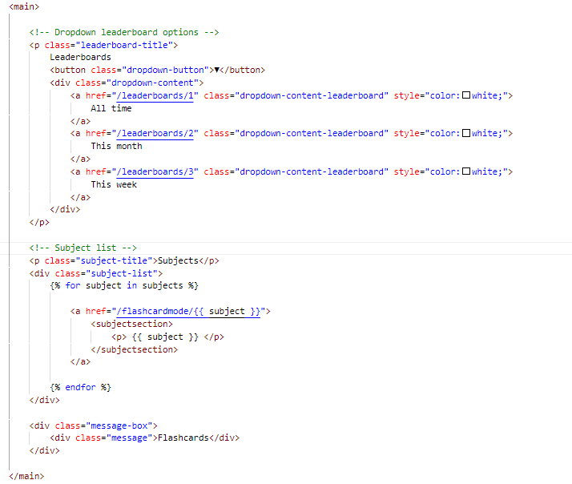

Leaderboards

List of all subjects

Both flashcard mode and quiz mode will have the same layout but the JavaScript functions will have different functionality. This is shown on the next page:

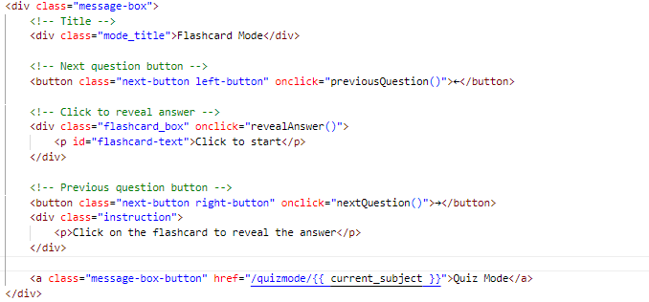FLASHCARDS AND QUIZMODE:

Next question button

Flashcard data

Previous question button

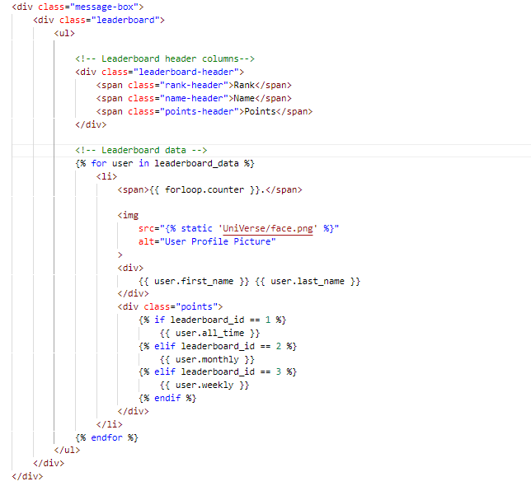LEADERBOARDS:

Leaderboard header columns

Next question button

**Test (10) : Testing to see if flashcards page HTML works:**

After creating the URL path in urls.py and the class for the different pages in the flashcards section in views.py as shown before I will run the server and go to the URL of the flashcards page to see if it works:

HOME PAGE:

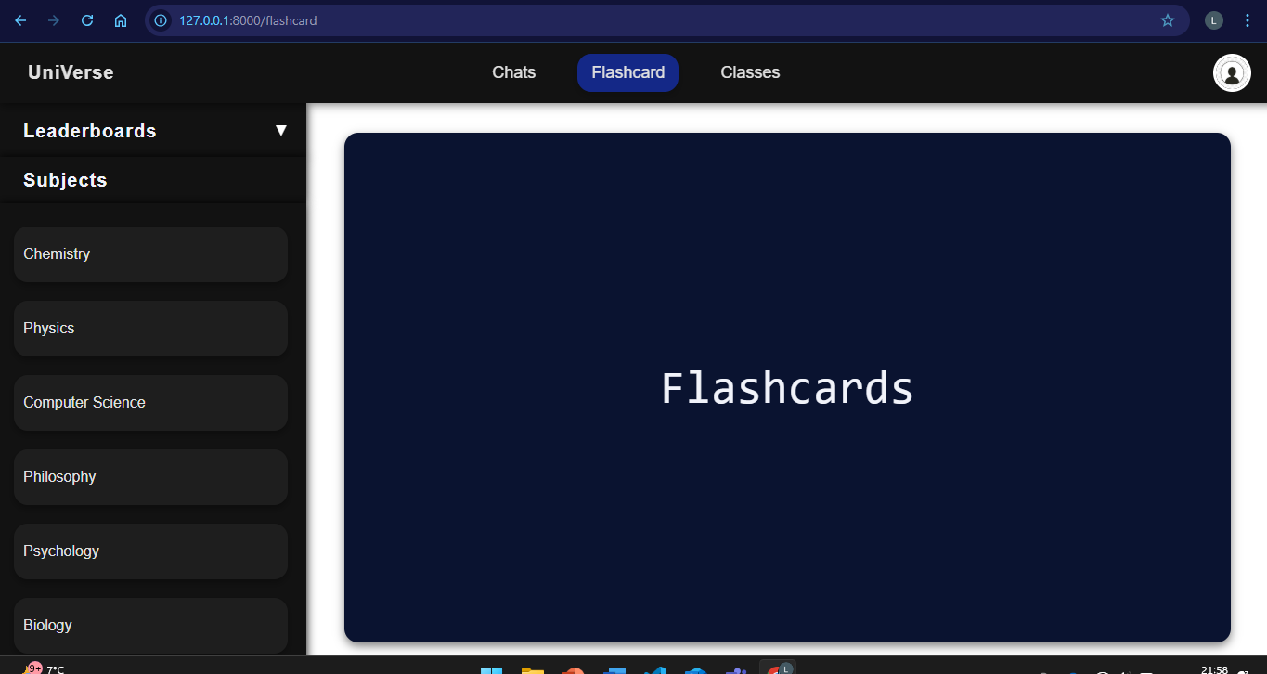

Leaderboards dropdown menu

Subjects list

FLASHCARD PAGE:

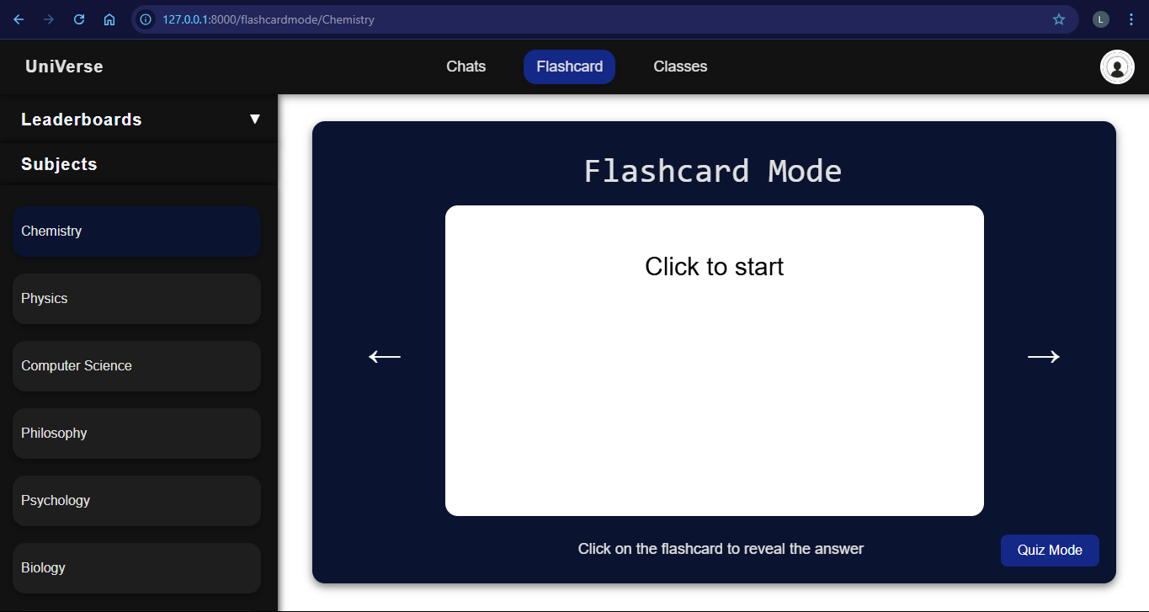

Flashcards

Quiz mode button

QUIZ PAGE :

All time points displayed

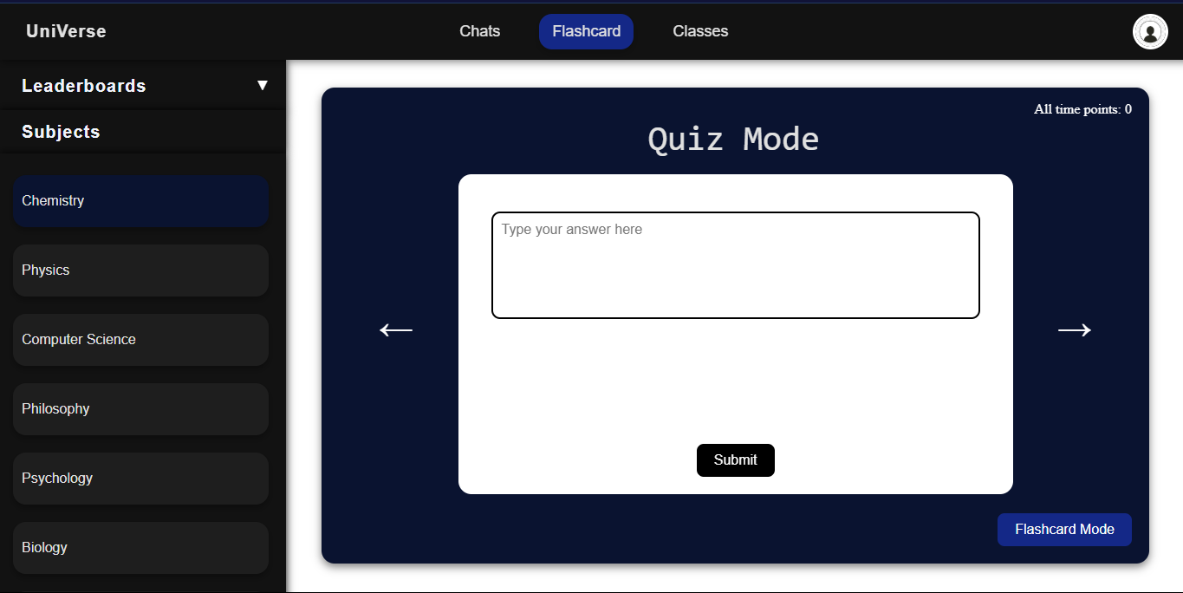

Input answer

Flashcard mode button

THE LEADERBOARDS PAGE :

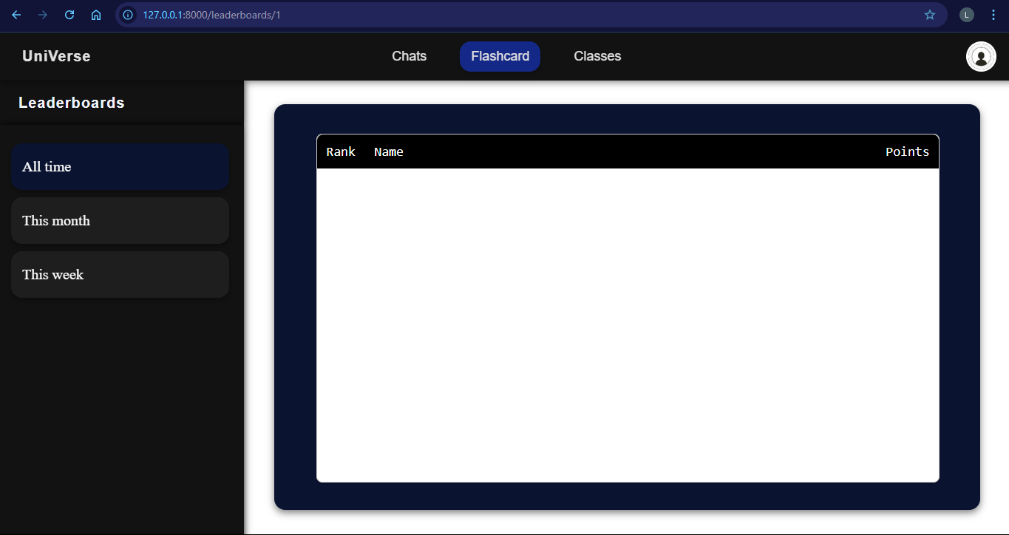

Leaderboard header

Leaderboard options

The pages include the different subjects to select flashcards from along with the leaderboards and quizzes and the pages look as expected hence **the test had been passed.**

**THE GROUP CHATS AND CLASSES PAGE:**

The user will be able to join group chats based on classes and send real-time messages. Each message will show the user’s name and profile picture. The HTML for the group chats page will be the same as the chats page apart from the group chat list as shown below:

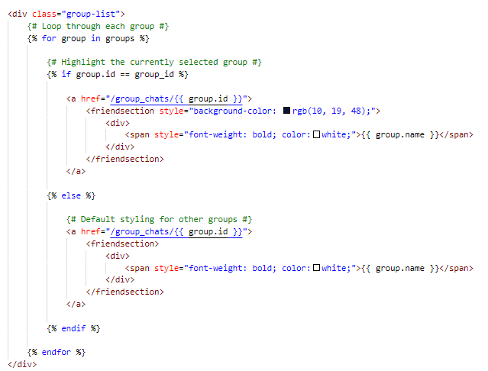**HTML:**

Loop through all groups

If group is current group highlight it

If not current group then use default styling

**Example of CSS:**

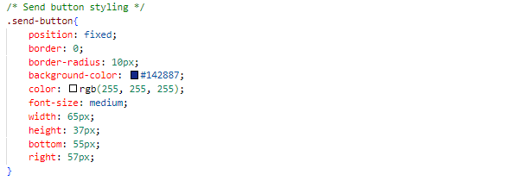

**Test (11) : Testing to see if group chats page HTML works:**

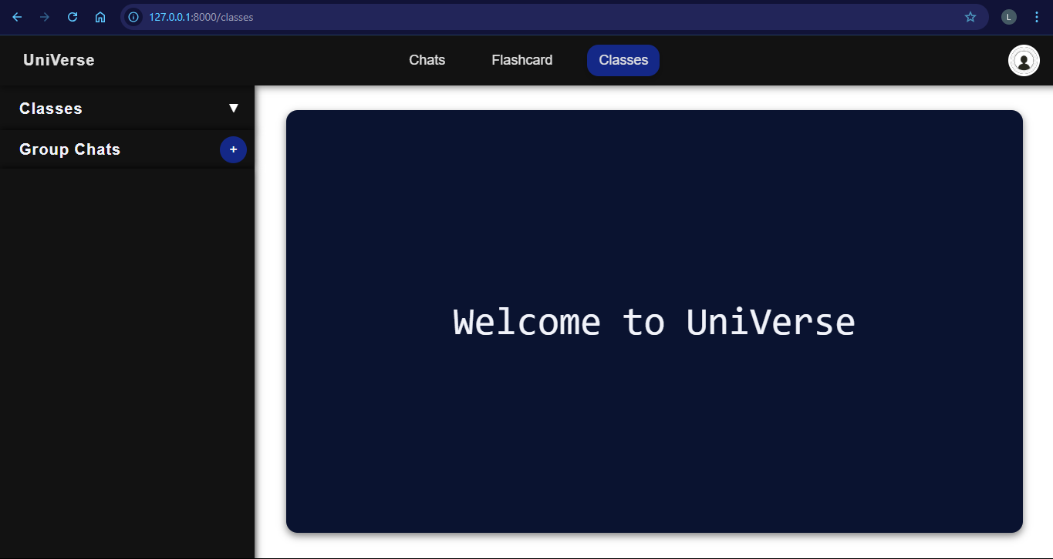After creating the URL path in urls.py and the class for the group chats page in views.py as shown before I will run the server and go to the URL of the group chats page to see if it works.

User classes group chats

Group chats list

Everything displayed as expected therefore **test has been passed**

**THE PROFILE PAGE:**

The user will be able to view and edit their profile, including their username, bio, and profile picture. The page will also show their subjects, interests, and friend suggestions. I will use reusable HTML components to avoid repeating elements like the header or navigation.

**HTML:**

**Friend suggestions HTML:**

Display users based on sorting done by friend suggestion algorithm

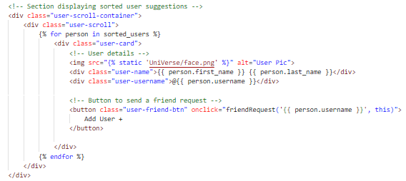

Friend request button

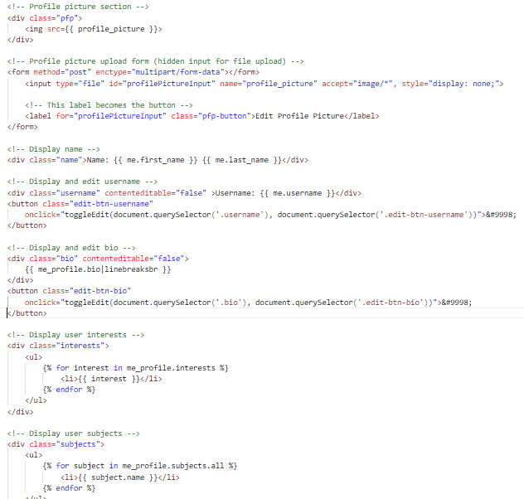**User details HTML:**

Displaying profile picture

Edit profile picture form

Display name

Edit and display name

Edit and display biography

Interests of user displayed

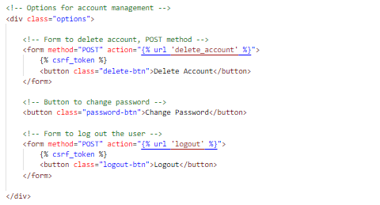**Option buttons HTML:**

Delete account button

Change password button

Log out button

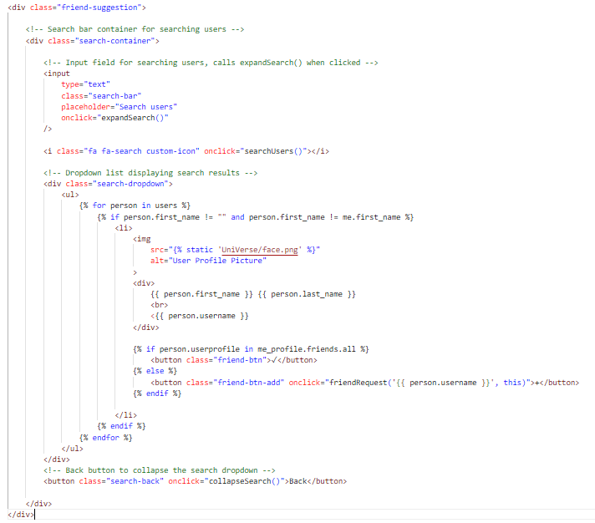**Search users HTML:**

Hidden initially pop up displayed when search bar clicked

Displays user details

Allows user to send friend requests

**Timetable HTML:**

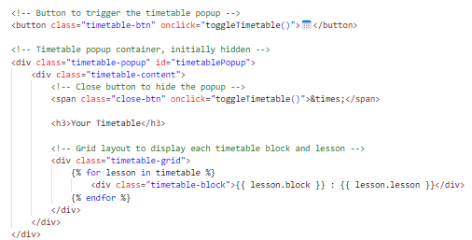

Displays timetable

Timetable popup button

**Example of CSS:**

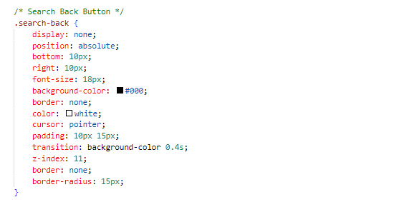

**Test (12) : Testing to see if profile page HTML works:**

After creating the URL path in urls.py and the class for the profile page in views.py as shown before I will run the server and go to the URL of the profile page to see if it works.

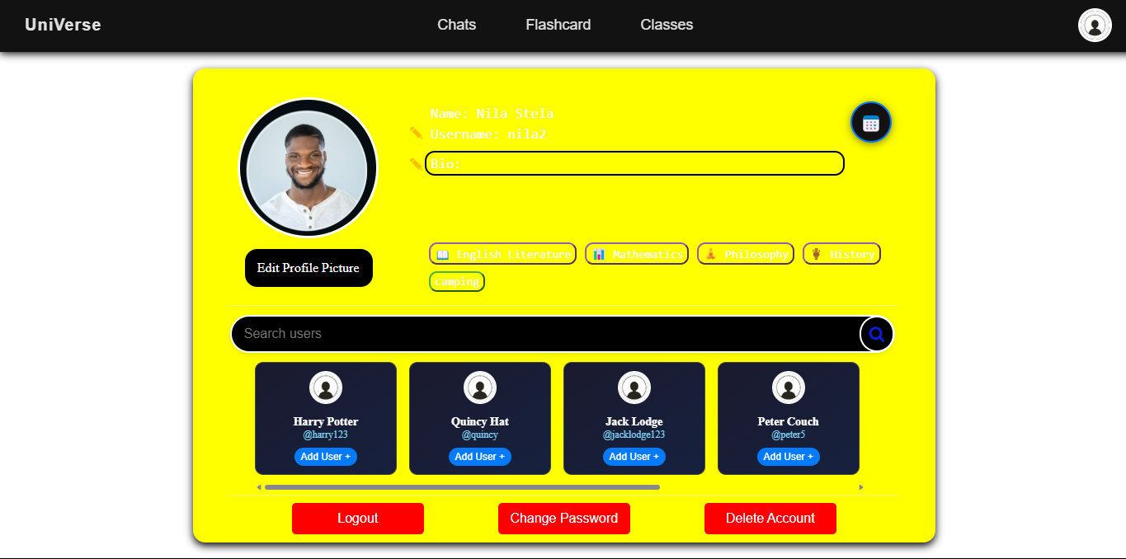

User details

Account management options

Friend suggestions

Everything displayed as expected therefore **test has been passed**

### CLIENT FEEDBACK 1:

I demonstrated the complete HTML webpage to my client Jack. Then I conducted an interview with him to check is he was happy with the functionality and appearance of the authentication system and to ask for feedback.

**Interview:**

**Q1: Was the website easy to use?**

A1: “Yes it was really easy to navigate throughout the website and the colour scheme apart from the profile picture was consistent throughout which I think will be appealing to the user.”

**Q2:Do you have any preferences for the order in which I complete my development?**

A2:“Maybe start with the main features like the group chat and leaderboard first, then move on to smaller things like the profile customisation and search.”

**Q3: Was the friend suggestion feature useful?**  
A3: “Yes, I thought it was helpful. It suggested people who had similar interests and subjects to me, so it made sense.”

**Q4: Is there anything you would like me to change?**

A4: “I think the colour is to bright and it is hard to read the details, maybe you should change it to a more minimalistic colour which contrasts with white so you can see the user details better.”

**Client feedback review:**

The client provided positive feedback on the webpages, highlighting its ease of use and clear buttons to help the user with the process. They also liked the consistent and minimalistic design, stating that it would appeal to users.

However she wanted some adjustments:

* Changing the colour scheme for the profile page

This will ensure that the reader can better read the text on the page by increasing the contrast between text and background.

**Client feedback adjustments:**

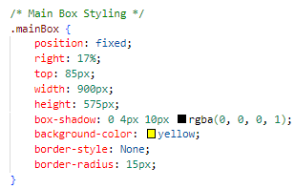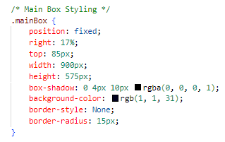

**Testing client feedback adjustments:**

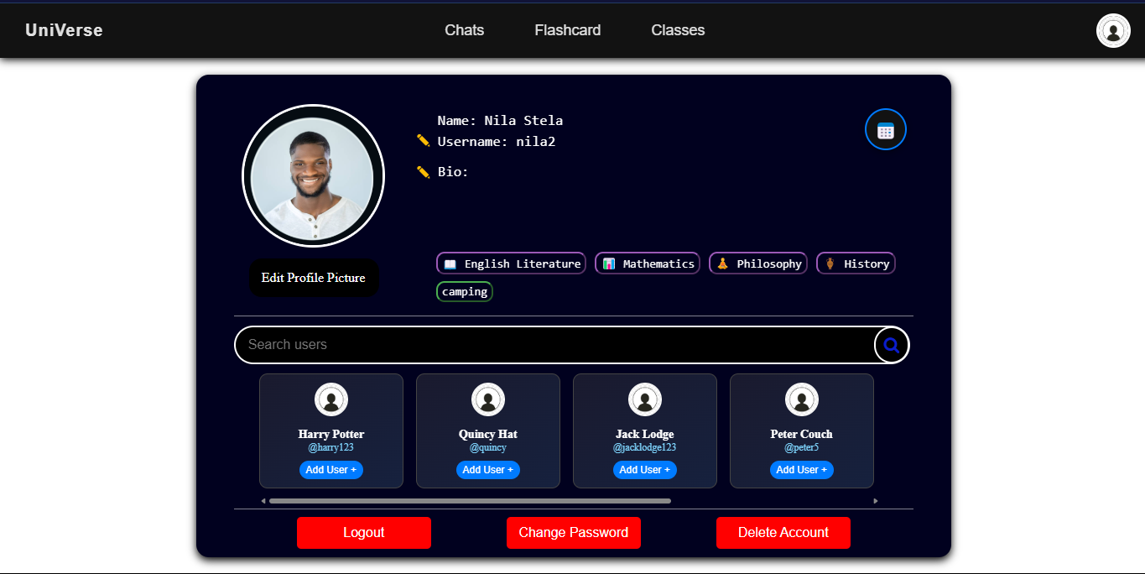

Colour scheme changed and user details are know more visible therefore **test has been passed**

### REVIEW 2:

I have finished responding to the client feedback and making the frontend of the website. It contains all buttons and links to allow the user to navigate around the website.

Now that the frontend is finished I can start creating the authentication system which will include:

* Setting up a database using Django administrator
* Accessing default User model provided by Django
* Creating the backend for the login and sign up process

Once I have completed this I will get feedback and move onto the next stage.

## STAGE 3 : CREATING THE AUTHENTICATION SYSTEM:

**Django models summary:**

The Django ORM (Object-Relational Mapper) allows interaction with the database using python instead of raw SQL. This abstraction helps manage complex database relationships while maintaining efficiency. It uses SQLite as the default database management system which we will be using. Each Django model represents a table, with attributes acting as columns and instances as rows.

**Django’s default User model:**

Django provides us with a default User model containing the fields which we will use in our authentication system: Username, First name, Last name, Email address, Password.

Before we can import the user model we need to run the following code in the terminal:

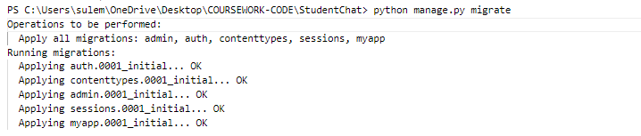

Migration ensures the necessary default database tables are created and ready to handle user authentication and management properly.

**Test (13) : Testing to see if database set up with default User model:**

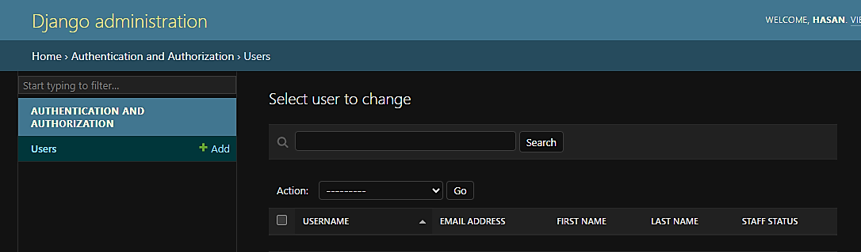

Password is encrypted and even the admin cannot view a user’s password. Apart from that we can see a User table containing the correct fields has been created hence **the test had been passed.**

**Importing the user model:**

****We can now import the user model in views.py to be used in the authentication system.

**Creating the backend for the sign-up system in views.py:**

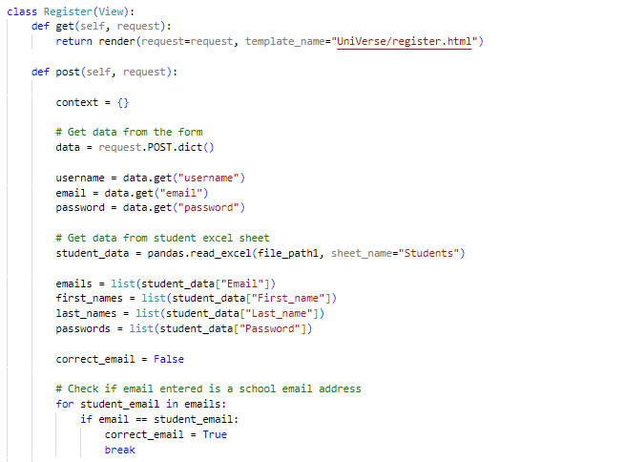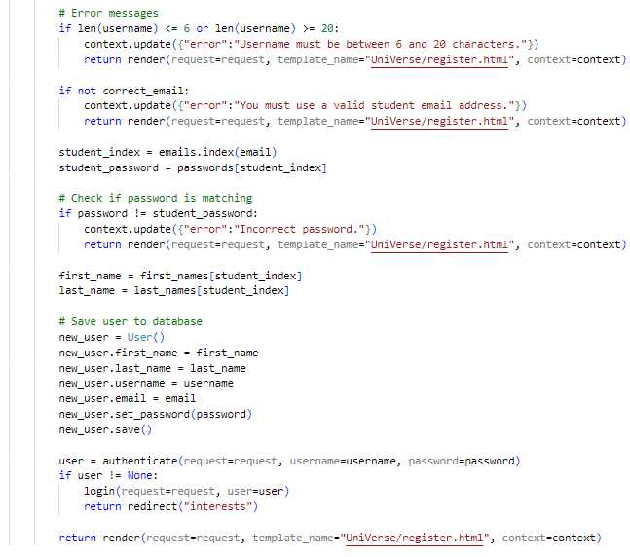

Get data from form

Extract details from data

Get student data form excel sheet provided by client

Get student data form excel sheet provided by client

**Validation:** Check if email address is a school email address

**Validation:** Validate username length

**Validation:** If not school email address return error message to website

**Validation:** Check password matches email address

Add user to database

Redirect user to interests page

**Creating the backend for the login system in views.py:**

Django provides us with a built in authentication system – django.contrib.auth which we can use to check if login details are correct, log the user in and more.

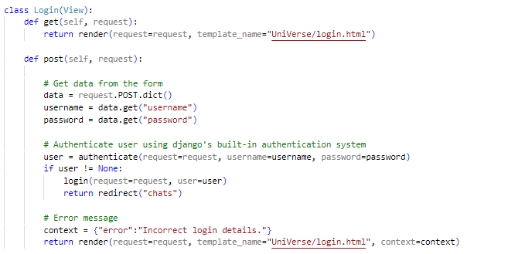

Get data from form

**Validation:** Check if details are correct using Django’s inbuilt authentication system

If details correct log user into the current session

Return error message

**Testing the authentication system:**

**Test (14) : testing username validation during sign-up:**

Erroneous data : username to long

Erroneous data : username to short

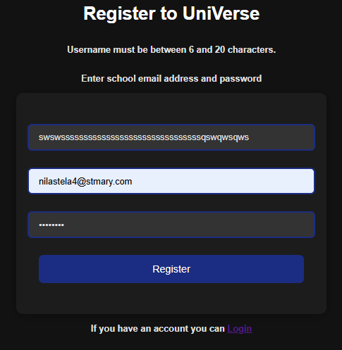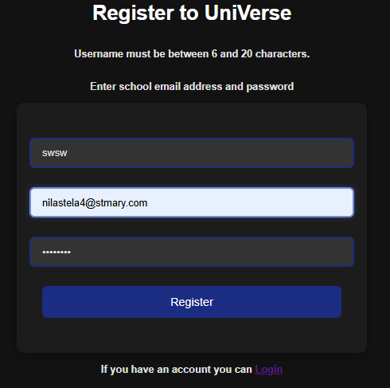

Error message displayed : **Test passed**

**Test (15) : testing email address and password validation during sign-up:**

Erroneous data : school email address not used.

Erroneous data : password does not match school email address

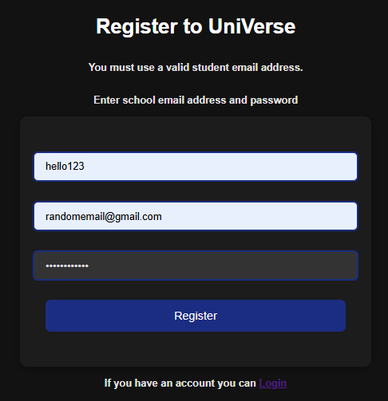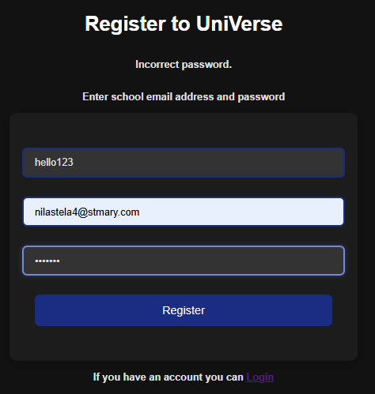

Error message displayed : **Test passed**

**Test (16) : testing to see if user details added to database on sign-up:**

****From the excel sheet provided by the client we will test if user details are added to database.

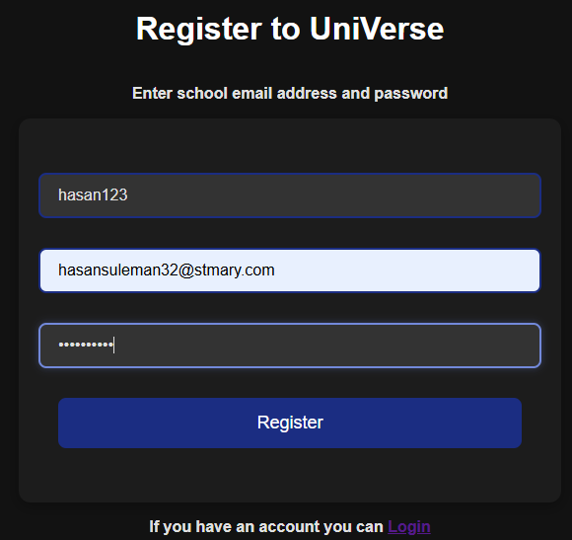

Entering school email address and password along with valid username.

After entering these details in the register page and pressing the submit button I will login to Django administration to see if user added to database.

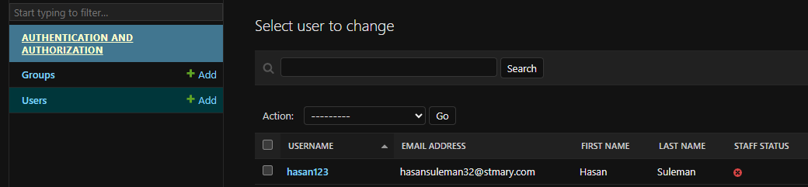

User details added to database: **Test passed**

**Test (17) : testing if username cannot be registered if already in use:**

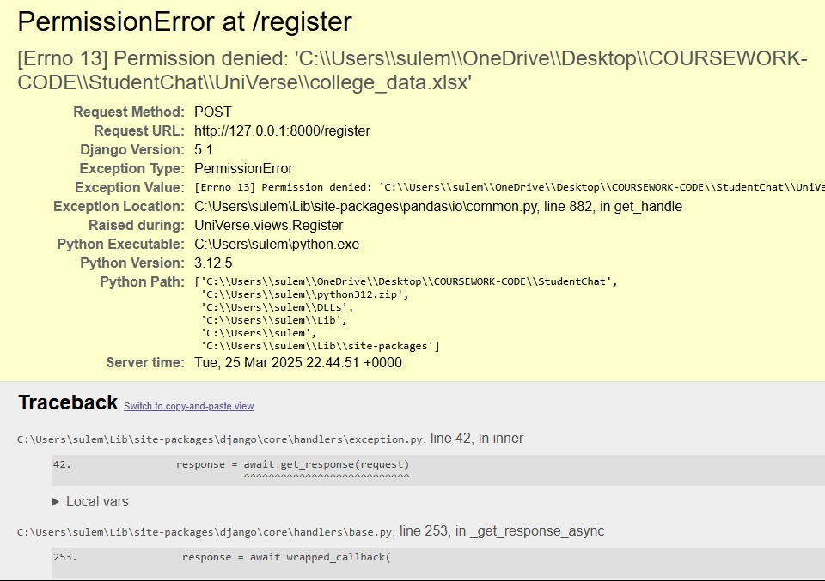Using the same username as used to create an account previously “hasan123” I will try to create an account and it should show an error message.

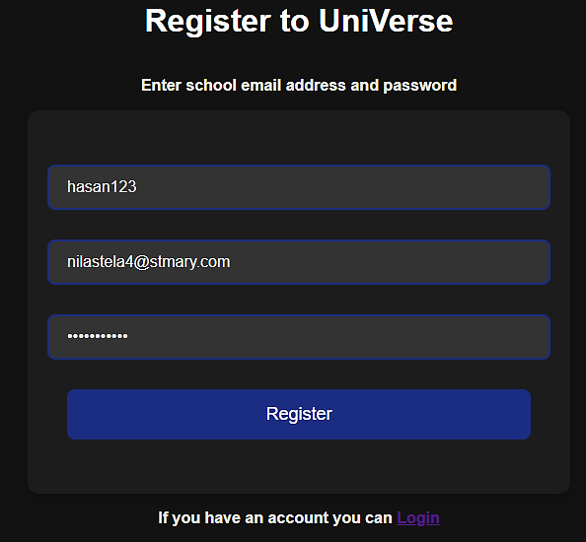

Rather then displaying an error message on the website the code crashes : **Test failed**

**Correcting failed test (17) :**

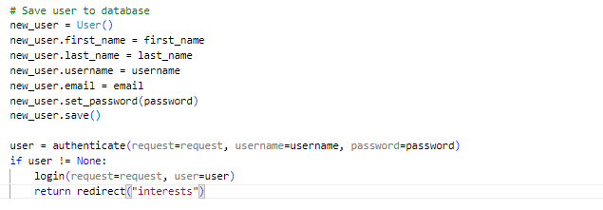ORIGINAL CODE:

Djangos in built authenticate function checks to ensure no usernames are repeated and if this requirement is not met it does not know what to do and crashes the code raising an error.

FIXED CODE:

However we want the error message to be displayed on our website without the program crashing. I will do this by using try and except to stop program from crashing and instead returning our own error message to be displayed on the website.

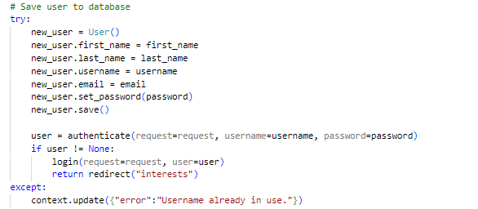

Try and except will stop code from crashing.

Error message sent to front end if validation not met.

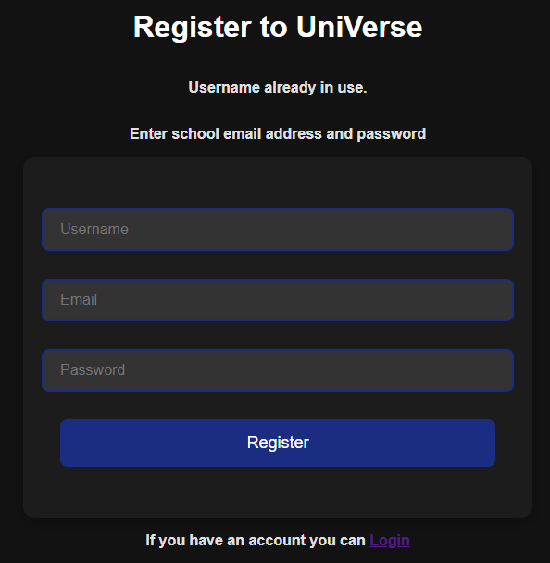

Error message displayed

**Test passed**

**Test (18) : testing if user is redirected to interests page after registration:**

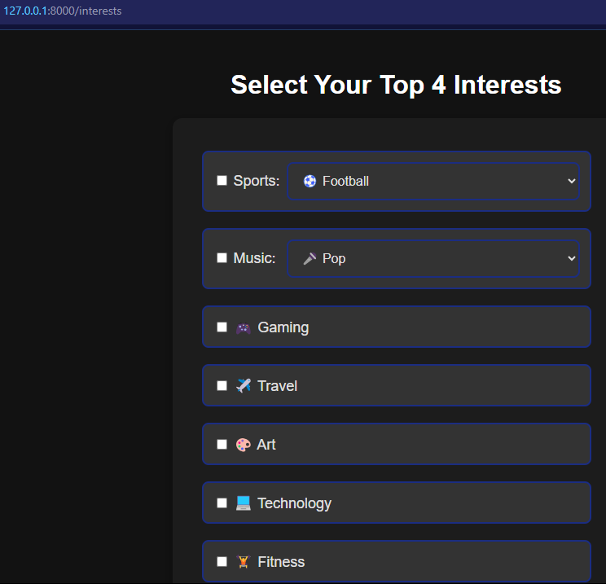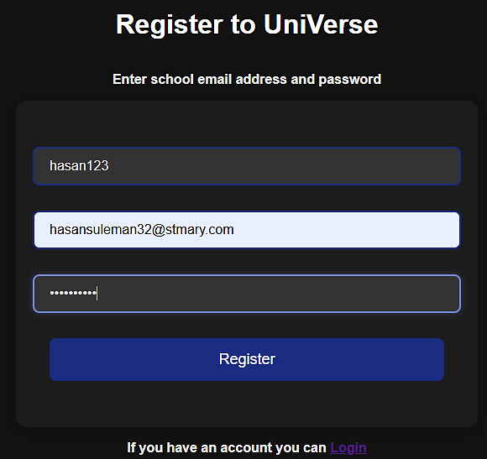

**Test passed**

**Test (19) : testing to see if user login is authenticated:**

Erroneous data : password does not match correct username

Erroneous data : password and username incorrect

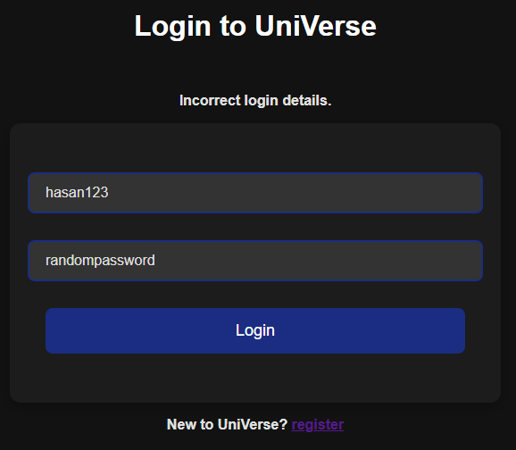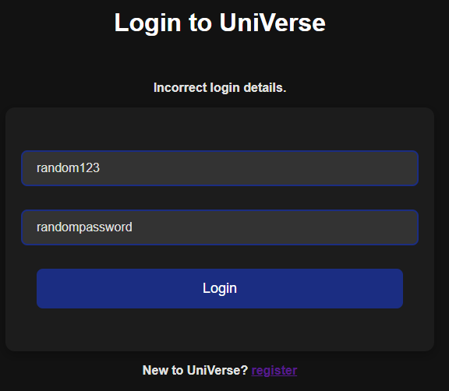

Error message displayed : **Test passed**

**Test (20) : Testing if user redirected to home page after login:**

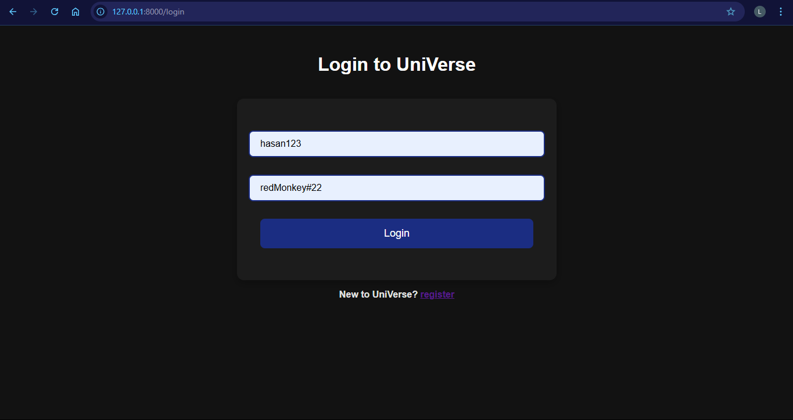

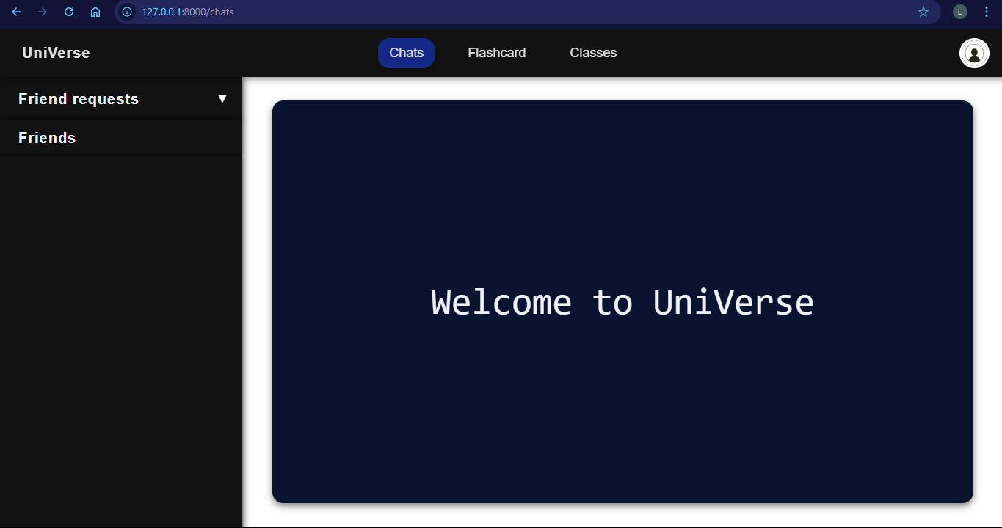

**Test passed**

### CLIENT FEEDBACK 2:

I demonstrated the complete authentication system to my client Jack. Then I conducted an interview with him to check is he was happy with the functionality and appearance of the authentication system and to ask for feedback.

**Interview:**

**Q1: Was the authentication system easy to use?**

A1: “Yes it was really easy to navigate and the error messages when I did not meet validation were clear to follow making the whole process quicker.”

**Q2: Did you like the design of the website and how it looked?**

A2: “Yes the theme was consistent throughout the authentication system with a minimalistic and clean design which I think will be appealing to the students.”

**Q3: Did you like the validation restrictions?**

A3: “Yes the validation met the requirements of only students being able to access the website. Also keeping the username length reasonable and unique will help identify users easily. However, I think it would be good there would be one account per student which you could do by ensuring email is not already in use during the registration process.

**Q4: Is there anything you would like me to change?**

A4: “Apart from what I mentioned above to ensure one account per student no , I think everything seems to be working fine and I am happy for you to move onto the next part.”

**Client feedback review:**

The client provided positive feedback on the authentication system, highlighting its ease of use and clear error messages to help the user with the process. They also liked the consistent and minimalistic design, stating that it would appeal to users.

However she wanted some adjustments:

* Implementing a check to prevent multiple accounts using the same email.
* Display error message if email entered already in use.

This will ensure that for each student he/she can only create one account.

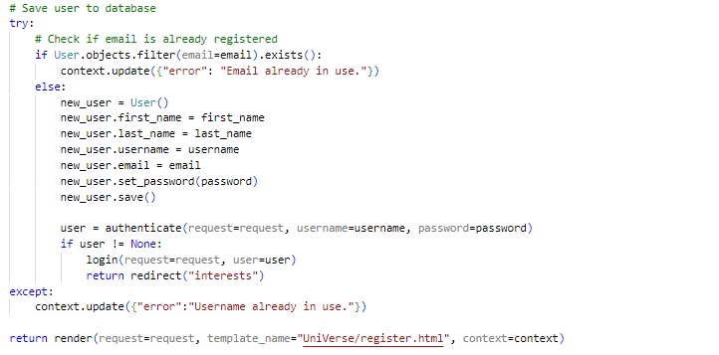**Client feedback adjustments:**

I have added a filter to check if email is not already in use or not. If it is in use it will return an error message.

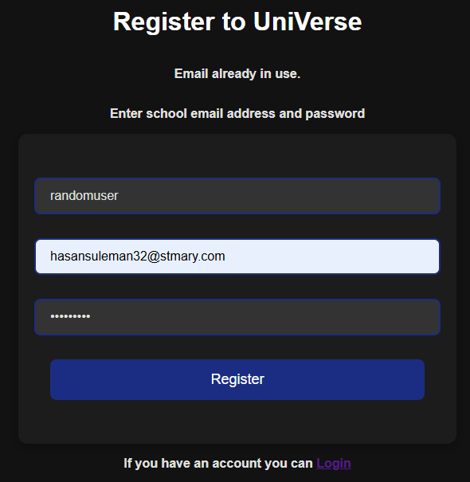**Testing if client feedback adjustments work:**

Error message displayed

**Test passed**

### REVIEW 3:

So far, I have prepared an environment where I can create my project. I have built the website using HTML and CSS, and have it run on a local server. I have built a working authentication system with validation and connected it to an SQLite database using Django models. My client gave me feedback which I responded to and fixed errors for said feedback. Now I will move onto working on the backend of the interests page which will help me to build the **friend suggestion algorithm as per the clients request in** **Client interview #4.**

## STAGE 4 : IMPLEMENTING THE INTERESTS PAGE:

**Creating the UserProfile model:**

I will create a UserProfile table in order to store the interest options selected and more data later on in the project. I will define this model in models.py:

I imported the ‘User’ model to allow a Primary-Foreign key link

Imports Django’s models module, which is used to define database models.

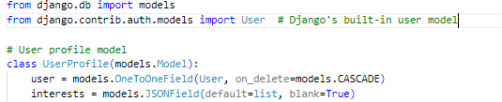

Our new ‘UserProfile’ table created as a class inheriting from ‘models’

Ensures each UserProfile is uniquely associated with one user.

•

Field #2 : ”interests” A list containing interests.

Means that if the associated User is deleted, the UserProfile will be deleted as well to maintain referential integrity

Field #1 : ”user

Links the UserProfile model to Django’s built-in User model.

**Creating the backend for the interests page in views.py:**

**Validation:**

Check if user is logged in

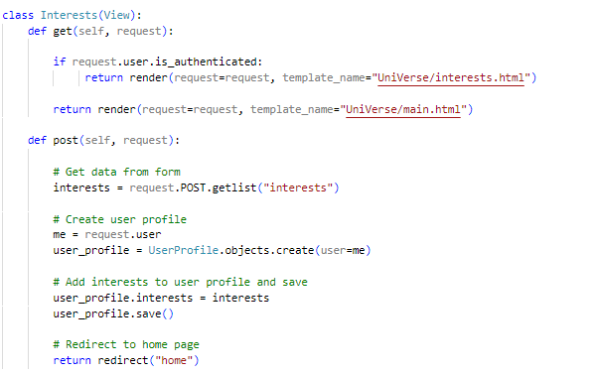

Get data from form

Get current user

Create user profile with current user as the user (user will only be redirected to interests page once so will not duplicate record)

Add interests and save

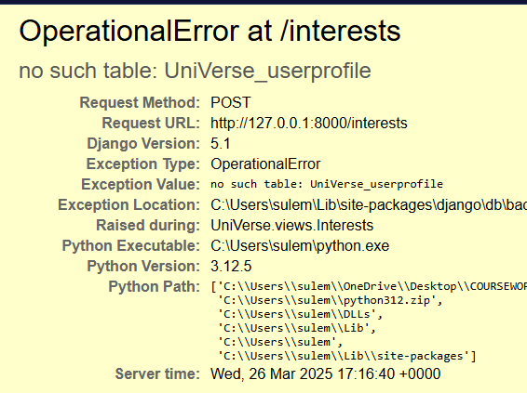**Test (21) : Testing to see if interests selected and added to database:**

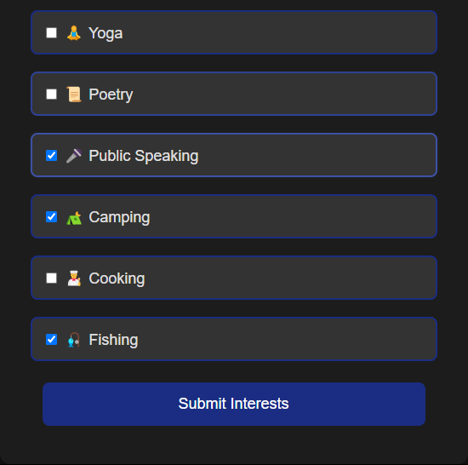

Error displayed and code crashes : **Test Failed**

**Correcting failed test (21) :**

The reason why the code crashed and said no such table as user profile was because we forget to run the migration after creating the model and hence Django did not create the corresponding table for the model in the database.

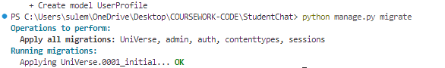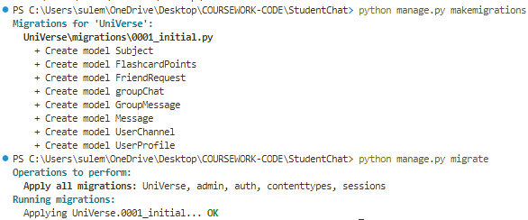

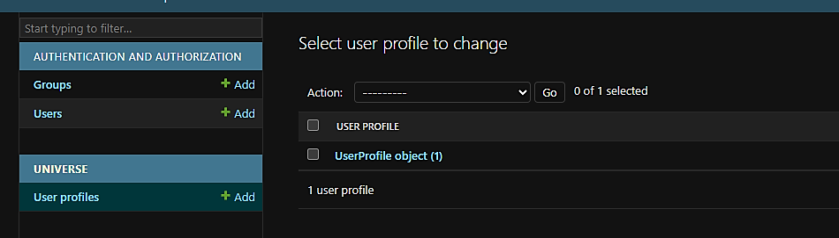

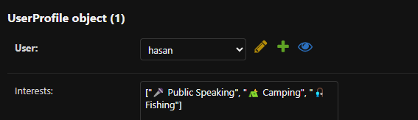

User able to select interests and interests added to database: **Test passed**

**Implementing dropdown options:**

Using JavaScript I will get the functionality of the dropdown options to work:

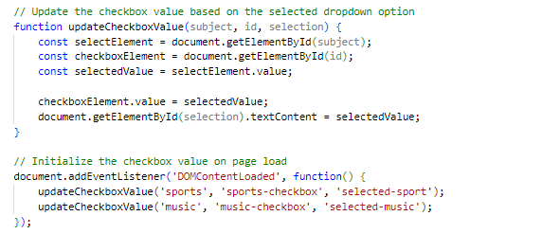

Get elements by ID

Make selected value the dropdown options selected

selects dropdown topic as default option upon page load

**Applying interests selection limitations:**

We will limit the amount of interests a user can choose using JavaScript to four to ensure the interests remain relevant and focused for the user and for other users who will view his profile.

selects all checkbox inputselements

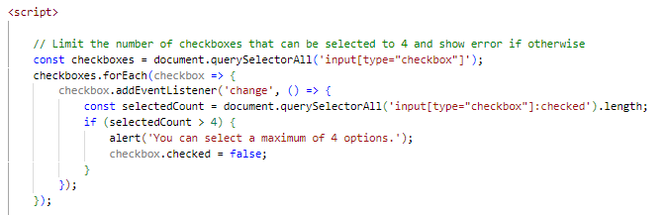

Check number of checkboxes selected

**Validation:** If there are more than 4 selected show error message and deselect option

**Test (22) : testing if user interests validation works:**

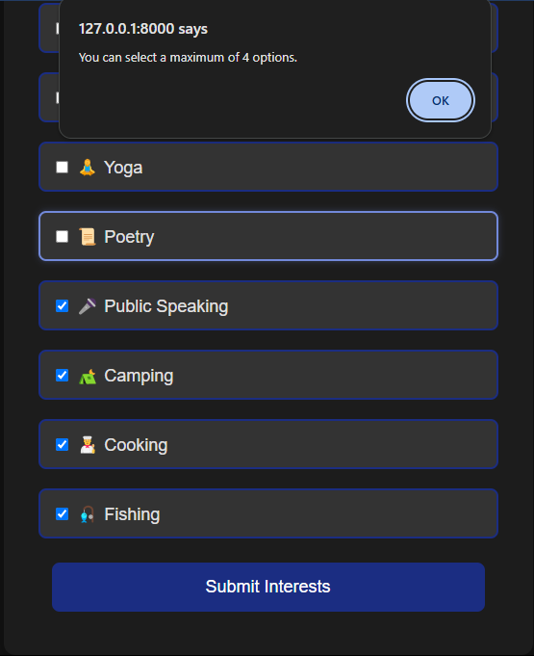

In attempt to select more than 4 options error message displayed

Error message displayed

**Test passed**

### CLIENT FEEDBACK 3:

I demonstrated the complete interests page to my client Jack. Then I conducted an interview with him to check is he was happy with the functionality and appearance of the page and to ask for feedback.

**Interview:**

**Q1: Was the interests page easy to use?**

A1: “Yes it was really easy to navigate and the title was clear in stating to select up to 4 interests making the whole process quicker.”

**Q2: Did you like the design of the website and how it looked?**

A2: “Yes the theme remains consistent and I advise you to continue to do so to give the website a professional look.”

**Q3: Did you like the validation restrictions?**

A3: “Yes the validation ensured users do not select to many interests as that would make it hard to display but also would prevent users from selecting more meaningful interests which they prefer over others. I think this will also help in creating the friend suggestion algorithm.”

**Q4: Is there anything you would like me to change?**

A4: “Maybe adding an “other interests” option to allow user to enter an interest not on the list with length validation would be useful to allow inclusivity.”

**Client feedback review:**

The client provided positive feedback on the interests page, highlighting its ease of use and clear instructions to help the user with the process. They also liked the validation as it would allow users to focus on more specific interests.

However she wanted an adjustment:

* Adding a “other interest” option

This will be enhance inclusivity by allowing users to select options which are not on the list.

**Client feedback adjustments:**

Other interest option with text input area

Allows only a maximum of 20 characters.

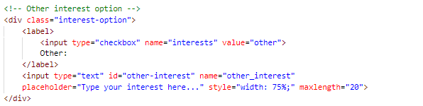

**Testing if client feedback adjustments work:**

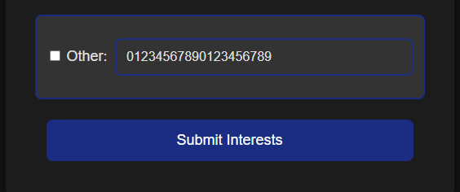

Allows only a maximum of 20 characters.

Other interest option

**Test Passed**

### REVIEW 4:

Now the interests page is complete, the steps required for a new user have been complete and I cannot move onto implementing the functionality of the HTML web pages that I have created. I have also finished responding to the client feedback whose suggestions has enhance my website.

Next I will work on the functionality of the home page for the user which will contain:

* Adding a friends field to the database to store friends
* Accessing all of the users friends to send to the front end to be displayed
* Adding friend request field to the database
* Accessing friend requests to send to the front end to be displayed

Once this is complete, I will get feedback from my client and make adjustments if necessary and move onto the next stage of my development.

## STAGE 5 : IMPLEMENTING THE HOME PAGE:

**Adding friends field to UserProfile model:**

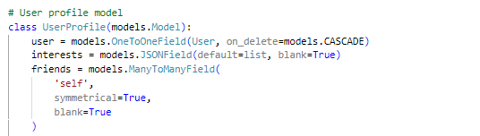

Field #3 : “friends”

A many to many relationship allowing user to have multiple friends whom can also have multiple friends.

Makes the relationship bidirectional (i.e., if A is friends with B, B is friends with A)

I will now make migrations to ensure user profile table has been updated.

**Creating a friend request model:**

Friend requests require multiple variables hence to keep the code **modular** I will create a separate model for friend requests.

Foreign key allows it to link to the user profile model using the user record.

**Validation:**

Max length is 10 characters

Field #1 : “from_user”

Represents the user who sent the friend request

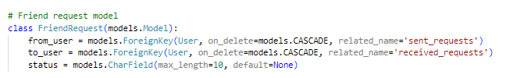

Field #3: “status”

Status of friend request wether user has accepted or rejected friend request or wether response is pending.

Related name allows for reverse look up

Field #2 : “to_user”

Represents the user who received the friend request

**Implementing friends and friend requests in views.py:**

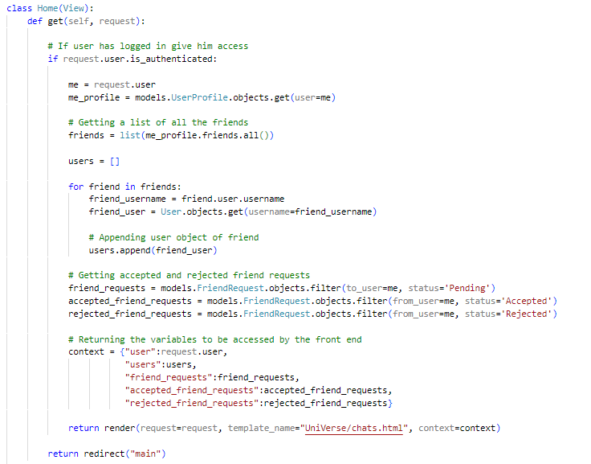

Check if user is logged in

Get all the users friends

Append the user object of each friend by using the primary key user as the link between the tables.

Separate accepted, rejected and pending friend requests to make it easier to display in front end.

Return data to frontend in a dictionary.

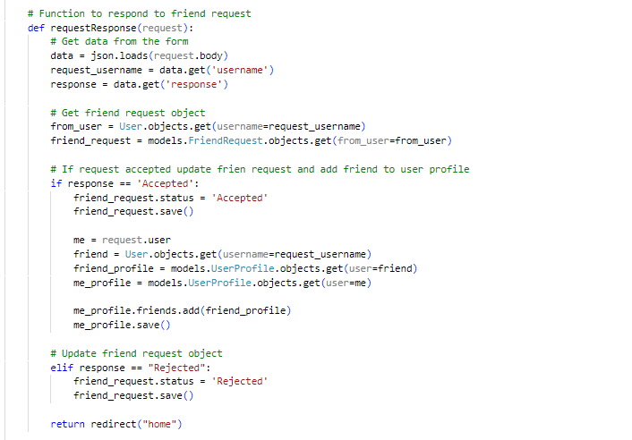

Return data from form

Return friend request object

Change friend request status to ”Accepted”

Add friend

Change friend request status to ”Rejected”

**Calling the requestResponse function in home.html:**

Calling the friend request response function

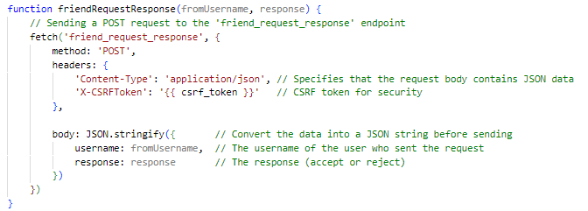

Creating a url path for the function to be accessed from the HTML

Returning data to function in JSON format



**Test (23) : Testing to see if friends displayed on friends list:**

Considering we haven’t worked on the profile page yet which will contain the option of actually adding friends I will need to manually add friends using the Django administration:

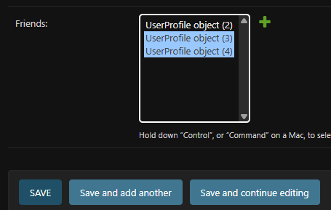

I have added to new friends to the user to test if these friends are displayed on friends list.

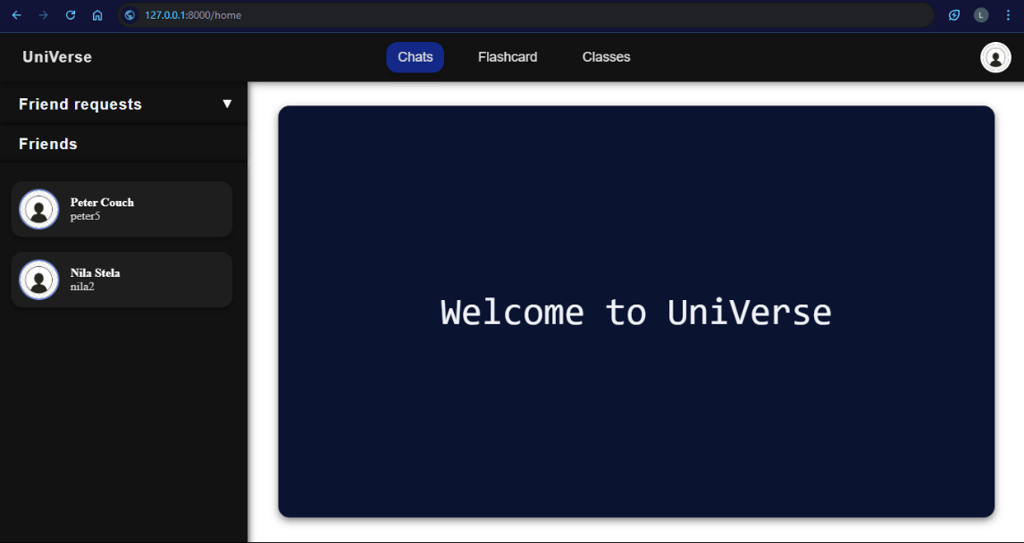

Friends displayed in friends list : **Test passed**

**Test (24) : testing to see if user can manage friend requests:**

Again we do not have the option to send friend requests yet so I will have to do so using Django’s administration system.

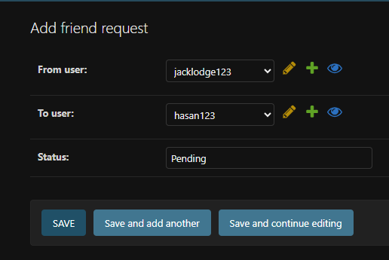

Sent a friend request from “jacklodge123” to “hasan123” with the status pending

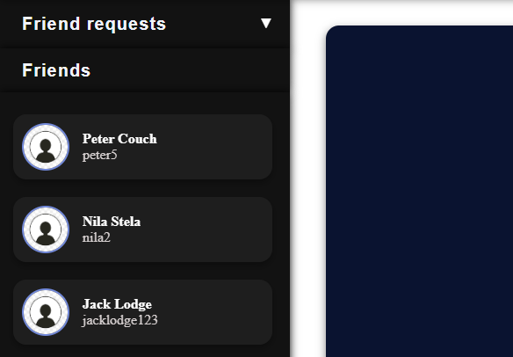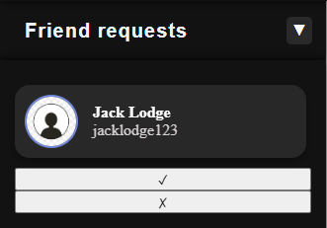**Accepting friend requests:**

Friend added

**Rejecting friend request:**

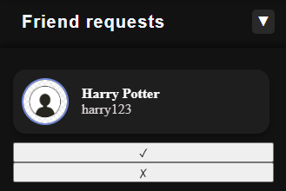

Friend request rejected

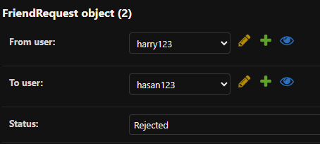

I am able to accept and reject friend requests and hence **Test passed**

**Updating settings.py to accommodate non-static images:**

In order to upload profile picture later in the profile page we will need to be able to save it in the database. Before we can do this we need to update settings.py to be able to handle images.

sets MEDIA_ROOT to a folder named 'media' inside the project directory.

Imports the os module to handle file paths in a cross-platform way

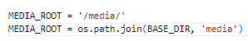

BASE_DIR refers to the project’s base directory, so 'media' will be created inside your project folder.

**Adding a profile picture field to the UserProfile model:**

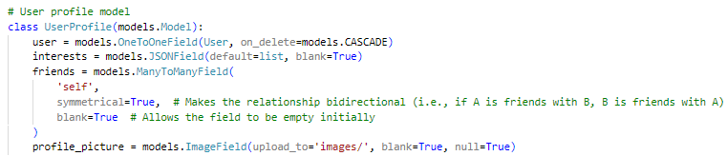

I will ensure to run migrations to update database.

Specifies the directory where the images will be uploaded

Field #4: “profile_picture”

Stores profile picture image of user

**#**

**Updating urls.py to accommodate non-static image file paths:**

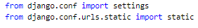



**MEDIA_ROOT**: The folder where uploaded files are stored.

**MEDIA_URL**: The web address for accessing media files (e.g., /media/).

**static():** Connects the URL to the folder so files can be served while debugging.

**Test (25) : Testing to see if profile button displays user profile picture:**

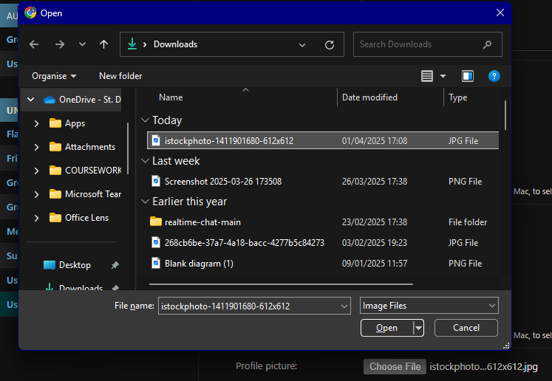We do not have the option to edit profile picture yet so we will manually upload a profile picture to a user using Django’s administrator to test it.

File uploaded

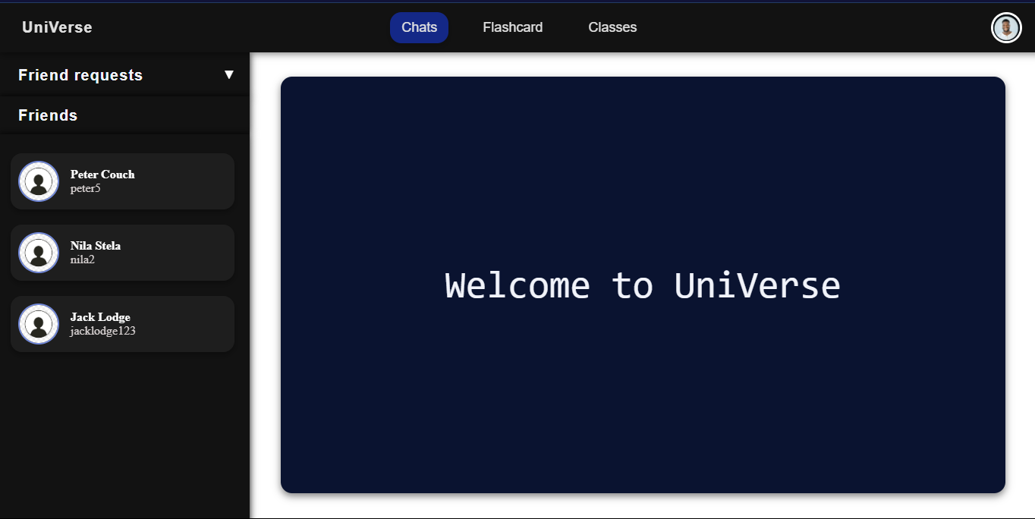

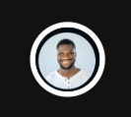

Profile picture displayed

**Test passed**

### CLIENT FEEDBACK 4:

I demonstrated the complete home page to my client Jack. Then I conducted an interview with him to check is he was happy with the functionality and appearance of the page and to ask for feedback.

**Interview:**

**Q1: Was the home page easy to use?**

A1: “Yes, it provided me with buttons linking too other parts of the pages which will be displayed once you have finished the project.”

**Q2: Did you like the design of the home page and how it looked?**

A2: “Yes the colours are professional and clean along with the titles which are clear and concise giving direction to the user.”

**Q3: Is there anything you would like me to change?**

A4: “No, I don’t think so, everything seems to be working okay for me, I am happy for you to move onto the next part.”

**Client feedback review:**

The client seemed content with the home page and found the functionality of the page meeting all the requirements. The client did not need me to change anything and is happy for me to continue with the project.

### REVIEW 5:

Since my last review, I have built the home page which will be the page from which the user will be able to navigate through the rest of the website. This will be done by clicking on the button which will redirect you to the pages which I will create.

Next I will work on the chats page which will contain :

* Creating a message model to save messages
* Creating a user channel model to save the channels across which message will be sent
* Handle real time communication using WebSocket in consumers.py and routing.py
* Display incoming and sending messages
* Display old messages upon refresh of the page

Once this is complete, I will get feedback from my client and make adjustments if necessary and move onto the next stage of my development.

## STAGE 6 : CREATING THE PRIVATE MESSAGING SYSTEM:

**Creating a message model:**

We will need to be able to store the messages to send them to other users which will require a separate message table in the database.

Field #3: “message”

The content of the message

Field #2: “to_whom” The recipient of the message which is a foreign key because it is linked to the user model

Field #1: “from_whom” The sender of the message which is a foreign key because it is linked to the user model

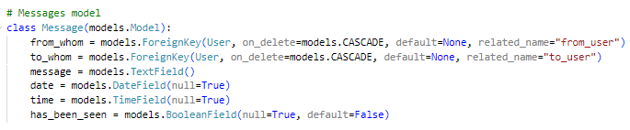

Field #6: “has_been_seen”

Tracks if the message has been read (default is False)

Field #5: “time”

The time the message was sent

Field #4: “date”

The date the message was sent

**Creating a user channel model:**

The user channel model be essential in creating and storing a channel between two communicating users to allow messages to be sent across the internet.

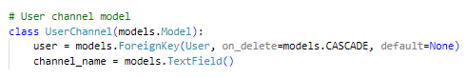

Field #2: “channel_name”

Stores the name of the channel specific user

Field #1: “user”

Links each UserChannel to a specific user

I will also now run migrations to ensure database is updated.

**Handling WebSocket connections in consumers.py for real time messaging:**

Django channels provides a service called WebSocket which enables asynchronous handling essential for real time messaging where multiple actions need to be carried out at once. E.g.: two users messaging at the same time.

We will start by importing necessary modules (not explaining previously explained modules):

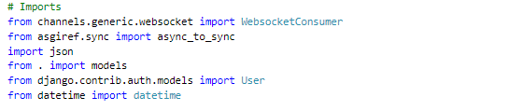IMPORTING MODULES:

Provides classes for working with date and time, used for timestamping messages.

Provides the base class for handling WebSocket connections in Django Channels.

Allows parsing and generating JSON data for communication over WebSocket.

Converts asynchronous code to synchronous so it can run in sync-based environments like Django views.

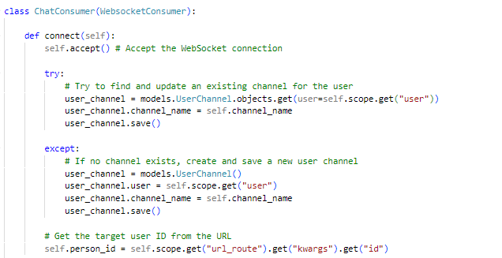

If user channel of user exists updates its name and saves it to the database

Extracts the target user's ID from the WebSocket URL

If no user channel exists creates a new user channel object with its corresponding fields

Accepts the WebSocket connection

ChatConsumer inherits from WebsocketConsumer which is a class designed to handle WebSocket connections

CREATING A CONNECTION:

**dqwdwd**

HANDLING SENDING MESSAGES:

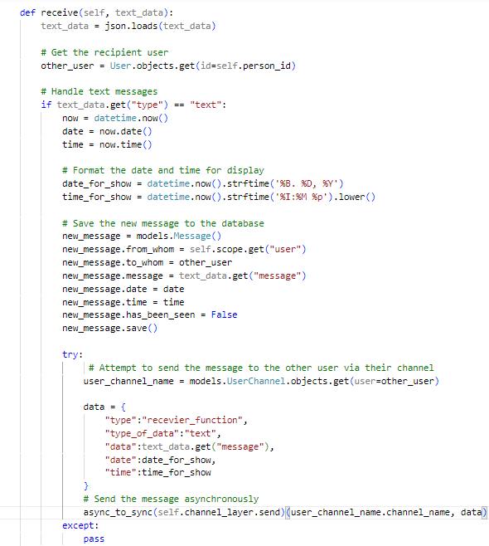

Converts raw JSON data from HTML input into a python dictionary so it can easily be worked with

Retrieves the recipient user

If data is a text it will get timestamp of it and format it

Creates a new message model instance and saves message details to database.

Retrieves user channel of recipient

Creates a dictionary to prepare the data that will be sent to the recipient.

Sends the prepared message data to the recipient’s WebSocket channel asynchronously.

HANDLING MESSAGE SEEN STATUS:

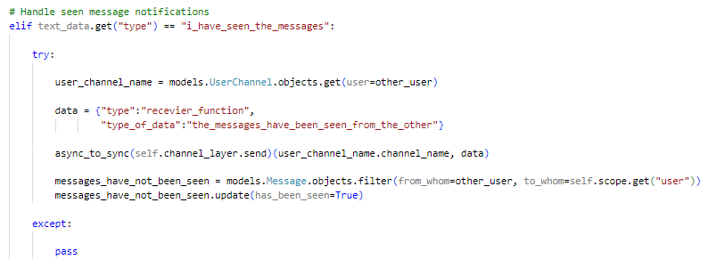

If message has been seen retrieves the recipient’s WebSocket channel and sends a "seen" notification.

Updates the database

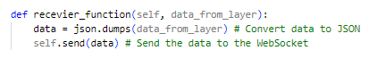HANDLING RECEIVING MESSAGES:

Data sent to WebSocket client allowing frontend to handle it

Converts string to JSON format so it can be sent over WebSocket

**WebSocket URL routing in routing.py:**

In order to create a channel of communication between two users WebSocket needs to know the endpoint defined by the user ID in the URL pattern in routing.py.

Converts the ChatConsumer class into an ASGI application, allowing Django to handle asynchronous WebSocket connections

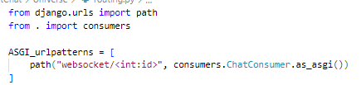

This defines a URL pattern for handling WebSocket connections using a unique id to define its endpoint

Imports the WebSocket logic connection in consumers.py

Path is used to define URL patterns that map to specific views or consumers in the application.

**Handling backend in views.py upon chats page load:**

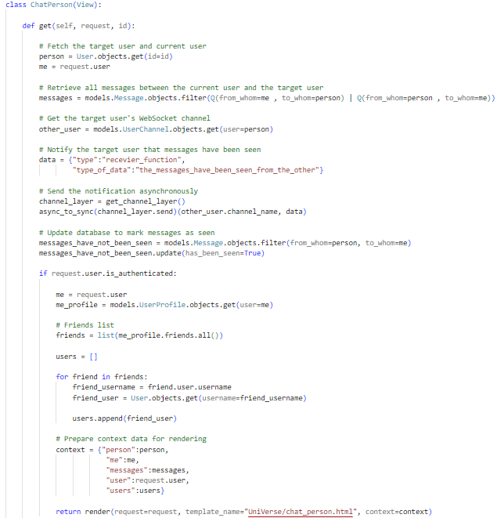

Fetch target and current user and all old messages in between them

Send notification to other user that message has been seen

Update seen status in database

**Validation:**

Check if user is logged in

Update seen status in database

Sending data to frontend

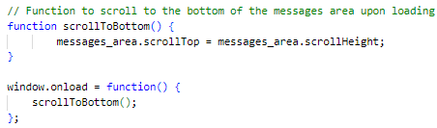**JavaScript scrollToBottom() function:**

Scrolls to bottom of messages when the chats page is loaded

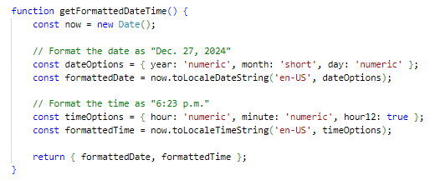**Formatting the date in JavaScript:**

Formatting the date and time for better readability

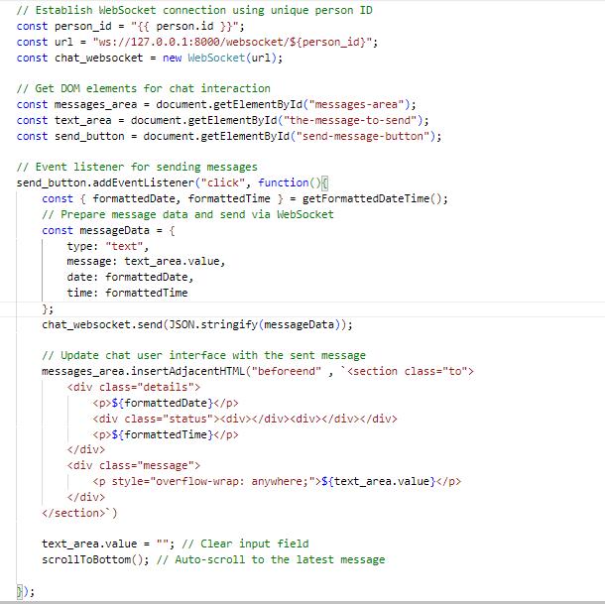**Displaying messages sent using JavaScript:**

Create a WebSocket connection unique to the user using their ID

Get elements required for chat interaction

Using event listener if button clicked send message and display it in messages area

Clear input text area of user after message sent and scroll to bottom to show message

**Displaying received messages using JavaScript:**

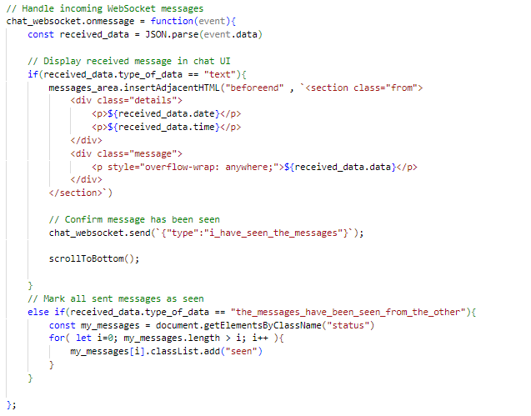

Get received message

**FAILED TEST IN USER CHANNEL FORGOT EXCEPT ONLY RUN WHEN USER ONLINE**

If message type is equal to text display message in messages area

**FAILED TEST IN MESSAGES NOT BEING IN CORRECT ORDER AT REFRESH**

**FAILED TEST IN JAVASCRIPT FORGOT WEIRD SPEECHMARKS**

Send I have seen the message notification

If message type is seen status update seen status button

**Test (26) : Testing to see if user can message friend:**

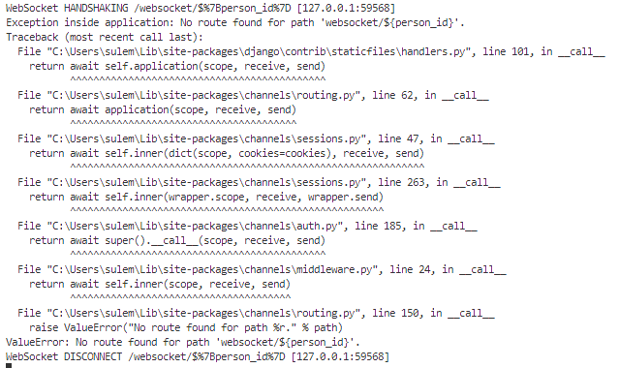

Error displayed:

**Test Failed**

**Correcting failed test (26) :**

The problem was in when we were defining our URL constant.

ORIGINAL CODE:



Over here we are attempting to string interpolate the id in the string, however JavaScript requires backticks instead of speech marks for this process.

FIXED CODE:

Backticks



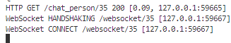Now we will test if any errors occur:

User connected to WebSocket and no error displayed in terminal

Now WebSocket is connected we can now continue to test if the user can send messages to his friend:

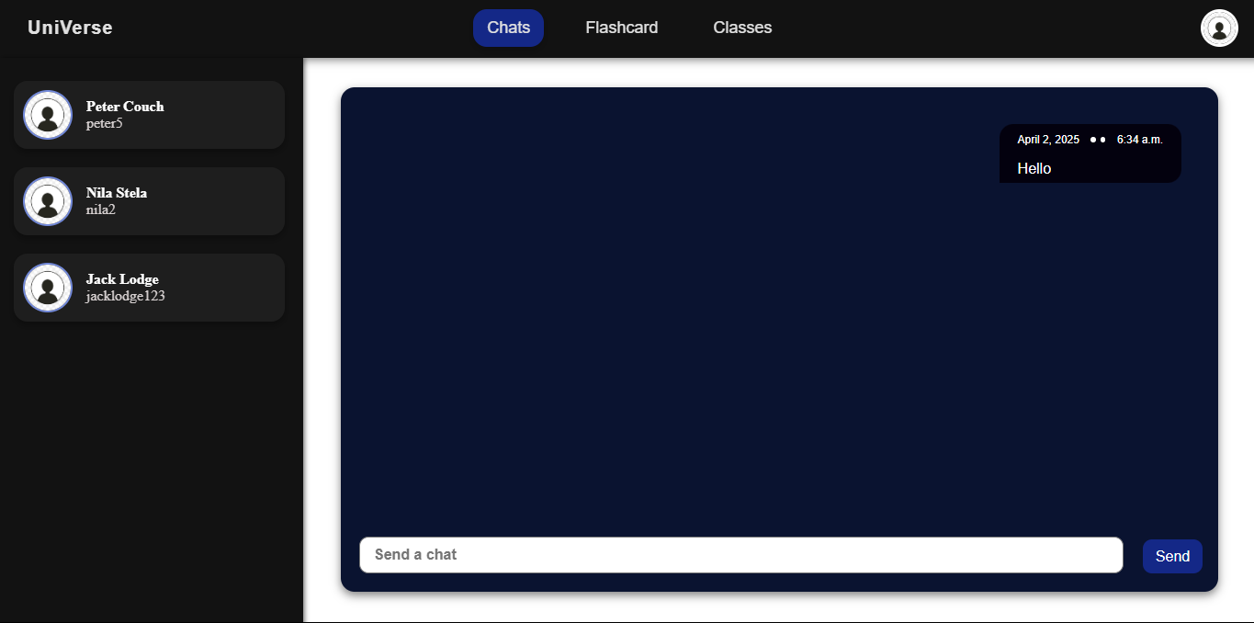

Message sent and displayed from user to nila stela

We will now check in Django administration if message object and user channel object has been created to confirm message has been sent to user:

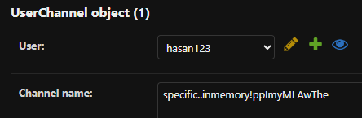

User channel object created

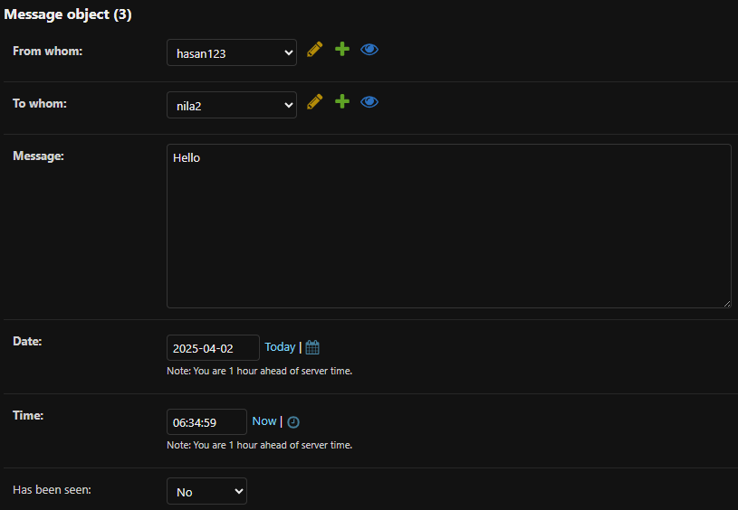

Message object created

Sent message displayed and user and message object created : **Test Passed**

**Test (27) : Testing is users can receive messages:**

We will now login to Nila Stella’s account and see if she received the message:

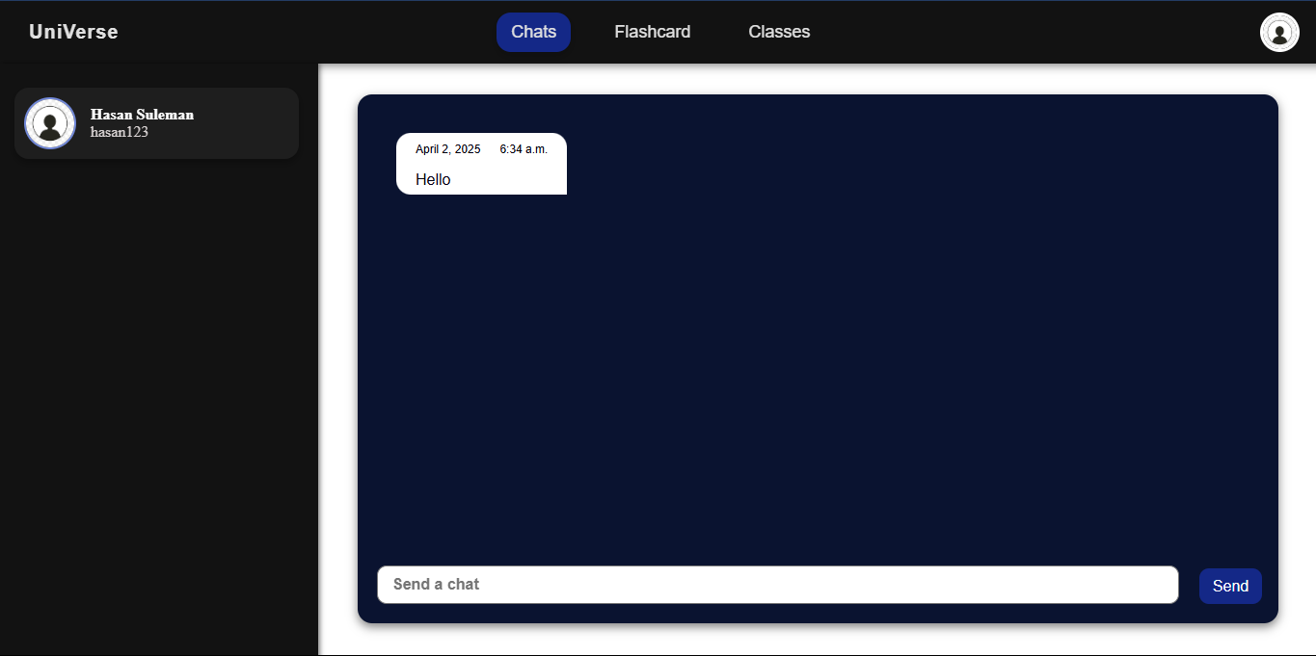

Message received and displayed : **Test Passed**

**Test (28) : Testing if user message history is displayed in order:**

I will now send multiple messages and refresh the page to see if message history is displayed:

**Messages before refresh:**

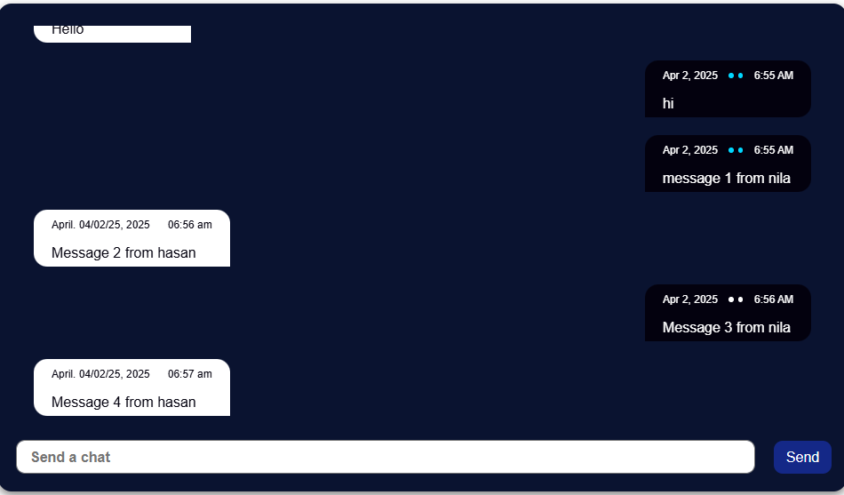

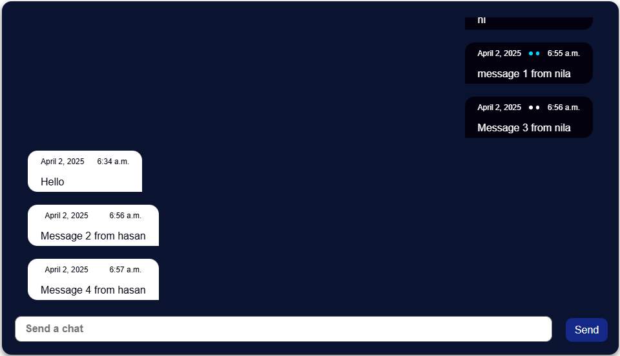**Messages after refresh:**

Message history conserved but not in correct order : **Test Failed**

**Correcting failed test (28):**

We were displaying messages but not in order of date and time rather by displaying all messages of one user then all messages of another user.

ORIGINAL CODE:



To order the messages in date and time order we need to use Django’s in built function order_by:



Now I will refresh the page to see if messages are displayed in correct order:

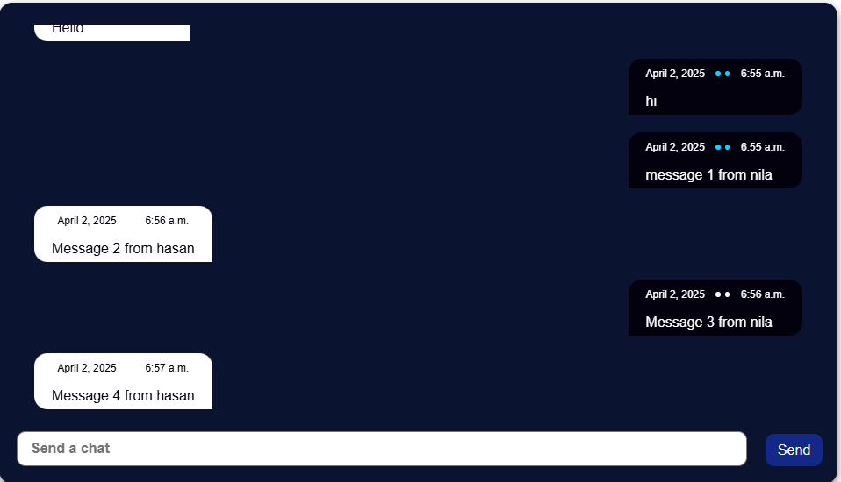

Message history displayed in correct order : **Test Passed**

**Test (29) : Testing if i_have_seen_message button works.**

Status button blue when message has been seen

Status button white when message has not been seen

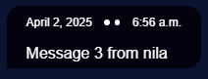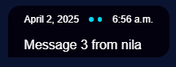

Button works : **Test Passed**

### CLIENT FEEDBACK 5:

I demonstrated the complete private messaging system to my client Jack. Then I conducted an interview with him to check is he was happy with the functionality and appearance of the system and to ask for feedback.

**Interview:**

**Q1: Was the chats page easy to use?**

A1: “Yes it was straightforward and user friendly. The button and input placement was perfect allowing messages to be shown as well. The scrollable messages area feature was also helpful in seeing previous messages.”

**Q2: Did you like the design of the website and how the displayed messages looked?**

A2: “Yes the theme was consistent throughout and the timestamps on to the messages were helpful in keeping track of the conversation history. The message seen status button will be a feature that I think students will like.”

**Q3: Are the messages sent and received in real-time as expected?**

A3: “The messages were received in real time almost immediately ensuring the conversations feel natural and engaging which will be appealing to the students.”

**Q4: Is there anything you would like me to change?**

A4: “I think you should highlight which user you are chatting to in the friends list maybe by using a different colour for the background of that user friend section. Apart from that I am happy with everything else and I am happy for you to continue moving on.”

**Client feedback review:**

The client was fairly satisfied with the chats page, specifically with the smoothness of the real time messaging along with the appealing user interface.

However she wanted one adjustment:

* Highlighting the friends section of the friend the user is chatting to.

This will allow the user to keep track of their conversations and give the user a better user experience.

**Client feedback adjustments:**

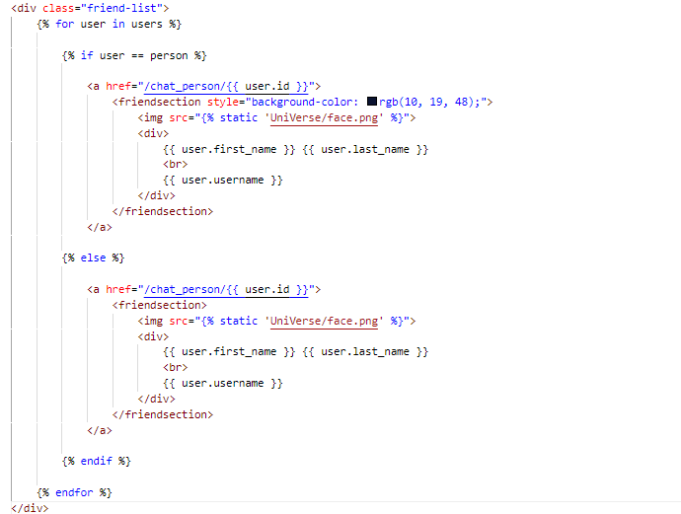We will need to edit the HTML of the code to highlight the friend the user is talking to:

If user is person you are chatting to change the background colour of the friend section

**Testing if client feedback adjustments work:**

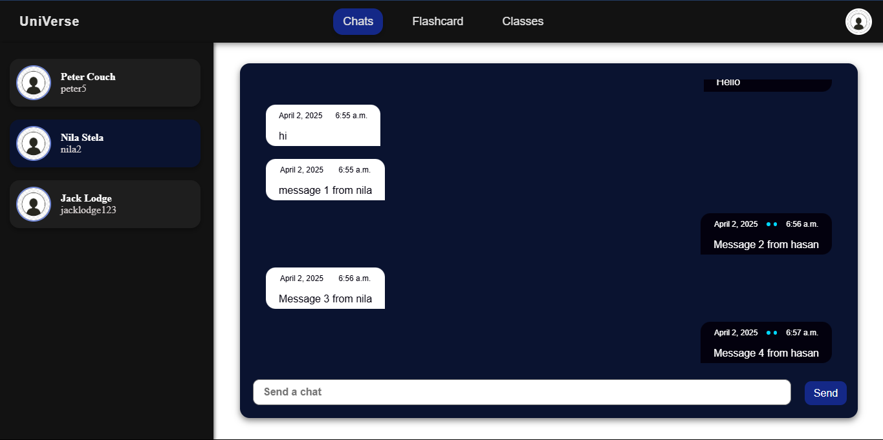

Friend section of friend highlighted : **Test Passed**

**ADD MORE FAILED TESTS**

### REVIEW 6:

Since my last review I have created a real-time private messaging system that allows the user to chat with his friends on an appealing user interface.

Next I will work on the group chats page which will contain:

* Creating models to store group chats and group chats messages
* Editing consumers.py and routing.py to handle group chat messaging logic
* Allow the user to create and manage group chats
* Allow user to upload files to group chat
* Creating classes using the student classes excel sheet provided by the client

Once this is complete I will get feedback from my client and move on to the next stage.

## STAGE 7 : CREATING THE GROUP CHATS MESSAGING SYSTEM:

**Creating Group Chat model:**

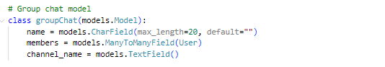We will need to be able to store the group chats created and its members.

Field #2: “members”

Establishes a many-to-many relationship between groupChat and the User model, allowing multiple users in a group chat.

Field #3: “channel_name”

Creates a text field to store the channel name

Field #1: “name”

Creates a text field for the group chat name with

**Validation** : max length 20 characters

**Creating Group Messages model:**

To store the messages and images sent in group chats we will need to create a group messages model.

Field #3: “message”

Contains the content of the message with

**Validation** : max length 200 characters

Field #2: “sender”

Creates a foreign key linking each message to the user who sent it

Field #1: “group”

Creates a foreign key linking each message to a specific groupChat

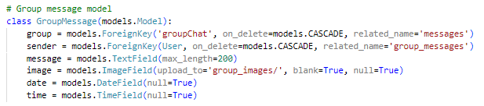

Field #5: “date”

Stores the date the message was sent

Field #4: “image”

Allows for an optional image to be uploaded with the message, stored in the group_images/ directory.

Field #6: “time”

Stores the time the message was sent

**Editing consumers.py to handle group chat messaging logic:**

Right now our consumers.py can only handle private messaging which requires sending a message from one user to another, however in group chats messages need to be broadcasted so all users in the group chat can receive the message:

CONNECTING USER TO GROUP CHAT CHANNEL:

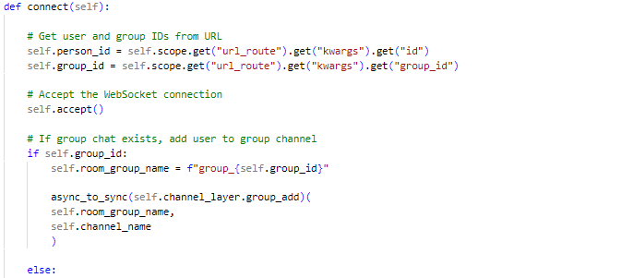

Get user id and group id

Accept WebSocket connection

If group chat exists add user to group channel

Else block: If no group chat exists, the message is for private messaging and you do what we showed in the chats page

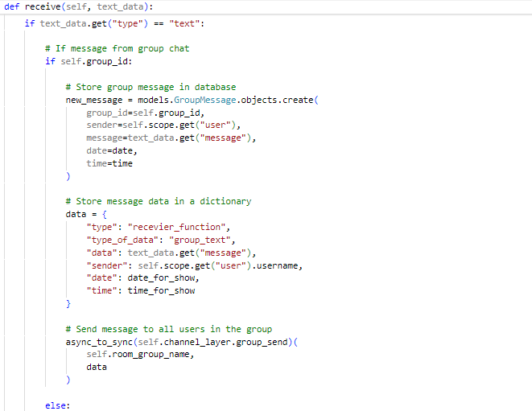EDITING HANDLING SENDING MESSAGES:

If user is trying to send a message from the group chat

Create and store message to database

Send data to group chat’s WebSocket channel asynchronously

Else block: If no group chat exists, the message is for private messaging and you do what we showed in the chats page

SENDING IMAGES:

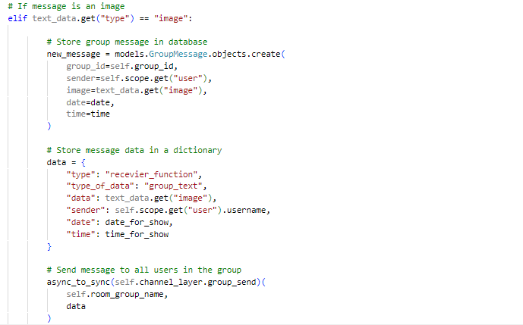

If message type is equal to image

Create and store message object with image to database

Send image to group chat’s WebSocket channel asynchronously

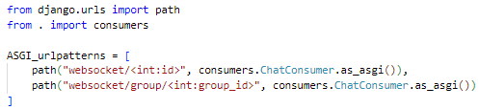**Editing routing.py to accommodate group chat WebSocket URL routing:**

This defines a URL pattern for handling WebSocket connections using a unique group id to define its endpoint

Separate URL patterns are required to handle private chats and group chat connections independently.

**Handling backend in views.py to send data to front end:**

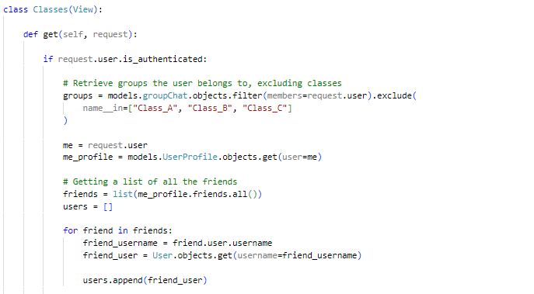GETTING BASIC DATA TO RETURN TO FRONTEND:

**Validation:** Check if user is authenticated

Retrieves all group chats apart from class group chats

Get current user profile

Get friends list to show in edit or create group chat option

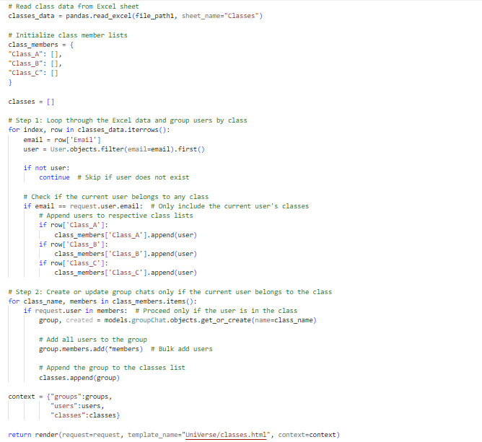CREATING OR GETTING THE CLASSES OF THE USER:

Get data from classes excel sheet sent by client

Create a dictionary containing lists of class members

Get current user object using email to search for it

**Validation:** Check if user exists

Check which class current user belongs to

Create or get class group chat with all its members

Return data to frontend

CREATE GROUP CHAT FUNCTION:

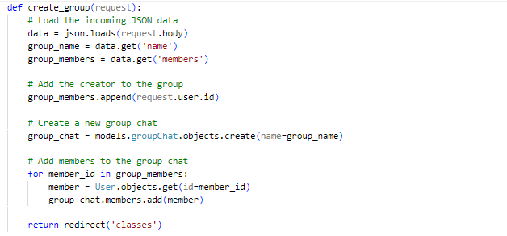

Load data from front end

Add creator of group to group chat members

Create group chat object from model

Update members field in group chat object

**Test (30) : Testing to see if class lists work:**

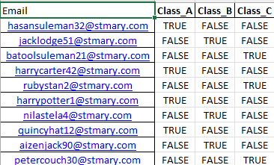

User hasan123 is in class A

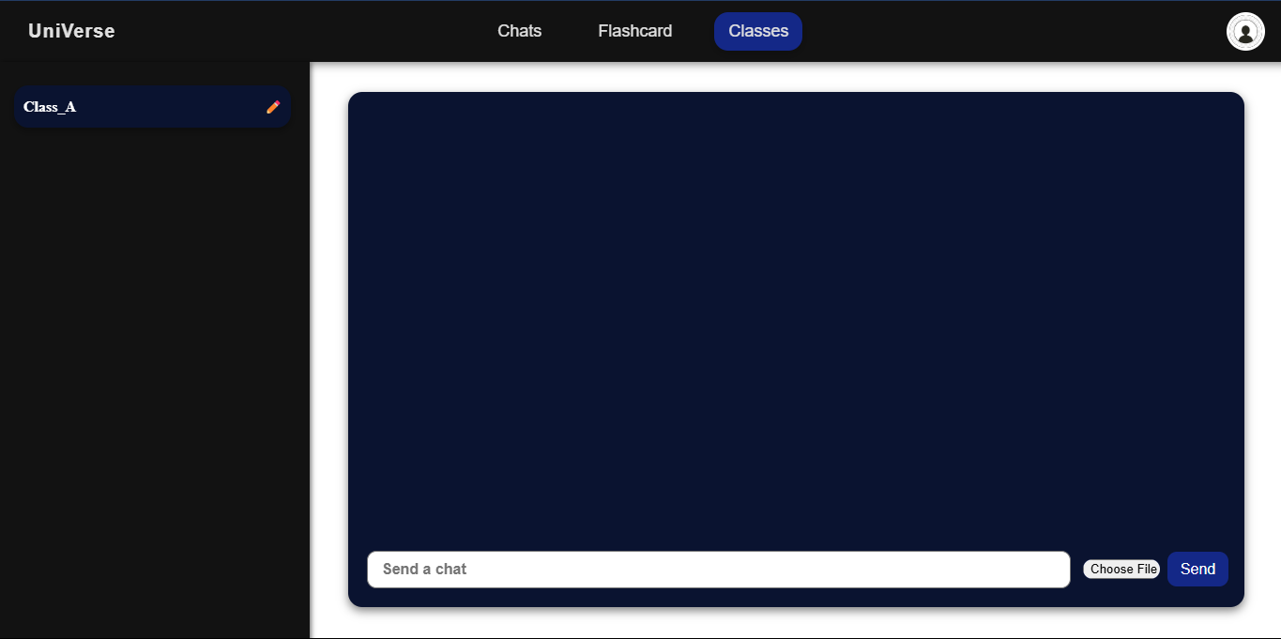

User added to class A group chat :

**Test Passed**

**Allowing user to create a group chat using JavaScript:**

Pop-up displayed when create group chat button clicked(button shown in HTML)

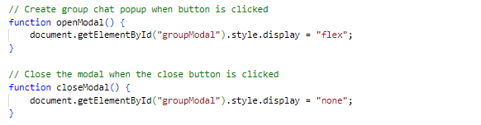DISPLAYING CREATE GROUP CHAT POP UP:

Pop up closed when close button clicked

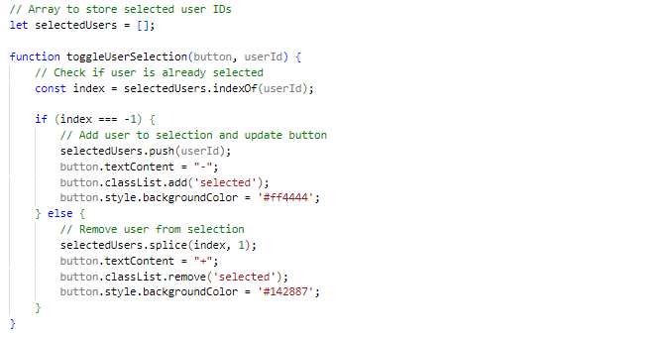ALLOWING USER TO EDIT MEMBERS OF GROUP CHAT:

Array to store user ID’s of selected members to add to group chat

Check if user is already selected or not

If not selected add user to array

If selected remove user from array

ALLOWING USER TO CREATE GROUP CHAT:

Getting the group name from the input field where the user is prompted to enter name in HTML

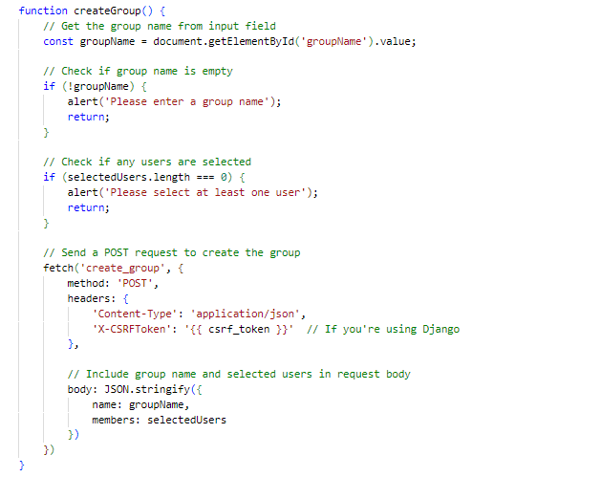

**Validation** :

Group name must not be empty otherwise error message displayed

**Validation** :

At least one user must be added to group chat

Function from views.py called and the group name and users selected to be added to group chat have been returned as well

**Creating URL path to allow the function create group() to be called:**



This is defined in urls.py within the urlpatterns variable which allows us to call this function in JavaScript

**Test (31) : Testing if user can create a group chat:**

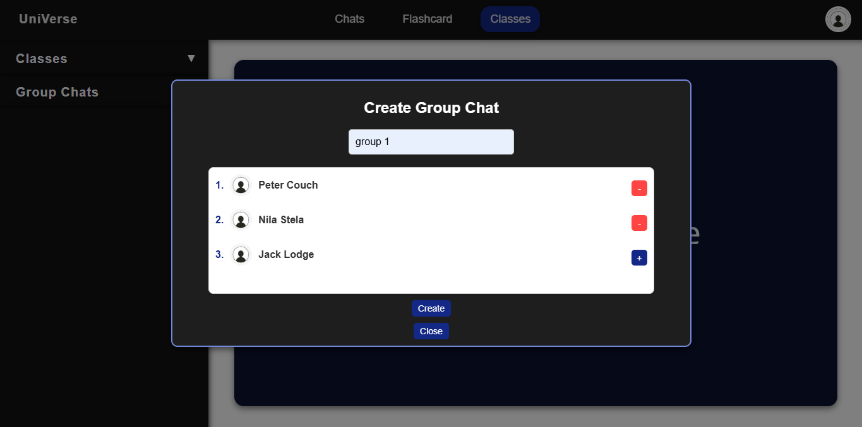

Group chat name

Added users minus button is shown to remove them from members

Error message displayed in terminal :

**Test Failed**

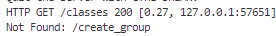

**Correcting failed test (31) :**

We were entering the path ‘/create_group’ in urls.py but in JavaScript we were entering the path ’create_group’ hence it was showing not found.

Changing function name to match JavaScript



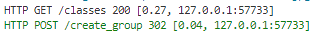

Function called

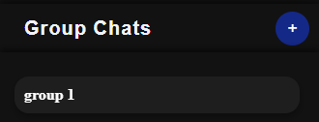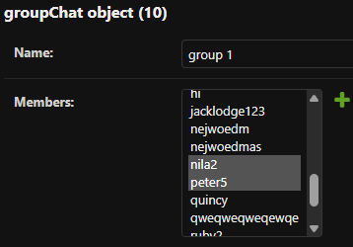

Group chat created with members:

**Test Passed**

**Allowing users to edit group chats using JavaScript:**

EDITING AND CREATING SEPARATE POPUP FUNCTIONS:

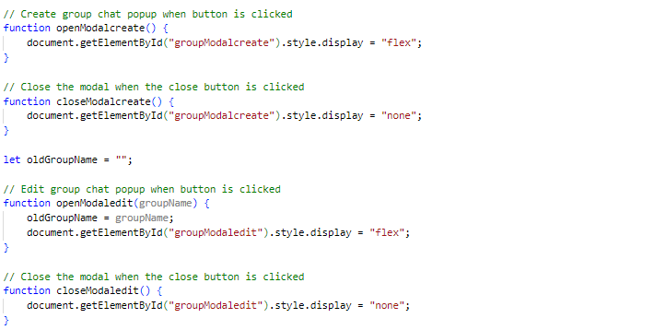

Separate pop ups of edit group and create group

Get old group name and store it to variable when pop up opened

Close pop up when close button clicked

Toggling user selection will use same function as shown before:

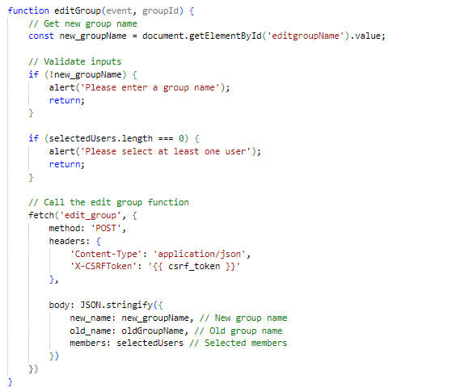ALLOWING USER TO EDIT GROUP CHAT:

Get new group name and store it to variable

**Validation** :

Group name must not be empty otherwise error message displayed

**Validation** :

At least one user must be added to group chat

Function from views.py called and the new group name and old group name and users selected to be added to group chat have been returned as well

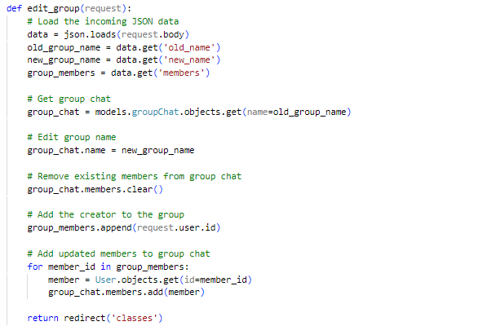EDIT GROUP CHAT FUNCTION:

Load data from front end

Get group chat object from model

Edit group name

Update members of group chat

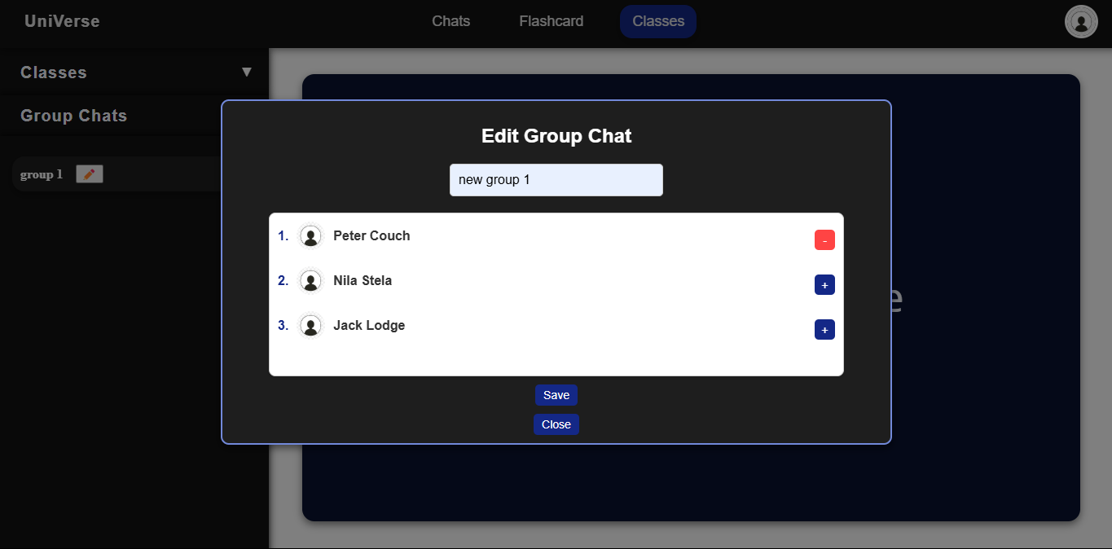**Test (32) : Testing if user can edit group chat:**

Only peter crouch and current user are now in group chat

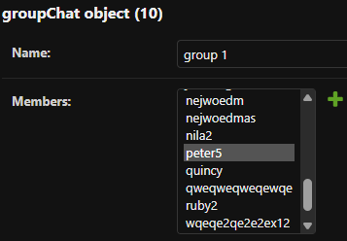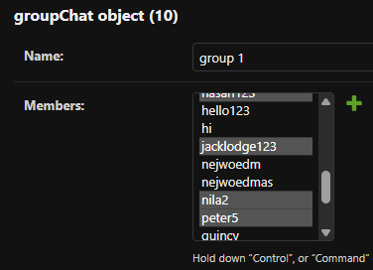

Members updated however group name not changed : **Test Failed**

**Correcting failed test (32):**

After doing some research I found that in order to make a change in the database I need to manually save it afterwards. I will do this when I change group name in views.py:

Saved group chat name after making a change

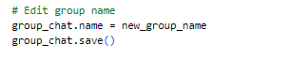

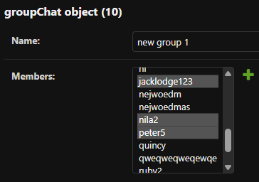

Group chat name changed and members updated :

**Test Passed**

**Test (33) : Testing to see if user can message in group chats:**

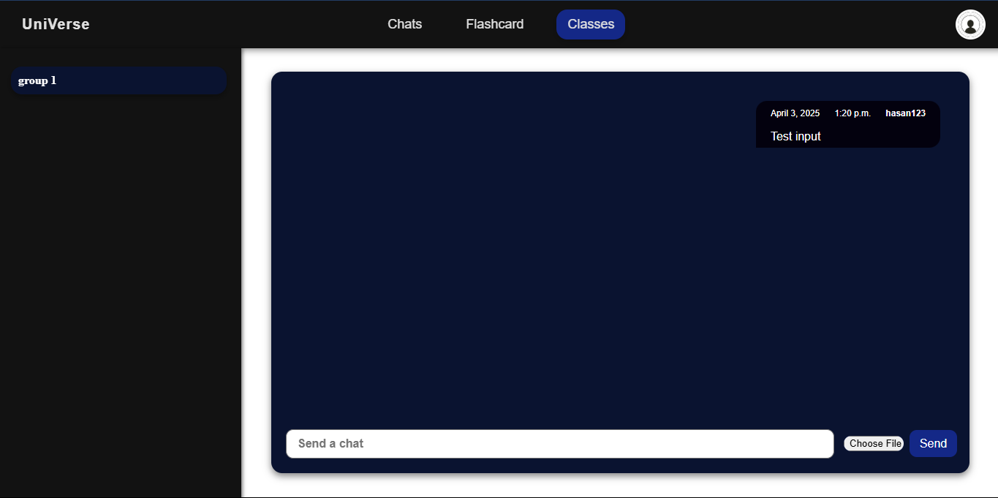

Message displayed with username and timestamp :

**Test passed**

**Test (34) : Testing to see if user can receive messages in group chats:**

I will now login in to another account of a user who is in the group chat to see if he has received the message:

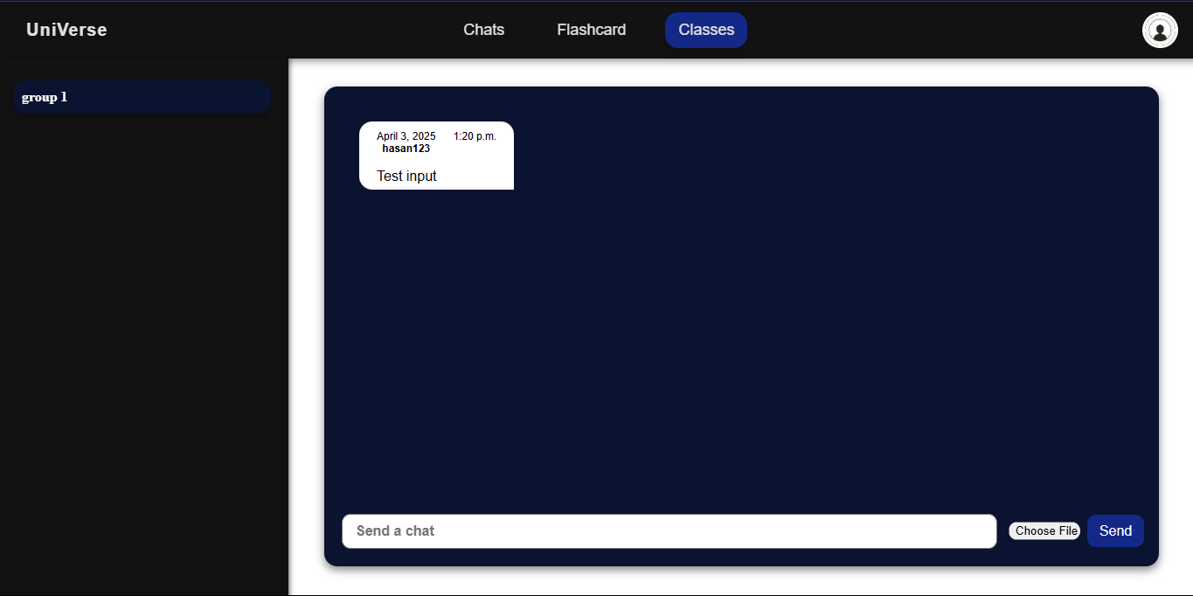

Message received and displayed with username and timestamp :

**Test passed**

**Test (35) : Testing to see if user message history displayed:**

I will now send multiple messages from multiple users and refresh the page to see if message history is displayed:

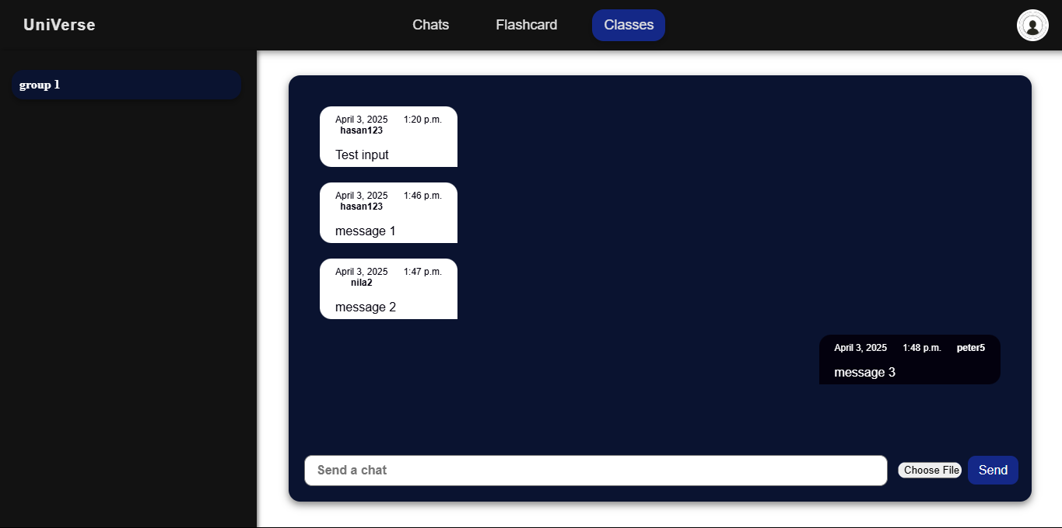

Message history conserved and displayed :

**Test passed**

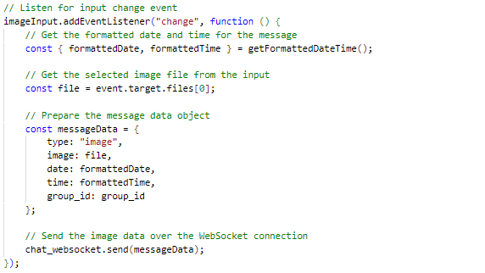**Enabling images to be sent using JavaScript:**

Event listener for uploaded image files

Get formatted time and date

Input file

Send data stored in a dictionary over WebSocket connection

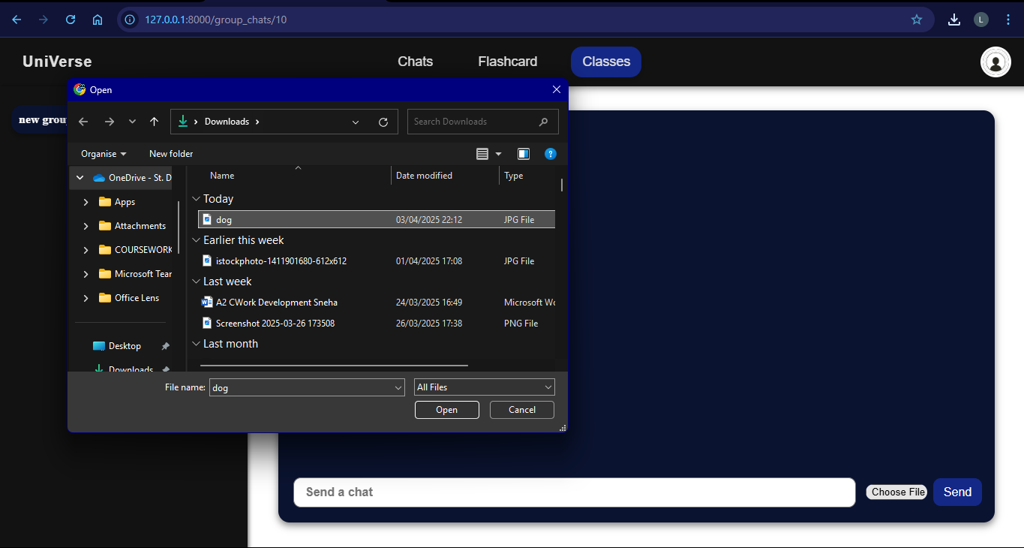**Test (36) : Testing to see if user can send pictures to group chats:**

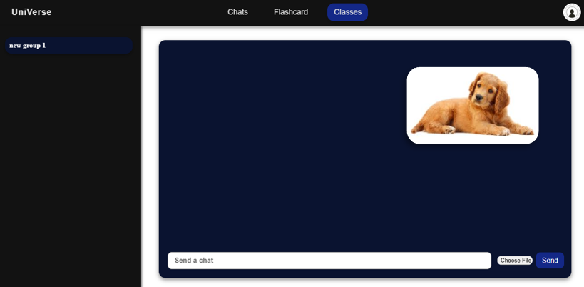

Image sent and displayed :

**Test passed**

### CLIENT FEEDBACK 6:

I demonstrated the complete group chat messaging system to my client Jack. Then I conducted an interview with him to check is he was happy with the functionality and appearance of the system and to ask for feedback.

**Interview:**

**Q1: Was the group chats page easy to use?**

A1: “The group chats page provided clear buttons and instructions to allow me to use the page along with the simple layout which I think will be appealing to the students.”

**Q2: Did you like the design of the website and the additional image sending feature?**

A2: “The design was similar to the chats page, which I think works well because it keeps a consistent theme and doesn’t feel overwhelming for the user. The additional image sending feature was also useful as students can share images to help each other with homework and studies in general.”

**Q3: Is there anything you would like me to change?**

A4: “Considering the group chats page had similar functionality to the chats page I don’t think there is anything you need to change and I am happy for you to continue with the project .”

**Client feedback review:**

The client seemed content with the group chats page and found the functionality of the page meeting all the requirements. The client did not need me to change anything and is happy for me to continue with the project.

### REVIEW 7:

Since my last review, I have built my group chats where users can create group chats and message multiple people in group chats. I have also created class group chats and automatically add users to their school classes. Along with messaging there is also a feature where users can send images to allow users to help each other with studies.

Next I will work on the flashcard page which will contain:

* Subject list for all flashcards as per **stakeholder survey #5**
* Flashcards per subject for user to learn as per **client interview #8**
* Quiz mode for each subject so user can test knowledge and earn points
* Leaderboard of different time schedule containing all user points

Once this is complete, I will get feedback from my client and make adjustments if necessary and move onto the last stage of my development.

## STAGE 8: CREATING THE FLASHCARDS SYSTEM:

**Creating FlashcardPoints model:**

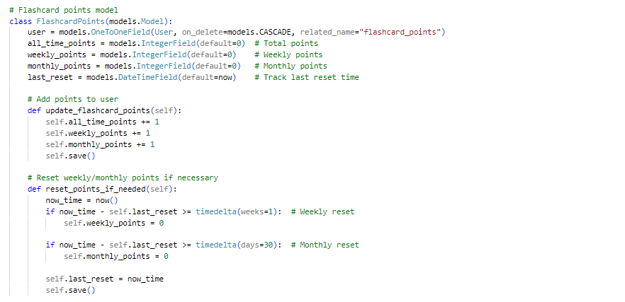

Field #1: “user”

Creates a foreign key linking user to flashcard points

Adds points to user when called

Field #2, #3, #4

Stored all-time, monthly and weekly points

Field #5 : “last_reset”

Stores last reset time when weekly and monthly points were reset

Resets monthly and weekly points if month or week passed since reset time

**Returning subject list and flashcards to frontend from views.py:**

Load subject data provided by client

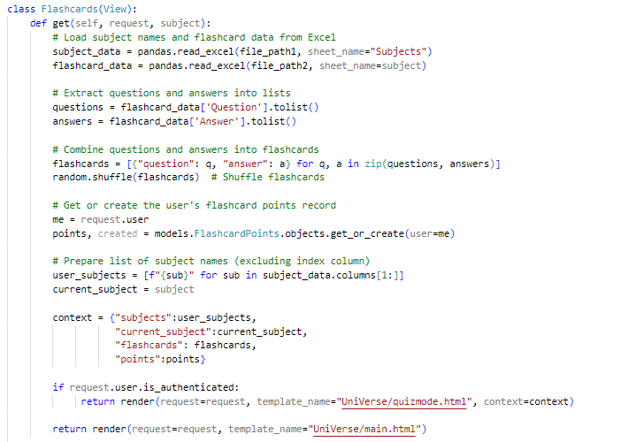

Load flashcards and extract and randomize questions and answers from it

Get or create flashcards points object

Validation:

Check if user is logged in before redirecting user to the page

Get current and all subjects

**Creating interactive flashcards using JavaScript:**

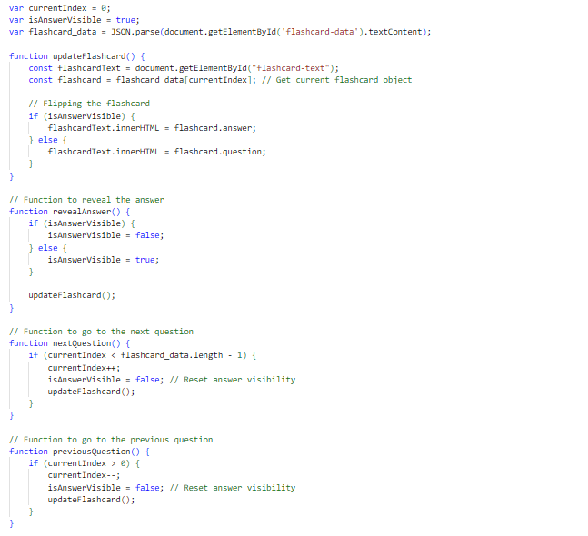

Get current flashcard

Flip the flashcard to show answer or question if answer is visible is true

If flashcard clicked make isAnswerVisible the opposite of its current value

If next question button clicked show next flashcard

If previous question button clicked show previous flashcard

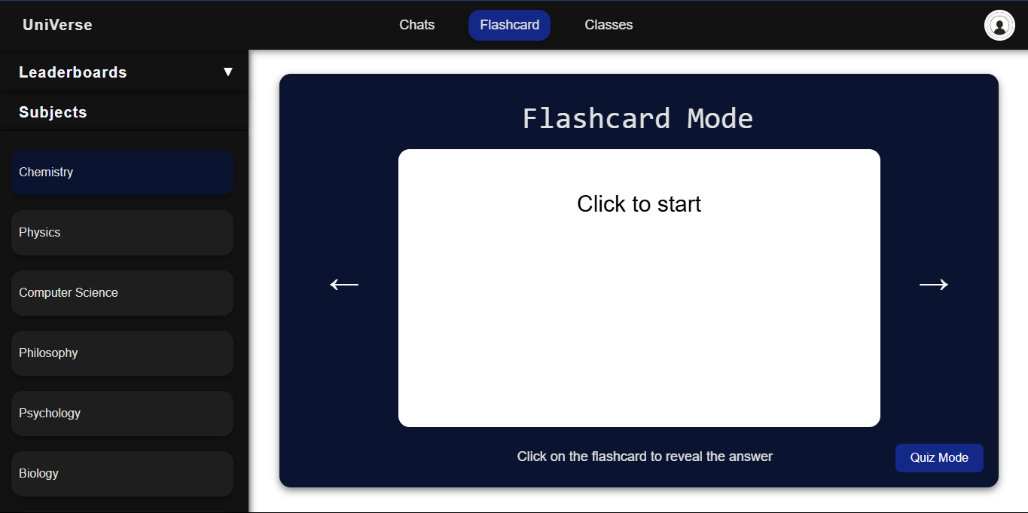**Test (37) : Testing if user can select subject and view flashcards:**

Testing if user can select subject

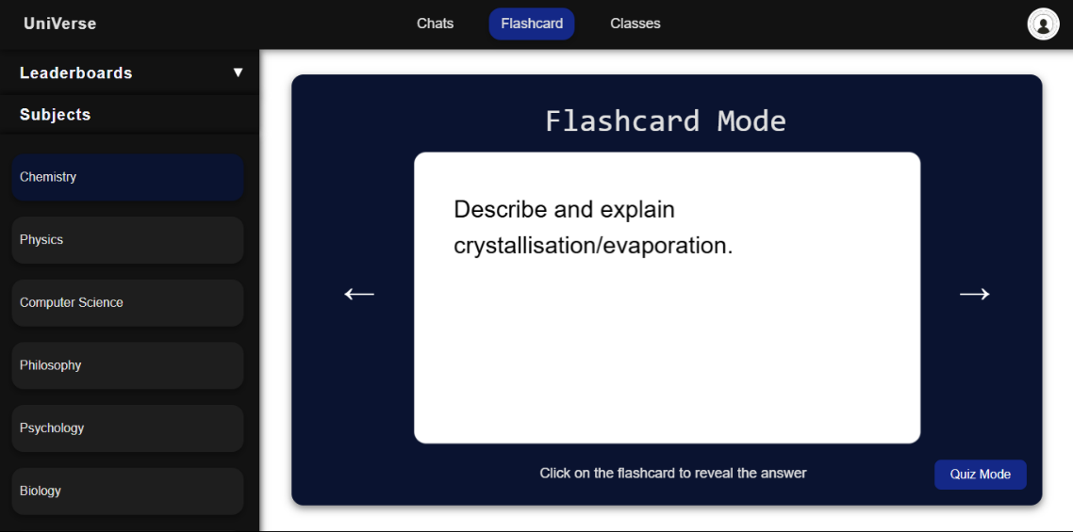

Testing if user can view flashcard

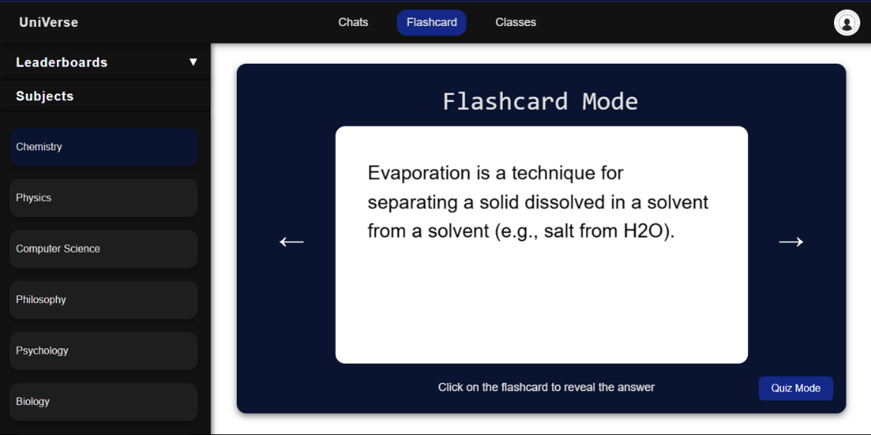

Testing if user can click and view answer

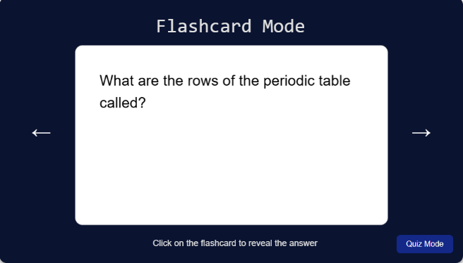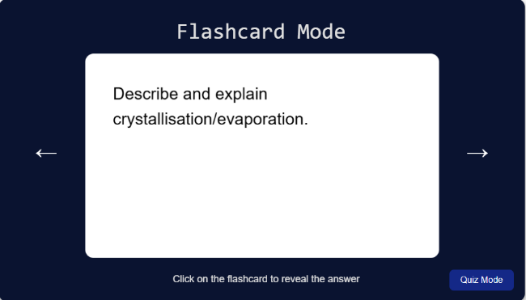

Testing if user can view next question

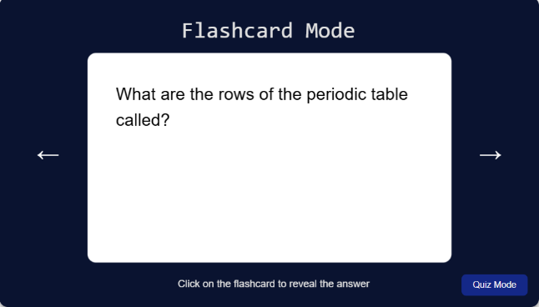

Testing if user can view previous question

User can select subjects and view flashcards and answers : **Test Passed**

**Implementing quiz mode using JavaScript:**

EDITING REVEAL ANSWER FUNCTION FOR QUIZMODE:

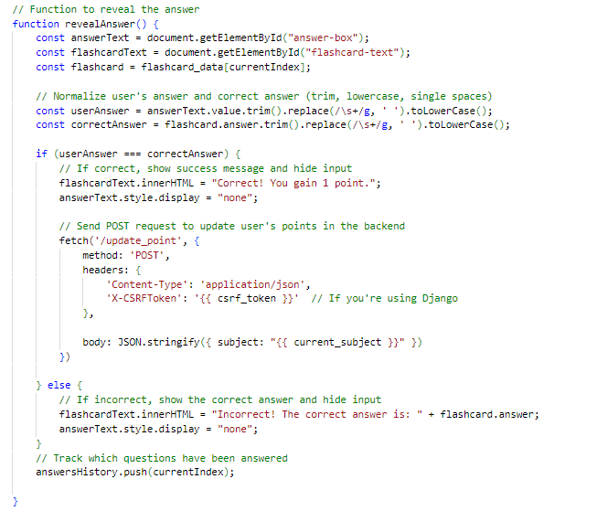

Get answer and question of flashcard

Normalize users answer

If correct answer display correct message and call update points function to add one point

If answer is incorrect display the correct answer

EDITING NEXT QUESTION FUNCTION FOR QUIZMODE:

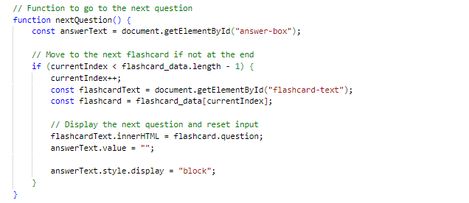

If it is not the last flashcard

Display next question and reset answer box

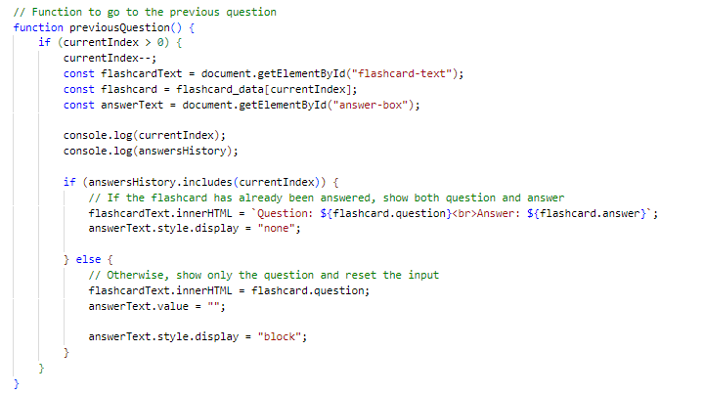EDITING PREVIOUS QUESTION FUNCTION FOR QUIZMODE:

Get flashcard number

If question answered show question and answer

If question not answered show question

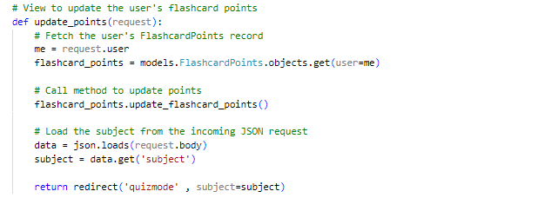**Creating update points function in views.py:**

Fetch flashcard points object

Update points using models function

Redirect to subject flashcard page

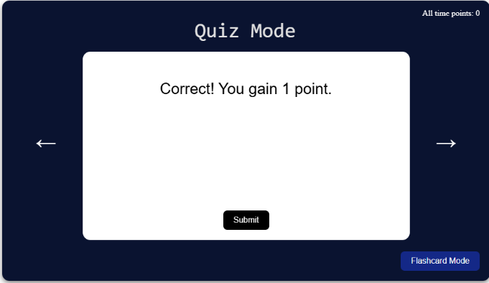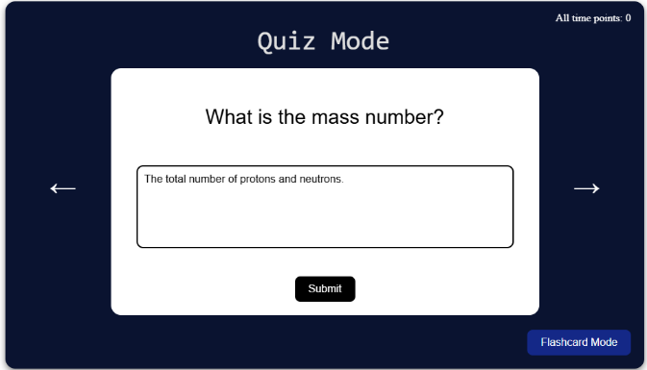**Test (38) : Testing if user can answer the flashcard in quiz mode:**

Answer is marked correctly however points are not updated in database :

**Test Failed**



**Correcting failed test (38):**

I miss typed the function name in JavaScript causing it to not be found:

FIXED CODE:

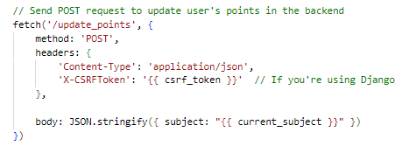

update_point changed to update_points



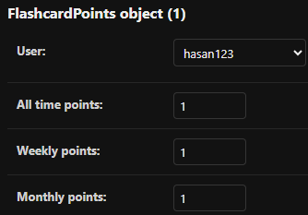

Function called and points updated so I will continue my test

I have been told my answer is incorrect and answer has been displayed

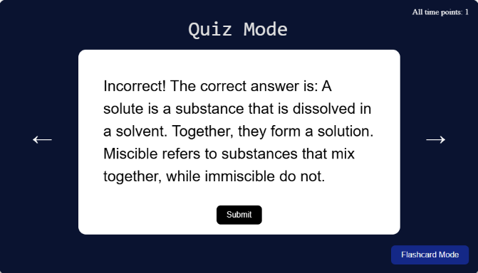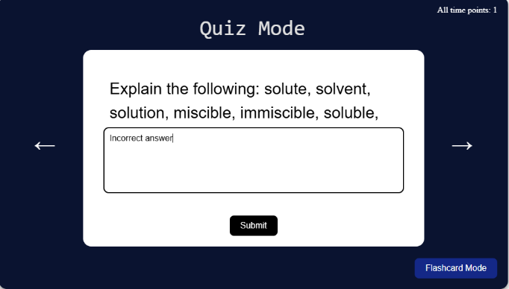TESTING INCORRECT ANSWER:

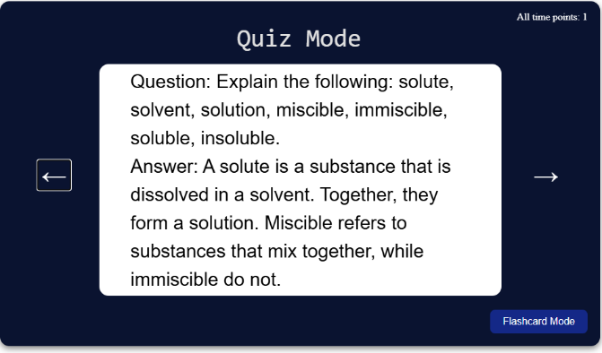TESTING PREVIOUS QUESTION BUTTON:

Answer and question displayed

The functionality of the test page works:

**Test Passed**

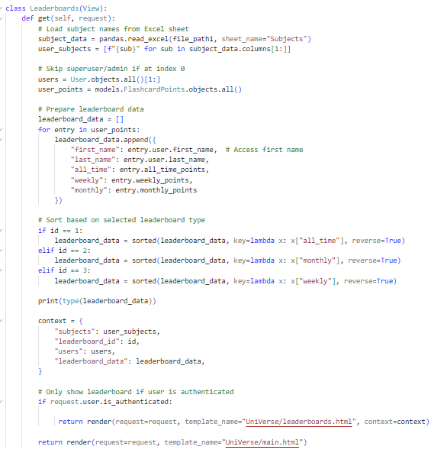**Returning user points to frontend from views.py:**

Load subjects from excel sheet

Exclude admin user from users and get rest of flashcard points objects

Create dictionary of user and his points for all users

Return data

Select type of leaderboard

**Validation:** Check if user is authenticated

**Test (39) : Testing if user can view all time leaderboard:**

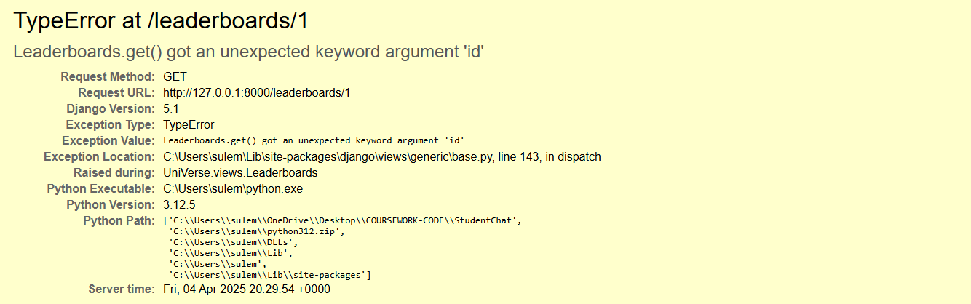

When I clicked on the all-time leaderboard this error was displayed : **Test Failed**

**Correcting failed test (39) :**

I was passing an id argument when calling the leaderboards get function however I did not put id in my parameters causing an error.

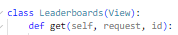FIXED CODE:

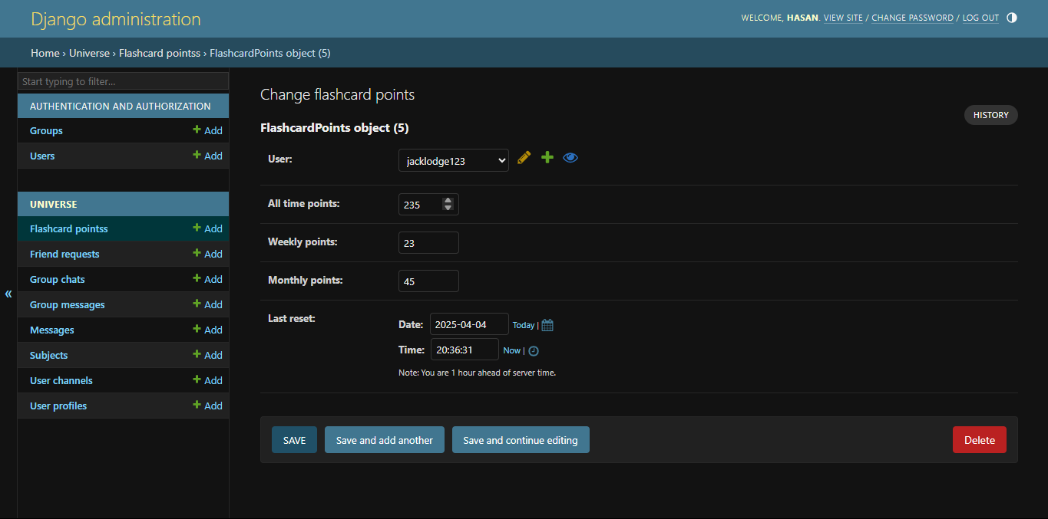

To test leaderboard I will manually add flashcard points objects

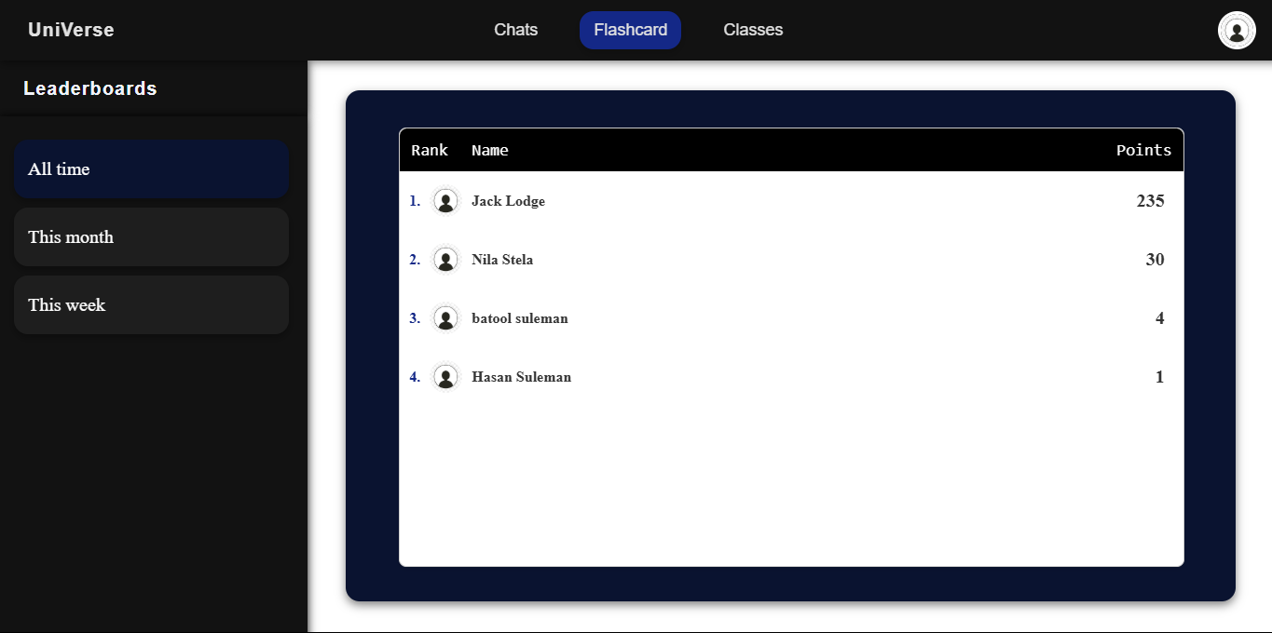

Leaderboard displayed in order of user all time points:

**Test Passed**

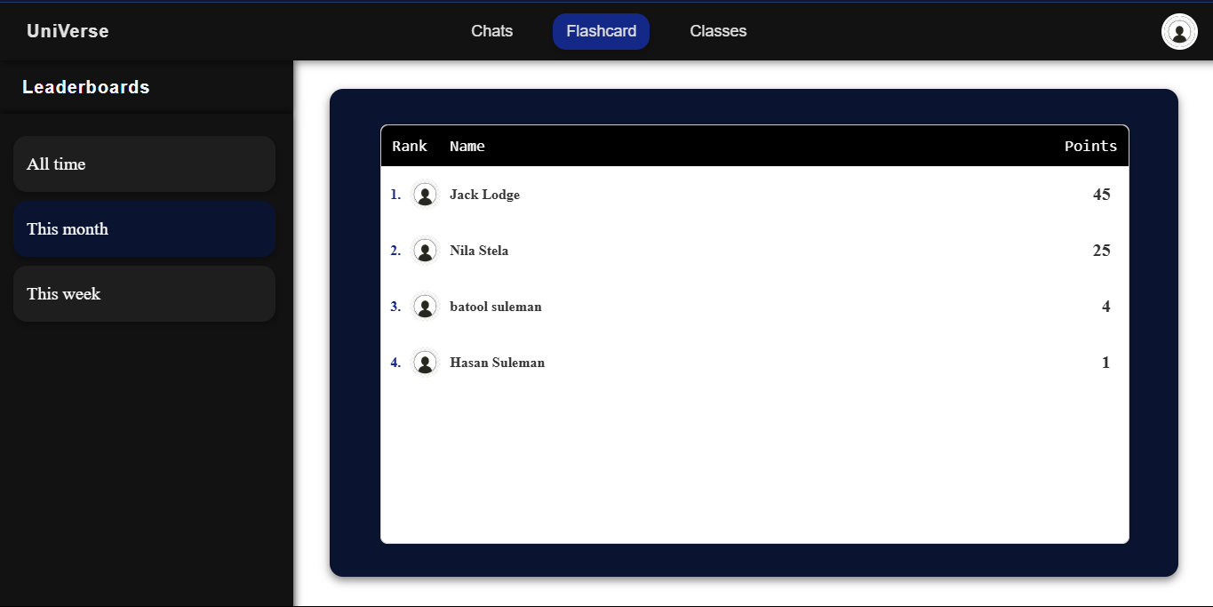**Test (40) : Testing if user can view monthly leaderboard:**

Leaderboard displayed in order of user monthly points:

**Test Passed**

**Test (41) : Testing if user can view weekly leaderboard:**

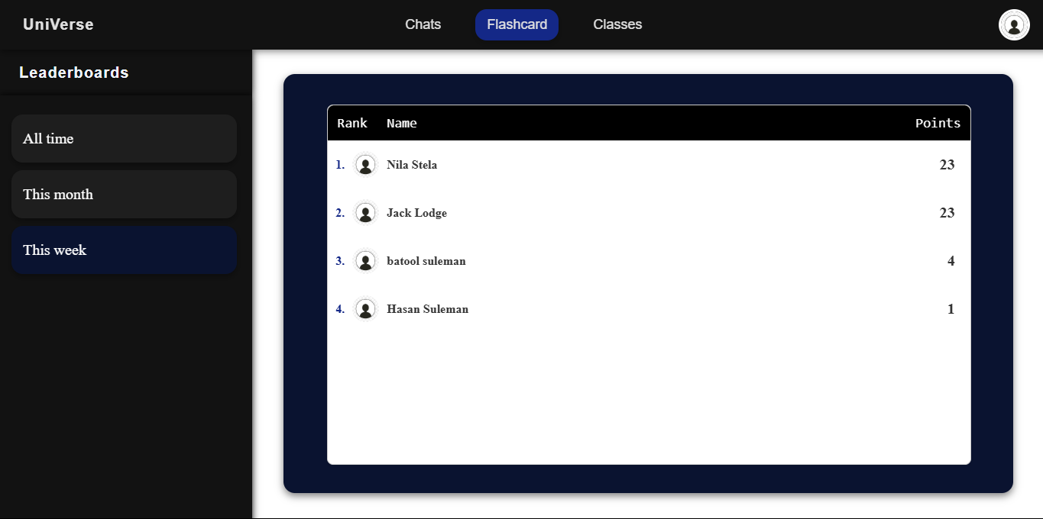

Leaderboard displayed in order of user weekly points:

**Test Passed**

### CLIENT FEEDBACK 7:

I demonstrated the complete flashcard system to my client Jack. Then I conducted an interview with him to check is he was happy with the functionality and appearance of the page and to ask for feedback.

**Interview:**

**Q1: Was the flashcards page easy to use?**

A1: “Yes, it was really easy to navigate. Everything was laid out in a simple and straightforward way, and the instructions made it clear what to do, so I didn’t feel lost at any point.”

**Q2: Did you like the design of the flashcard page and its appearance?**

A2: “Yeah, I liked the design a lot. It has a clean and minimal look, which makes it nice to use without feeling overwhelming. The flashcard layout was smooth, and the buttons for switching between flashcards and quiz mode were super clear and easy to find.”

**Q3: Did you like the functionality of the quiz mode and flashcards?**

A3: “Yeah, the functionality was great—everything worked smoothly, and it was easy to switch between quiz and flashcard mode. I liked how the answers were handled and how the system gave feedback right away.”

**Q4: Is there anything you would like me to change?**

A4: “I would like you to number the flashcards and quiz questions so the user knows how many he has done , but apart from that I am happy for you to continue on with the project.”

**Client feedback review:**

The client provided positive feedback on the flashcards page, highlighting its useful and appealing functionality i.e.: the flashcard mode and the quiz mode for each subject. They also liked the appearance and clear instructions allowing the user to navigate the page with ease.

However she wanted an adjustment:

* Number the flashcards and quiz questions

This will allow the user to track the amount of work he/she has done.

**Client feedback adjustments:**



Update the flashcard number when flashcard is updated

Add flashcard number in html



**Testing if client feedback adjustments work:**

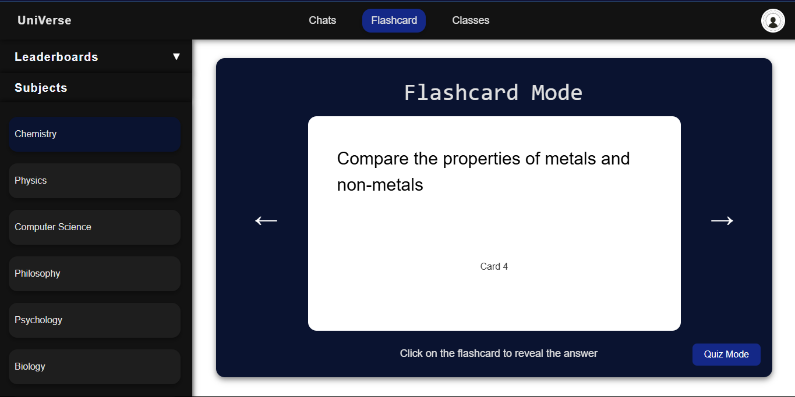

Flashcard number displayed :

**Test Passed**

### REVIEW 8:

Now the flashcards page has been completed the user can learn using flashcards and test their knowledge using the quiz mode competing with other users for points creating a competitive addition to the website. I have also responded to the client feedback whose suggestions improved my website.

Next I will work on the profile page which will contain:

* Option to view and edit user details as per **stakeholder survey #3**
* Option to search for users and send friend requests
* Friend suggestions displayed with links to other user profiles as **per client interview #4**
* The ability for the user to log out
* Option for user to delete their account

Once I have completed this, I will get feedback from my client and make adjustments if necessary and will be finished with my development stages.

## STAGE 9 : CREATING THE PROFILE PAGE:

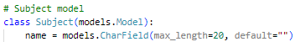**Creating subjects model:**

**Validation:**

Max length of 20 characters

Field #1 : “name”

Contains the name of the subject

**Editing user profile model:**

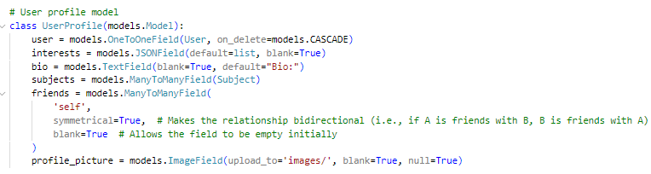

Field #3 : “bio”

Contains the biography of the user

Field #4 : “subjects”

A many to many relationship field allowing users to have multiple subjects

**Sending user details to display on frontend from views.py:**

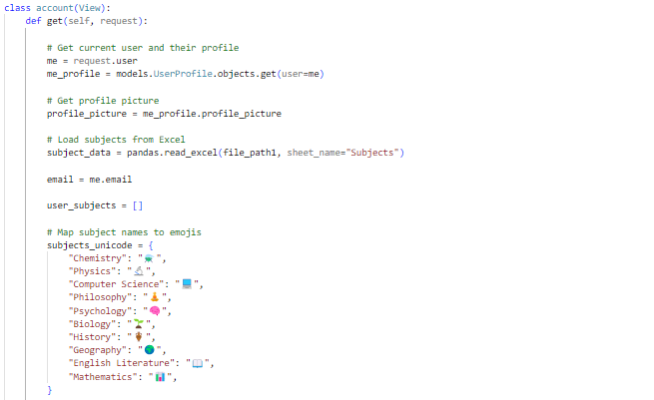

Get current user profile and profile picture

Load subject data from excel sheet provided by client

Create dictionary with subject name along with symbol

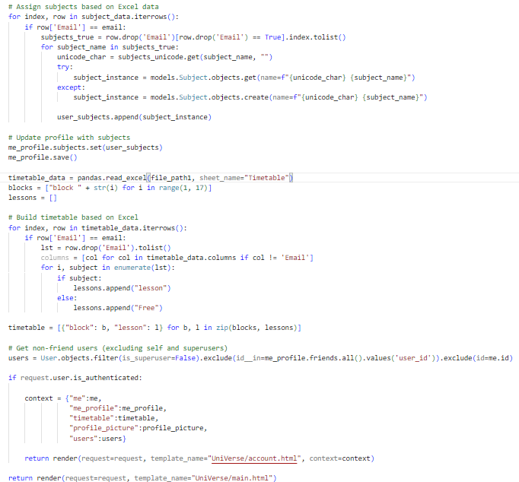

TRUE means user has lesson and FALSE means user has a free period. Using this we create a 2d list with each list containing block number and lesson or free

Check subjects user does filtering users through email

**Validation:**

Check if user is logged in

Get all users excluding current user and super user(Django admin account)

Save changes made after adding subjects to current user profile

**Implementing functions in JavaScript to enable user search pop up:**

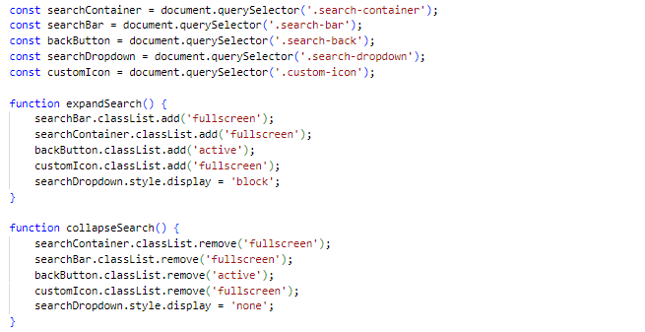

Get all HTML elements required to enable user search pop up

To expand search make search container full screen

To remove search remove the container

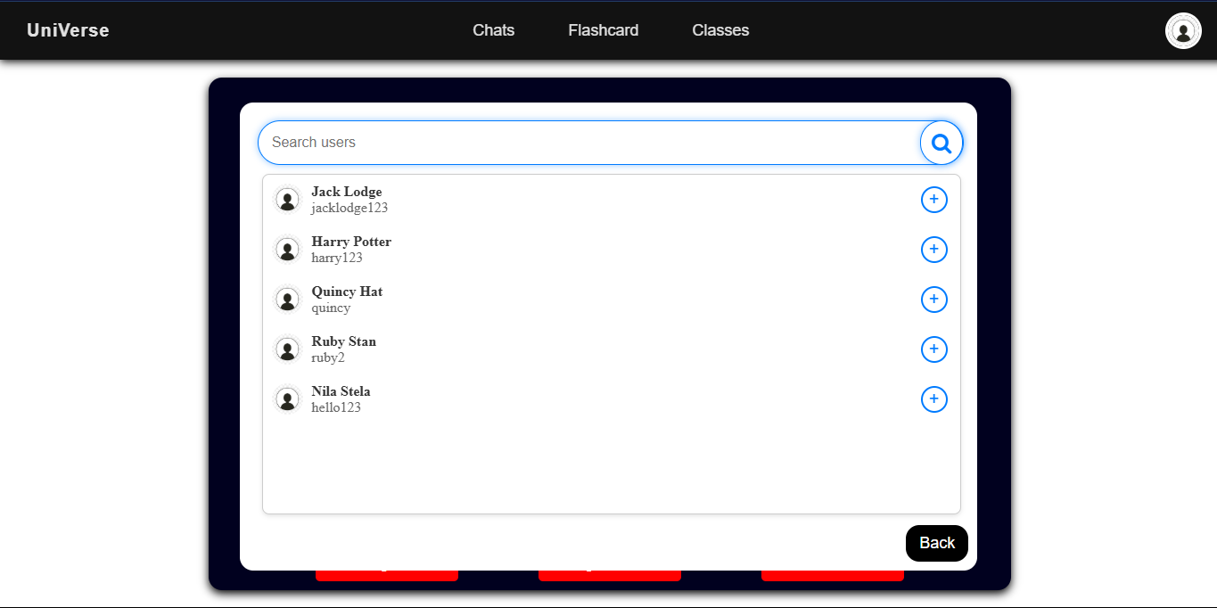**Test (42) : Testing to see if user can view all users:**

User can view all users:

**Test Passed**

**Functions allowing user to change details:**

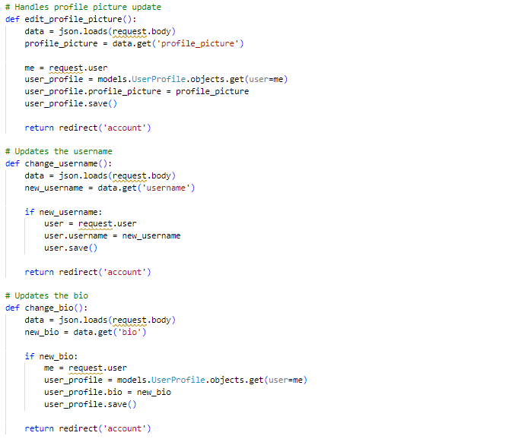

Fetch profile picture uploaded from front end

Add to user profile and save

Load new username entered from front end

**Validation:**

Check if username has changed if it has update database and save

Load new biography entered from front end

**Validation:**

Check if biography has changed if it has update database and save

**Using JavaScript to allow user to edit user details:**

EDITING PROFILE PICTURE:

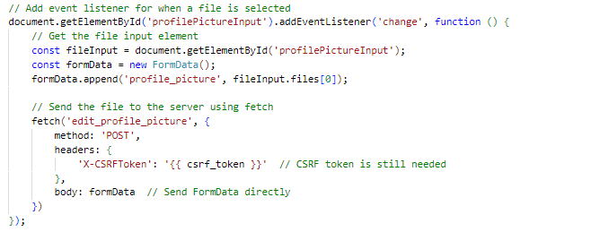

Get profile picture uploaded in form when input changed

Call edit profile picture function and input profile picture into it

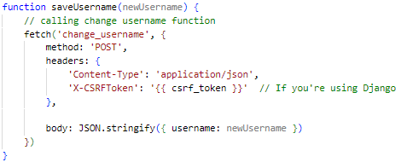EDITING USERNAME:

Call change username function and input new username into it

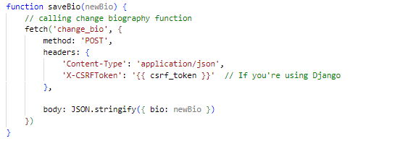EDITING BIOGRAPHY:

Call change biography function and input new biography into it

**Test (43) : Testing to see if username can be updated:**

Error message displayed : **Test Failed**

**Correcting failed test (43):**

The error occurred because I had forgotten to pass the request argument in the change username function along with the other functions.

FIXED CODE:

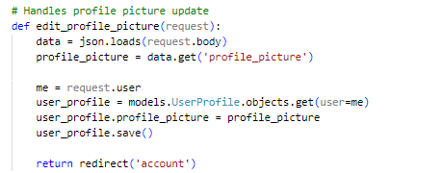

Request passed as argument (did with other functions as well)

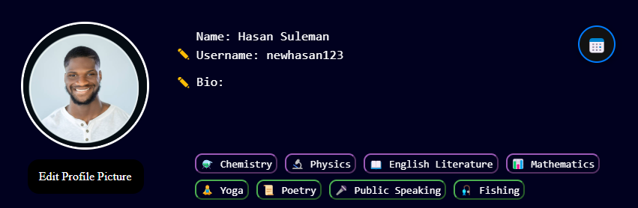

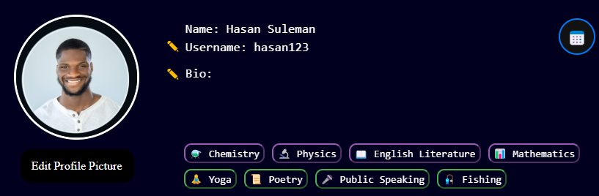

Username changed : **Test Passed**

**Test (44) : Testing to see if biography can be updated:**

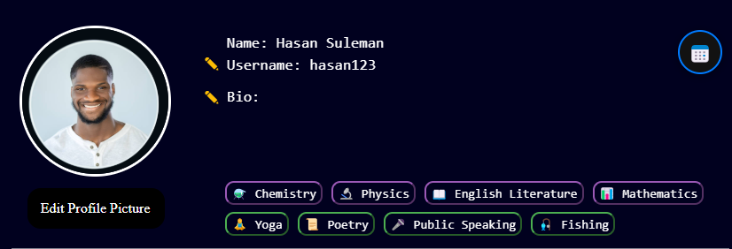

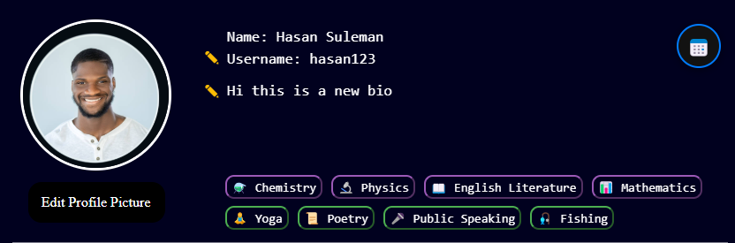

Biography changed : **Test Passed**

**Test (45) : Testing change profile picture button:**

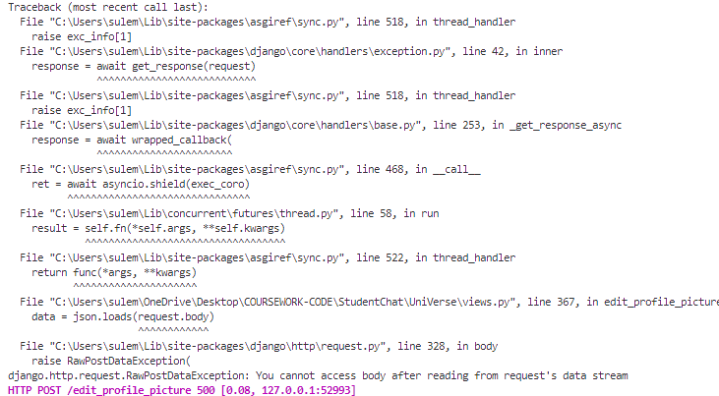

Error message displayed

**Test Failed**

**Correcting failed test (45):**

After doing a little research if figured that file uploads (like profile pictures) are sent as multipart/form-data, not JSON, so trying to json.loads(request.body) on it will raise an error. Instead you should do the following:

When a file is uploaded via a <form> or JavaScript FormData, Django puts the uploaded file into request.FILES, not request.body.



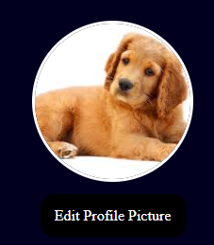

Profile picture changed :

**Test Passed**

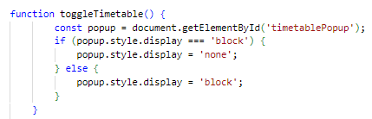**Using JavaScript to create a timetable pop up:**

Displays pop up when timetable button clicked

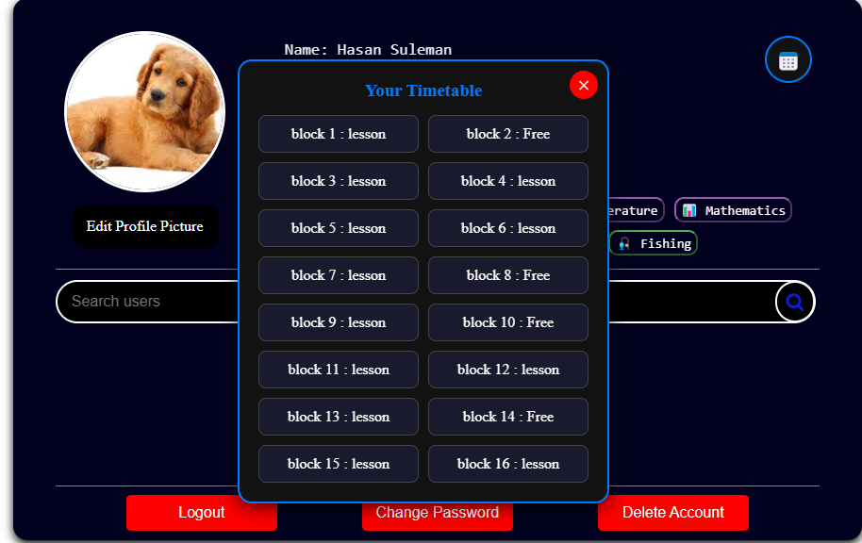**Test (46) : Testing timetable button:**

Timetable displayed

**Test Passed**

**Enabling change password system:**

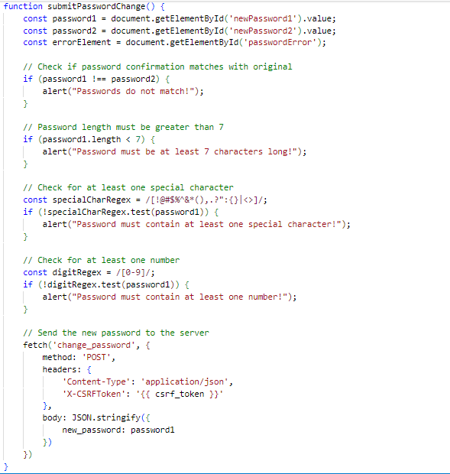JAVASCRIPT VALIDATION AND CALL CHANGE PASSWORD FUNCTION:

Get password and password confirmation inputs

**Validation:**

Check if password and password confirmation are the same to prevent typing errors

**Validation:**

Check if password length is greater than 7

**Validation:**

Check if password contains at least one special character

**Validation:**

Check if password contains at least one number

Call change password function while inputting in new password

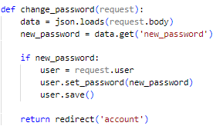CHANGE PASSWORD FUNCTION IN BACKEND, VIEWS.PY:

Load data from frontend and get new password

Change user password

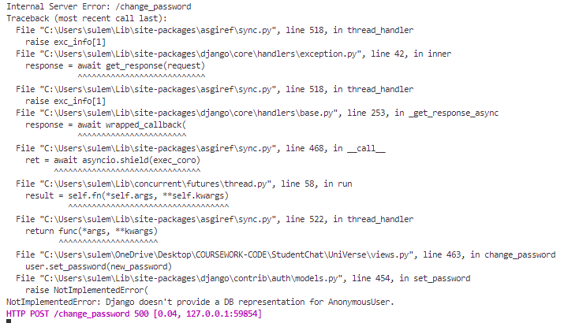**Test (47) : Testing change password button:**

Error message displayed

**Test Failed**

**Correcting failed test (47):**

The problem was when changing the user password it would log out the user and hence when trying to save the new password Django could not do so as user was not logged in.

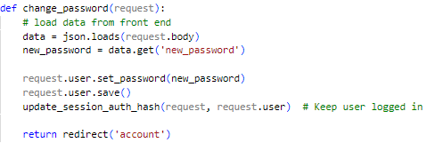FIXED CODE:

Keeps user logged in

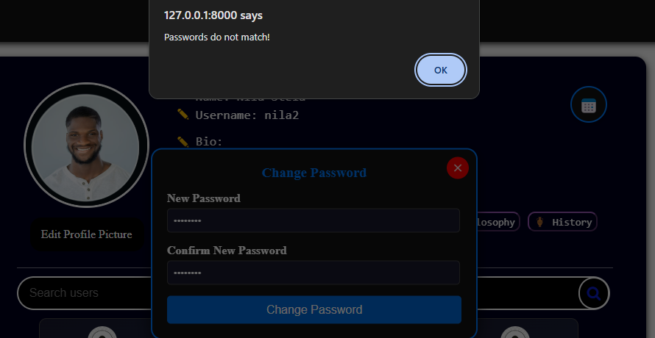TESTING TYPING ERROR VALIDATION:

Error message displayed when Typing error occurs between password and confirm password

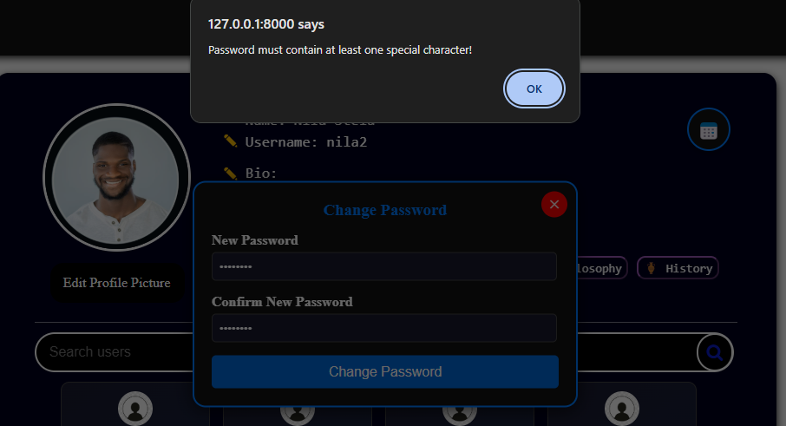TESTING SPECIAL CHARACTER VALIDATION:

Error message displayed when special character not in password

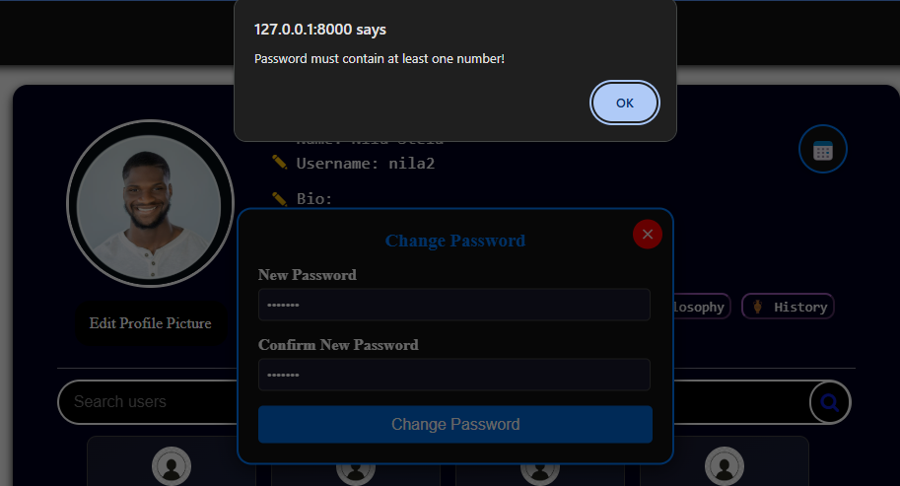TESTING NUMBER VALIDATION:

Error message displayed when number not in password

TESTING CHANGE IN PASSWORD:

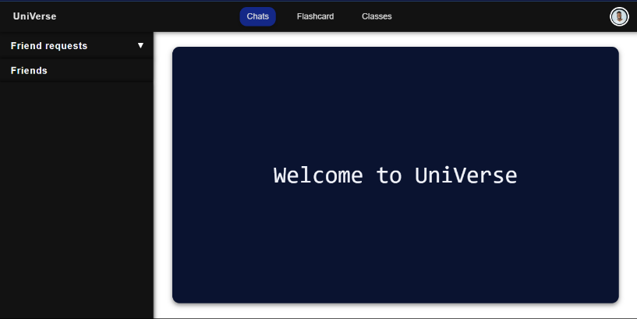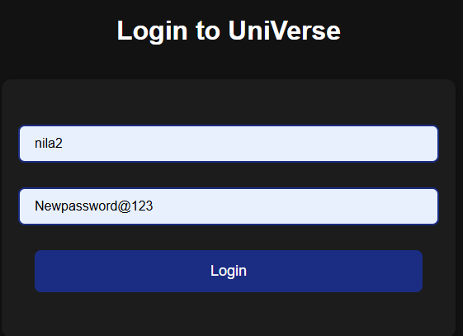

User logged in and redirected to home page

User password changed with validation working : **Test Passed**

**Creating a function to allow the user to send friend requests:**

FUNCTION IN VIEWS.PY:

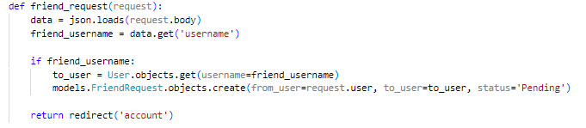

Load user you want to adds username from front end

Add friend request to user profile model with status pending

CALLING FUNCTION IN JAVASCRIPT:

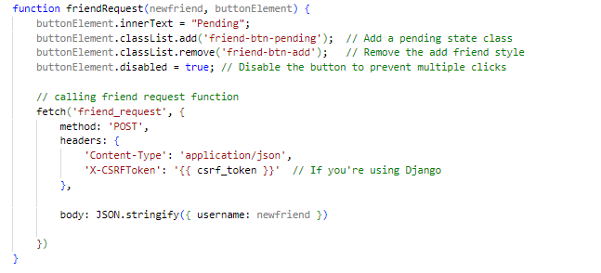

Change add button text to pending and disable button

Call friend request function and input user you want to add into it

**Test (48) : Testing if user can send friend requests:**

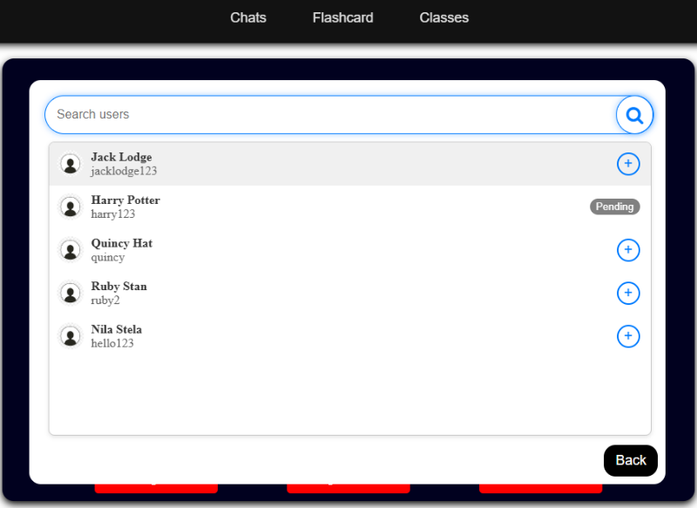

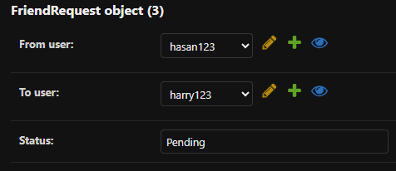

Friend request sent

**Test Passed**

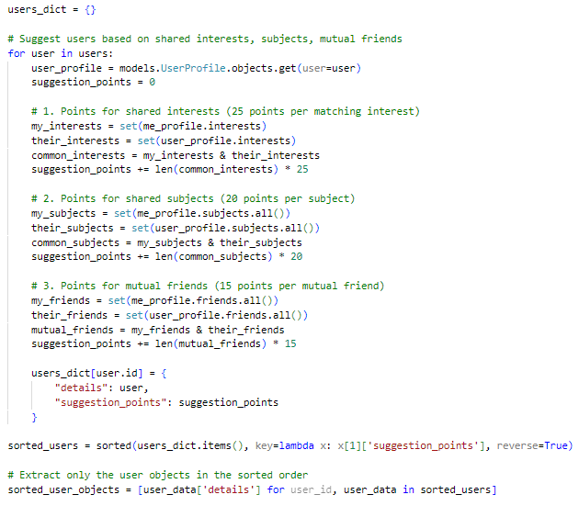**Creating a friend suggestion algorithm:**

Get user profile for each user

Add 25 points for each mutual interest

Add 20 points for each mutual subject

Add 20 points for each mutual friend

Sort users based on suggestion points (will be put into context)

**Test (49) : Testing to see if user friend suggestions displayed:**

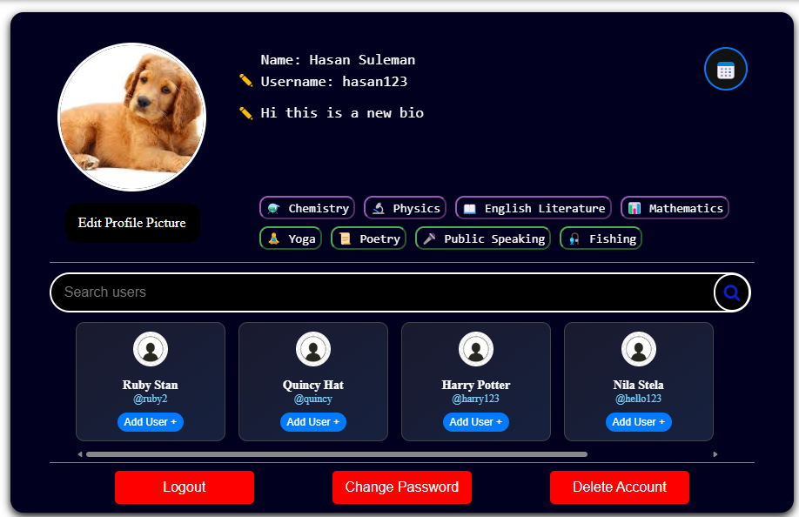I have made the user ruby stan have the most mutual subjects etc. so friend suggestions should be displayed with her first.

Friend suggestion displayed in correct order

**Test Passed**

**Allowing user to log out:**

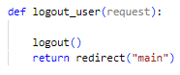

Function inside account class which log user out of their account

**Test (50) : Testing if user can log out:**

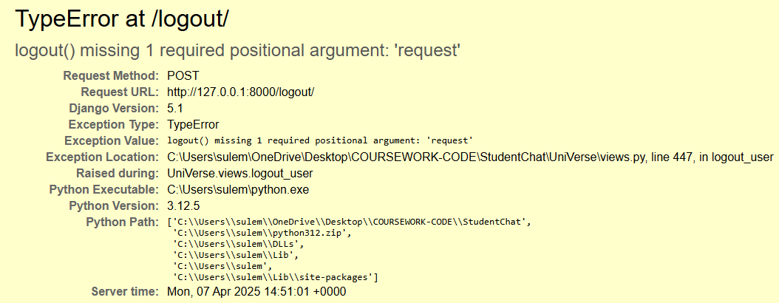

Error message displayed

**Test Failed**

**Correcting failed test (50):**

I forgot to put the request argument in logout()

FIXED CODE**:**

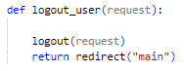

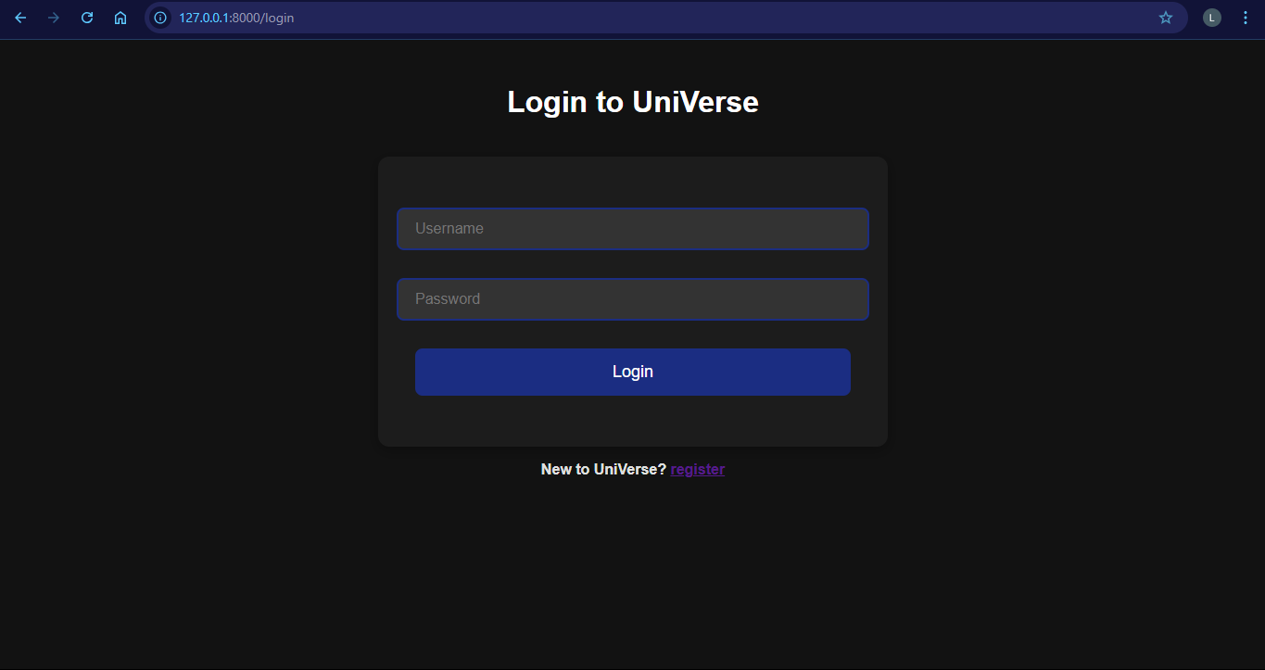

User redirected to login page and logged out

**Test Passed**

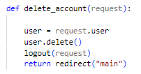**Allowing user to delete their account:**

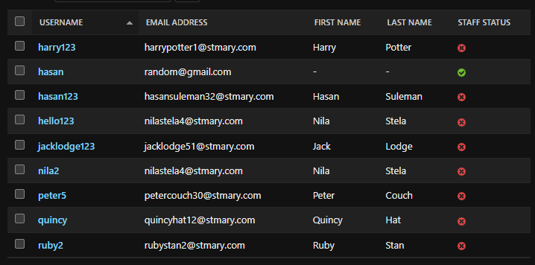**Test (51) : Testing if user can delete account:**

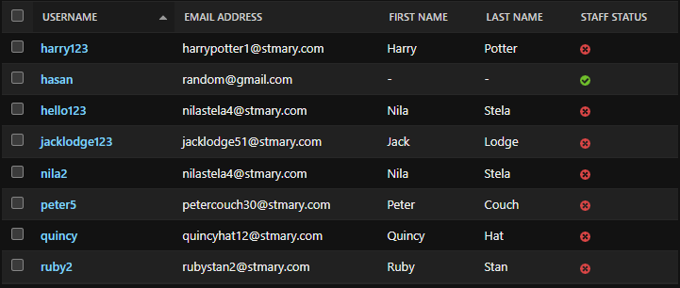

User hasan123 deleted : **Test Passed**

### CLIENT FEEDBACK 8:

I demonstrated the complete profile page to my client Jack. Then I conducted an interview with him to check is he was happy with the functionality and appearance of the system and to ask for feedback.

**Interview:**

**Q1: Was the profile page easy to use?**

A1: “The profile page provided clear buttons and instructions to allow me to use the page along with the simple layout which I think will be appealing to the students.”

**Q2: Did the friend suggestion algorithm meeting your requirements?**

A2: “Yes, the friend suggestion algorithm met my requirements well. It suggested people based on shared interests, subjects, and mutual friends, which made the recommendations feel relevant and personal.”

**Q3: Do you feel the system worked reliably?**

A3: “Yes, it didn’t crash or freeze. It worked smoothly when I uploaded my profile picture, changed my bio, and browsed users.”

**Q4: Did the system meet your expectations overall?**

A4: “Yes, it did. I wanted something that helped me connect with like-minded people in a simple way, and it did exactly that.”

**Q5: Is there anything you would like me to change?**

A5: “No I think you have don’t a good job with the profile page and this project in general and I am happy with it.”

**Client feedback review:**

The client seemed content with the profile page and found the functionality of the page meeting all the requirements hence the client did not want me to change anything.

### REVIEW 7:

Over the course of developing this project I have created a social media platform which provides private messaging along with group chat messaging. I have also created educational features such as classes group chats and flashcards. The profile page we just developed allows users to add friends and view other users along with editing their own details.

I have now finished developing the website and my client is happy. I can now start evaluating the solution.

# EVALUATION:

## POST DEVELOPMENT TESTING:

The following tests will be done to check whether the program has met the success criteria after development. These tests will test the **function** and **robustness** of the program and will also provide annotated evidence for usability features. I will be using post development tests as defined in the design section:

| No. | Feature | Justification | Input/How to test | Result/Evidence |
| --- | --- | --- | --- | --- |
| 1 | Allow user to login. | Client interview Q6  All website analysis | Email: [nilastela4@stmary.com](mailto:nilastela4@stmary.com)  password:WhiteLion@34  Email: [123@gmail.com](mailto:123@gmail.com)  password:ting123 | If the user enters the correct email and password, they will be redirected to the homepage |

**TESTING CORRECT DETAIL LOGIN**

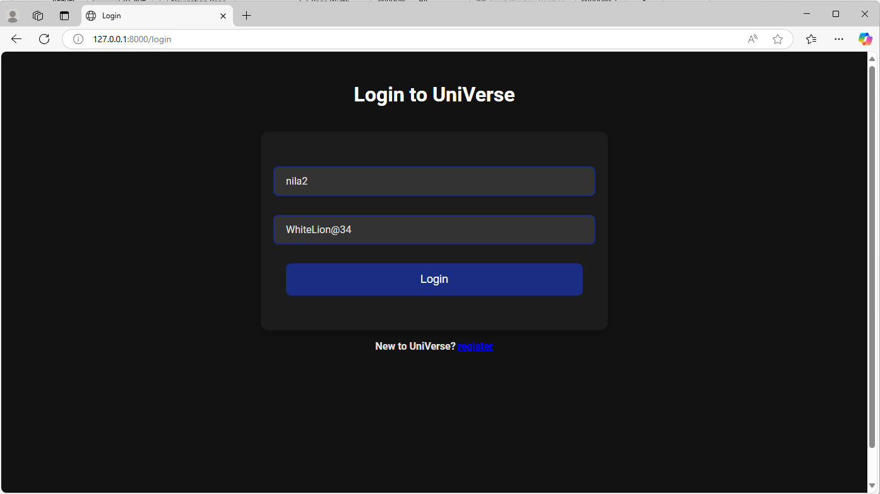

Testing **function** of login page using user account login with correct details

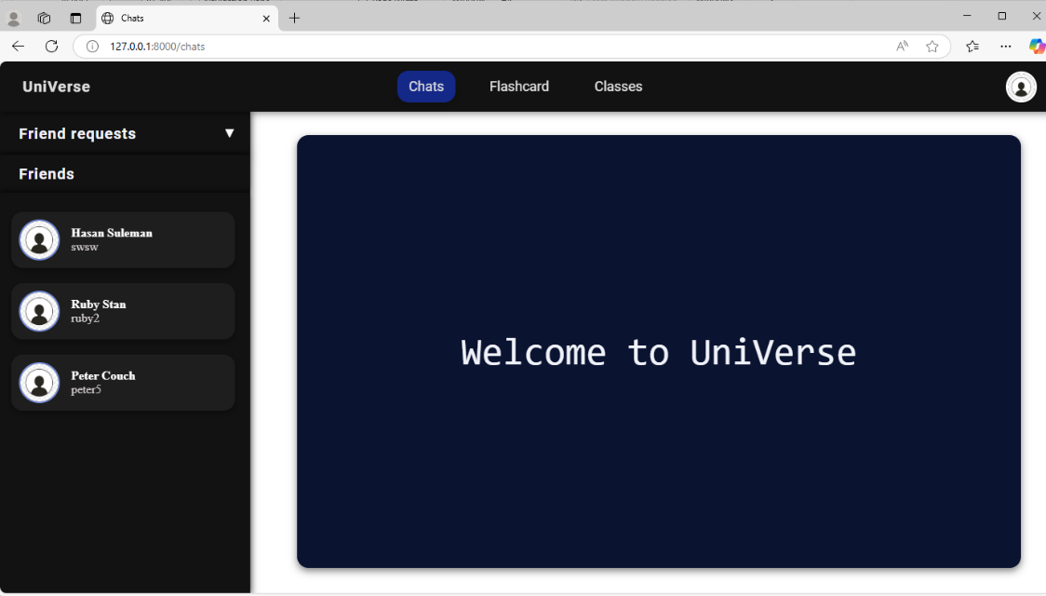

User logged in and redirected to home page

**TESTING ERRONEOUS DETAILS:**

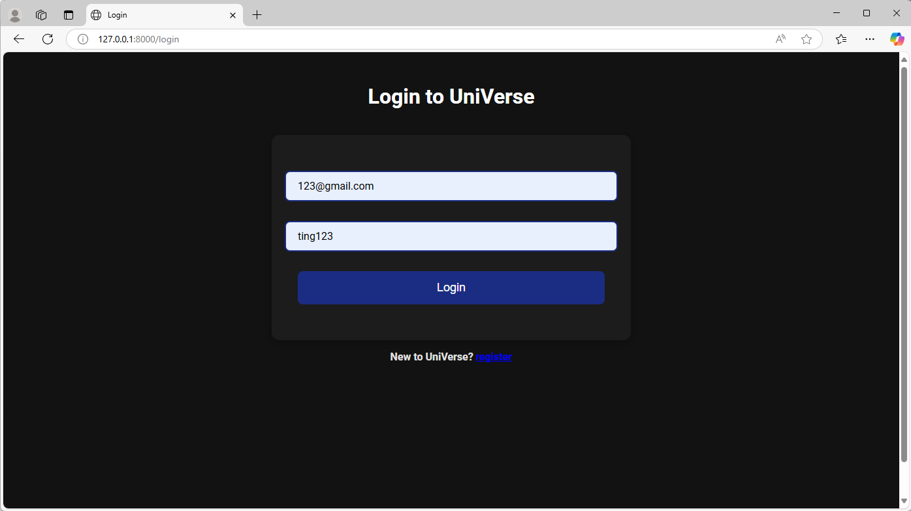

Testing **function** of login page using user account login with erroneous details

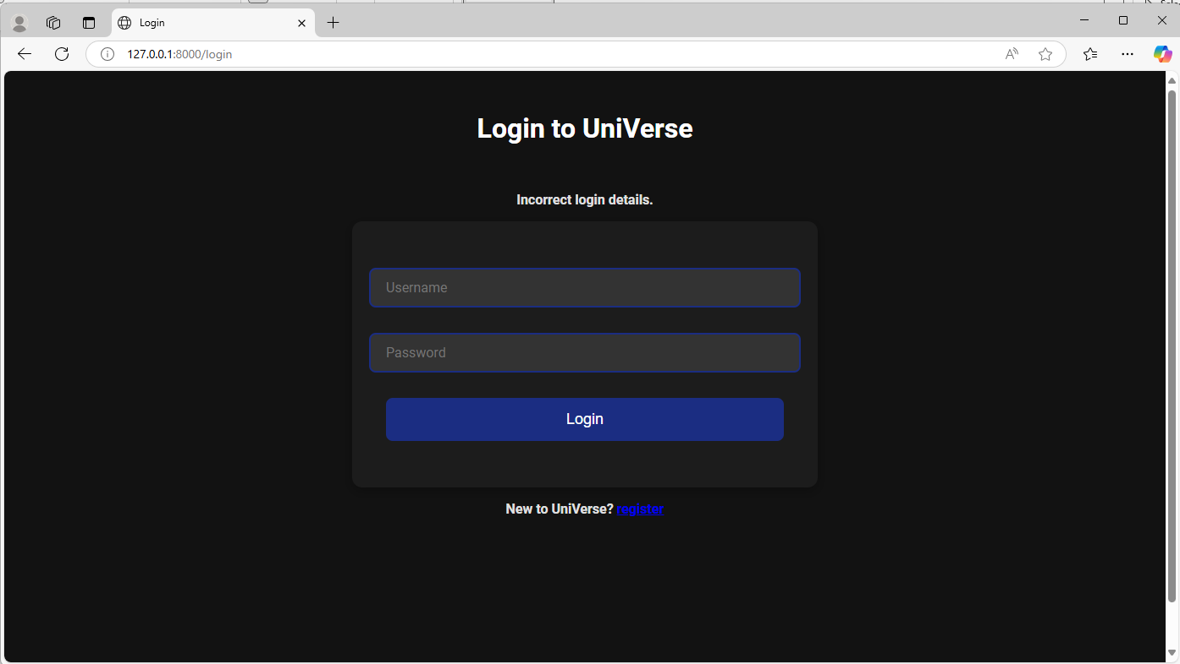

Error message displayed providing **robustness** for program

**Evidence provided** that user can login if they enter valid details : **Test Passed**

|  |  |  |  |  |
| --- | --- | --- | --- | --- |
| No. | Feature | Justification | Input/How to test | Result/Evidence |
| 2 | Allow user to create account. | Client interview Q6  All website analysis | Email: [nilastela4@stmary.com](mailto:nilastela4@stmary.com)  password:WhiteLion@34  Erroneous:  -enter non school email address and password | The user can create an account with their email, username and password and then will be redirected to the interests page after successful creation |

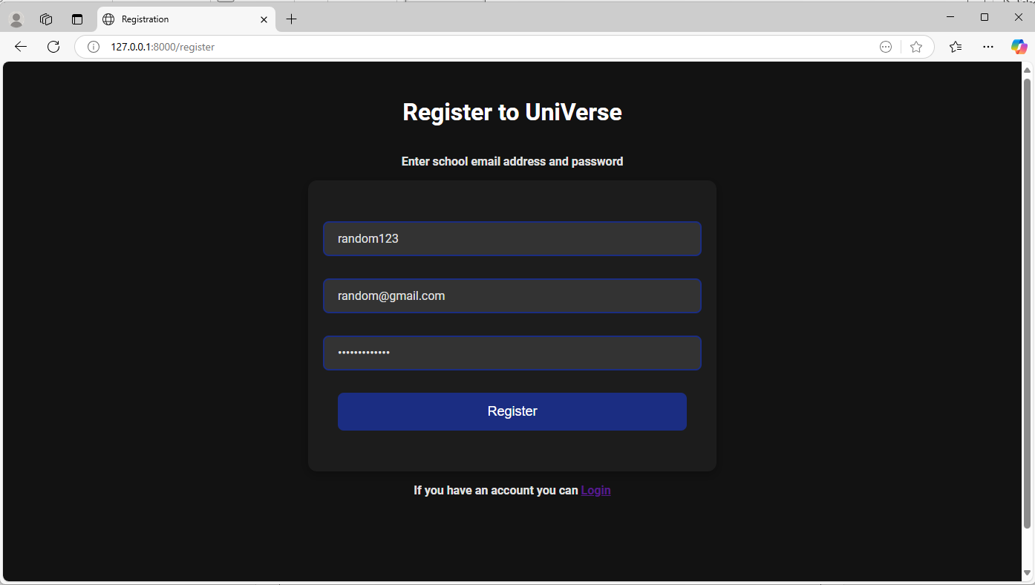**TESTING ERRONEOUS DETAILS:**

Testing **function** of registration page using user account registration with erroneous details

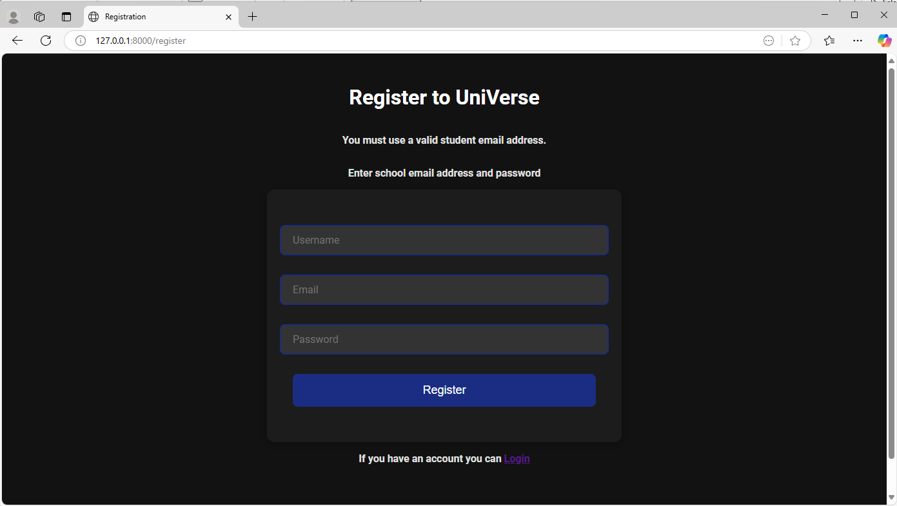

Error message displayed providing **robustness** for program

**TESTING CORRECT REGISTERATION DETAILS:**

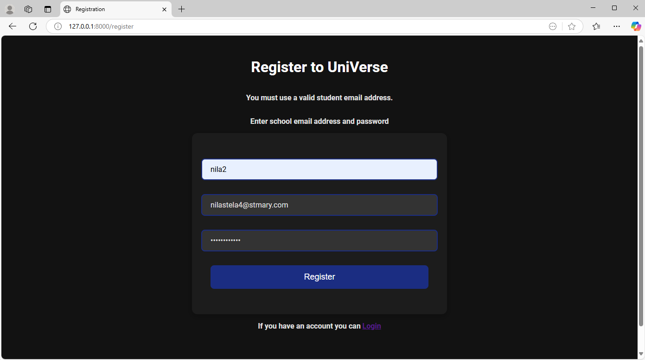

Testing **function** of registration page using user account registration with correct details

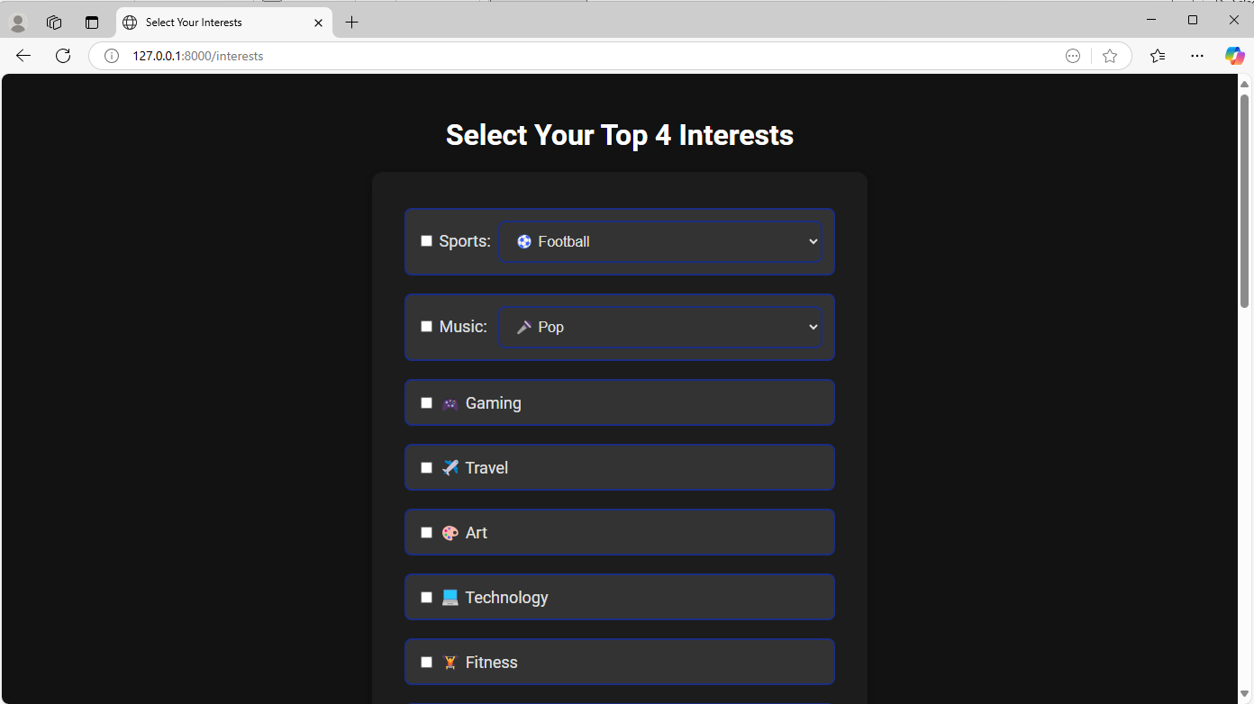

User registered in and redirected to interests page

**Evidence provided** that user can register an account if they enter valid details : **Test Passed**

|  |  |  |  |  |
| --- | --- | --- | --- | --- |
| No. | Feature | Justification | Input/How to test | Result/Evidence |
| 3 | Allow user to log out. | All Website analysis | Click logout button | User will be directed to login page and logged out. |



Testing **function** of logout button

Logout button clicked

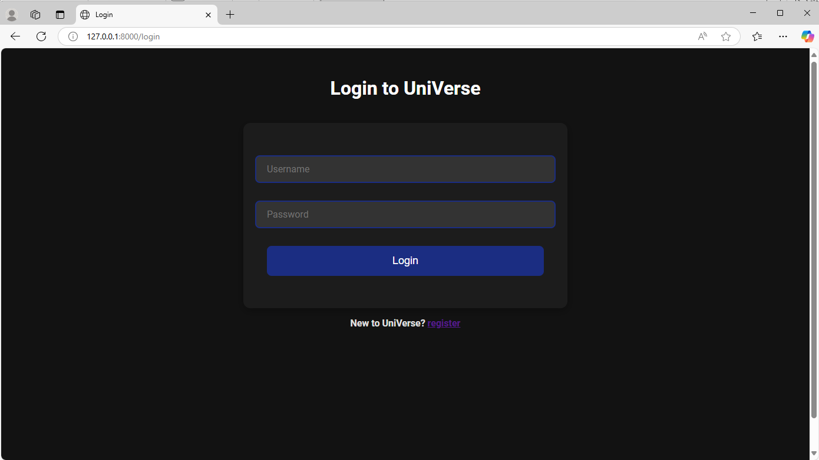

User logged out and redirected to login page

**Evidence provided** that user can log out : **Test Passed**

|  |  |  |  |  |
| --- | --- | --- | --- | --- |
| No. | Feature | Justification | Input/How to test | Result/Evidence |
| 4 | Option to change details (username, biography, profile picture) | Website analysis 1 & 2  Stakeholder survey Q3 | username: “testuser”  Biography: ”hi”  Change profile picture button clicked. | Details updated on profile page. |

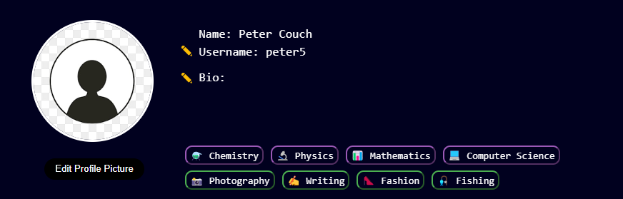TESTING **FUNCTION** OF CHANGE USERNAME BUTTON:

Username edit button clicked

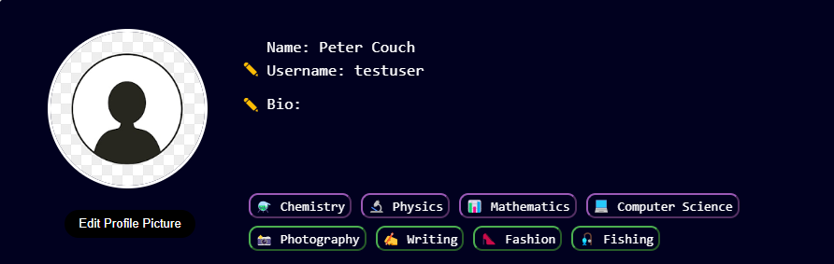

Username updated showing **robustness**

TESTING **FUNCTION** OF CHANGE BIOGRAPHY BUTTON:

Biography edit button clicked

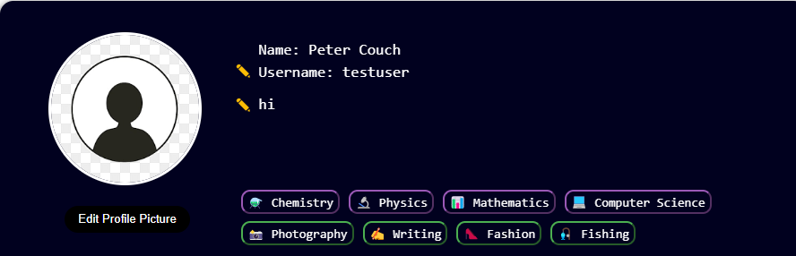

Biography updated showing **robustness**

TESTING **FUNCTION** OF CHANGE PROFILE PICTURE BUTTON:

Profile picture edit button clicked

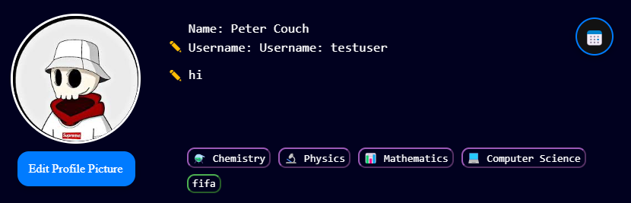

Profile picture updated showing **robustness**

**Evidence provided** that user can change his details : **Test Passed**

|  |  |  |  |  |
| --- | --- | --- | --- | --- |
| No. | Feature | Justification | Input/How to test | Result/Evidence |
| 5 | Option to delete account | Website analysis 1 & 2 | Delete account button clicked. | User will be redirected to login page and details will be removed from database. |



Testing **function** of delete account button

Delete account button clicked

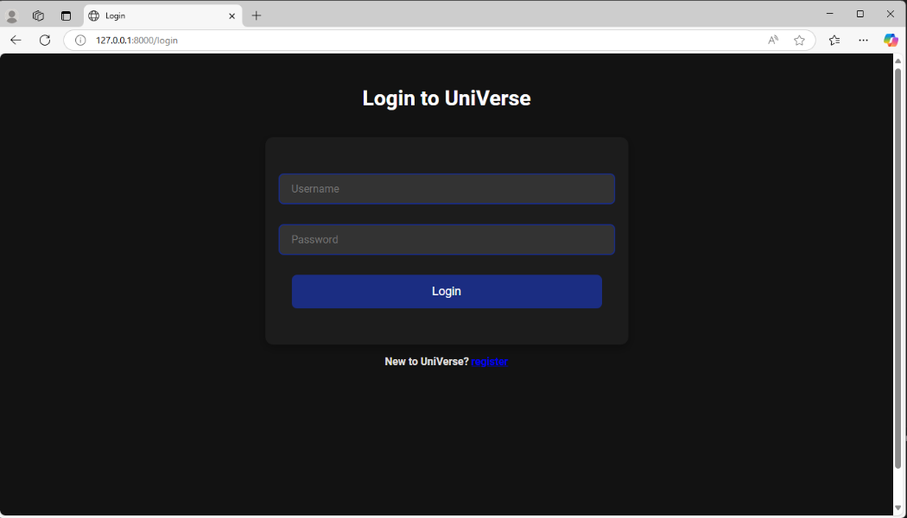

User redirected to login page

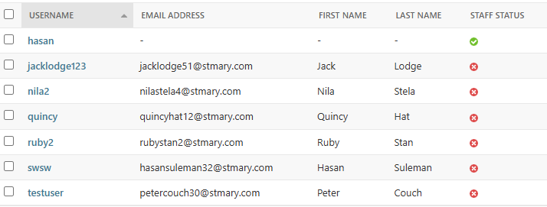

User account deleted not in database maintaining referential integrity for **robustness**

**Evidence provided** that user can delete account : **Test Passed**

|  |  |  |  |  |
| --- | --- | --- | --- | --- |
| No. | Feature | Justification | Input/How to test | Result/Evidence |
| 6 | Displays interactive flashcards for each subject. | Client interview Q8  Stakeholder survey Q5 | Click on interactive flashcards. | Notes will be displayed per subject. |

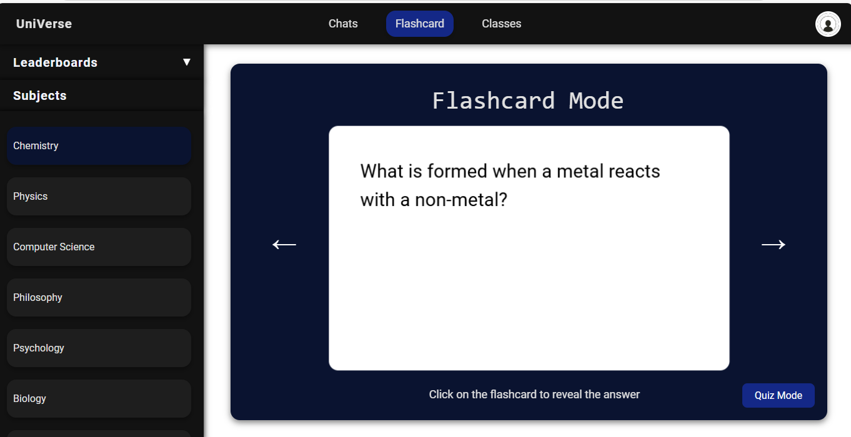

Testing **function** of flashcards

Flashcard displayed

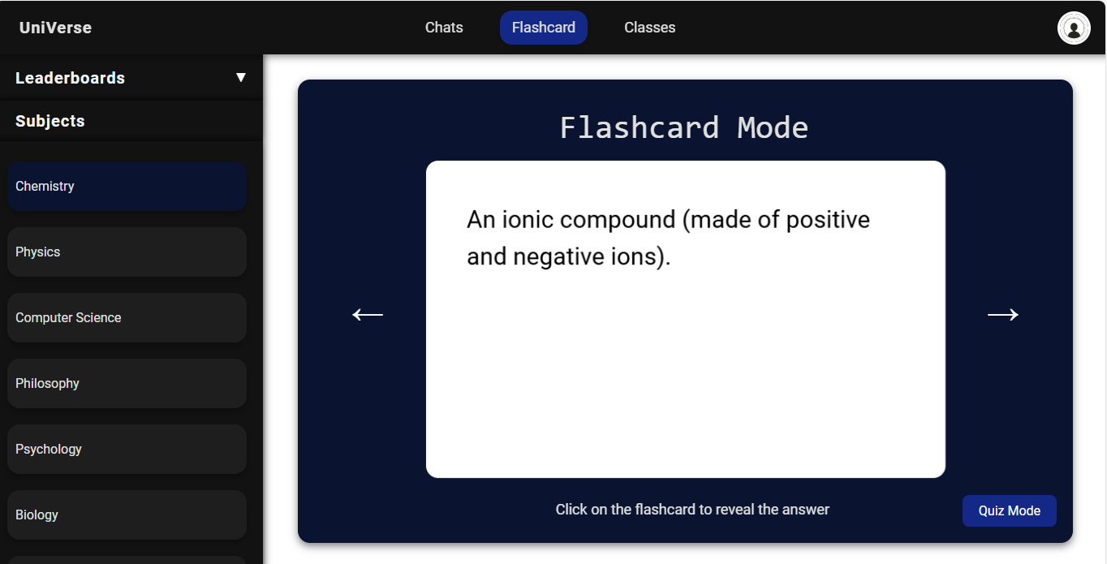

Answer displayed when flashcard clicked c

**Evidence provided** that interactive flashcard displayed However we only created flashcards for some of the subjects the college offers: **Test only partially successful**

|  |  |  |  |  |
| --- | --- | --- | --- | --- |
| No. | Feature | Justification | Input/How to test | Result/Evidence |
| 7 | Displays questions in quiz mode and allows user to answer them. | Client interview Q8  Stakeholder survey Q5 | Click on quiz and answer. | Response displayed on answer whether correct or not |

TESTING **FUNCTION** OF FLASHCARDS FOR CORRECT ANSWER:****

TESTING **FUNCTION** AND **ROBUSTNESS** OF FLASHCARDS FOR INCORRECT ANSWER:****

**Evidence provided** that quiz mode allows user to answer questions: **Test Passed**

|  |  |  |  |  |
| --- | --- | --- | --- | --- |
| No. | Feature | Justification | Input/How to test | Result/Evidence |
| 8 | Display flashcard points leaderboards | Client interview Q8  Stakeholder survey Q5 | Click on leaderboards | Leaderboards displayed with correct points. |

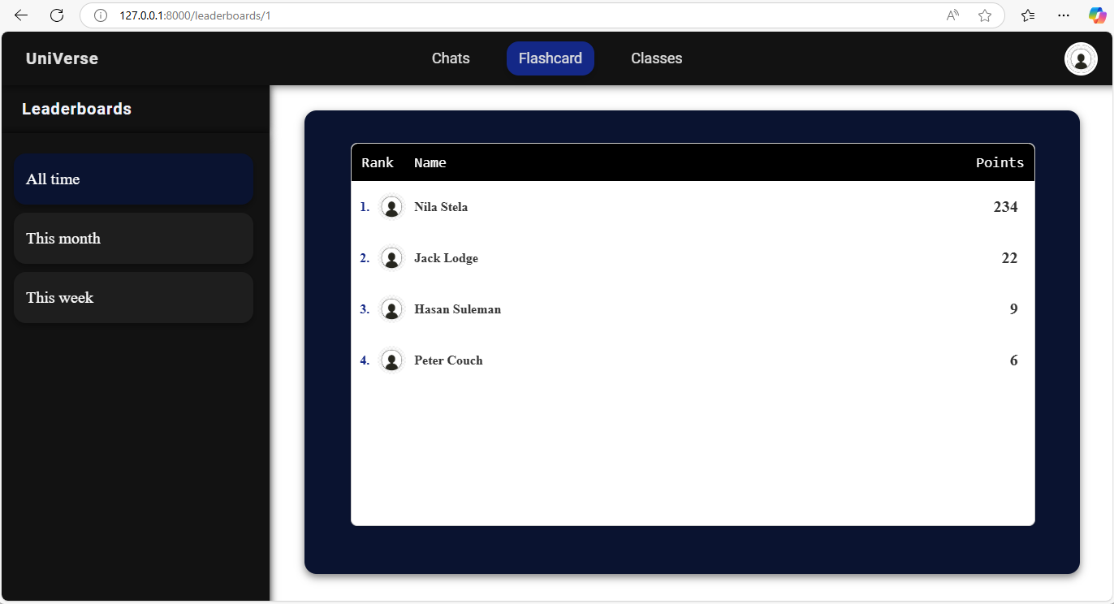

Testing **function** of flashcard leaderboards

**Evidence provided** that flashcard leaderboard displays points: **Test Passed**

|  |  |  |  |  |
| --- | --- | --- | --- | --- |
| No. | Feature | Justification | Input/How to test | Result/Evidence |
| 9 | Allow user to message friends | Stakeholder survey Q3  All website analysis | Enter text: “test text” | Message displayed in chat area and sent to user. |

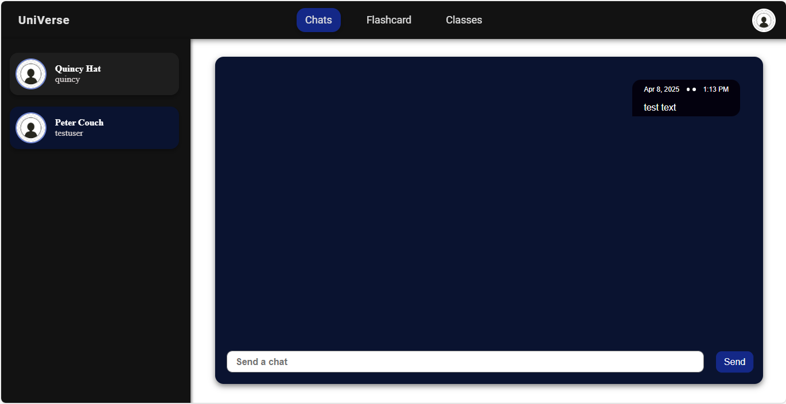

Testing **function** of private messaging system

**Evidence provided** that user can message friends : **Test Passed**

|  |  |  |  |  |
| --- | --- | --- | --- | --- |
| No. | Feature | Justification | Input/How to test | Result/Evidence |
| 10 | Allow user to create, manage and message in group chats. | All website analysis | Create group chat: “group1”  Add users.  Message in group. | Group chat created and message broadcasted to all users. |

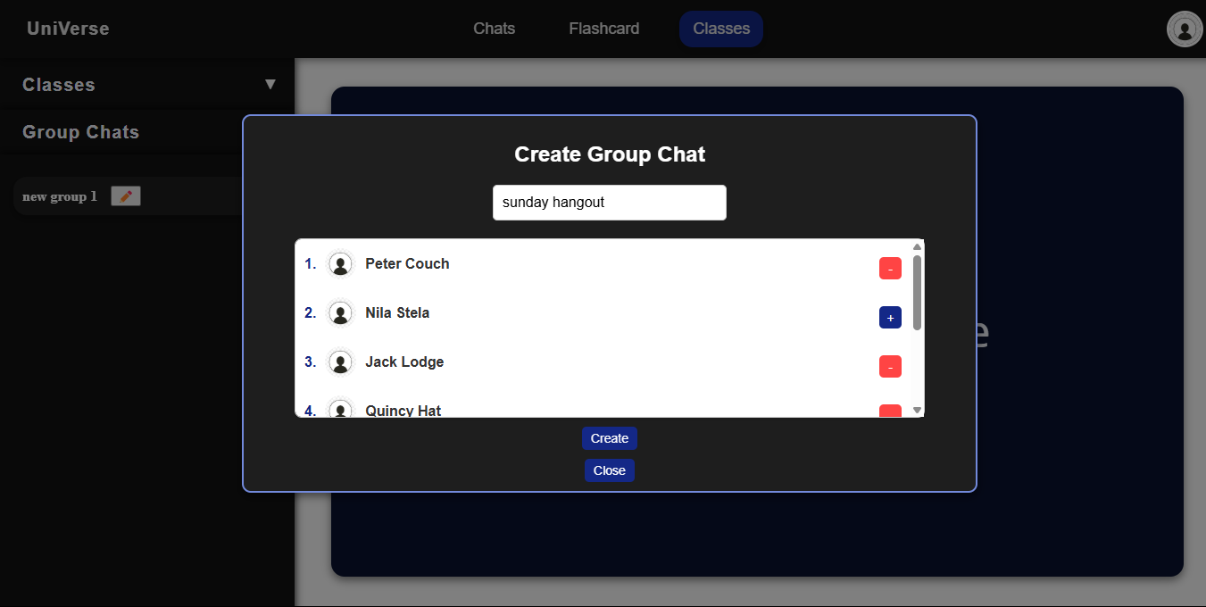CREATING GROUP CHAT:

Testing **function** group chats page

Creating a group chat and managing who is going to be in the group chat

MESSAGING IN GROUP CHAT:

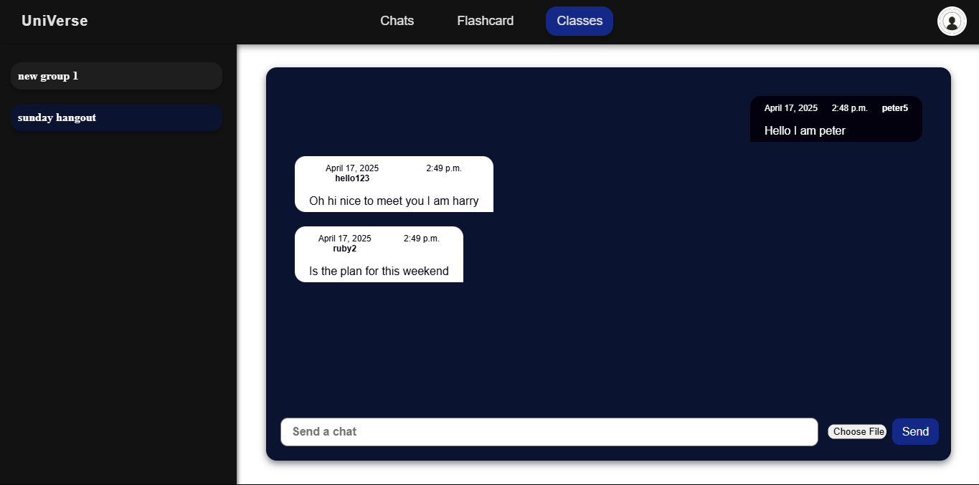

Messages displayed with user that send the message and time

MANAGING A GROUP CHAT:

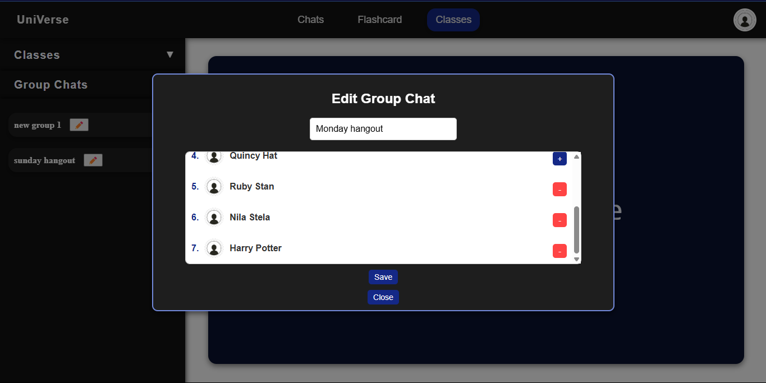

Option to change group chat name and edit its members

**Evidence provided** that user can create, manage and message in group chats **Test Passed**

|  |  |  |  |  |
| --- | --- | --- | --- | --- |
| No. | Feature | Justification | Input/How to test | Result/Evidence |
| 11 | Displays friend suggestions to user. | Client interview Q4  Website analysis 1 & 2 | Friend suggestions should be displayed in order determined by friend suggestion algorithm. | Friend suggestions should be displayed in a horizontal list. |

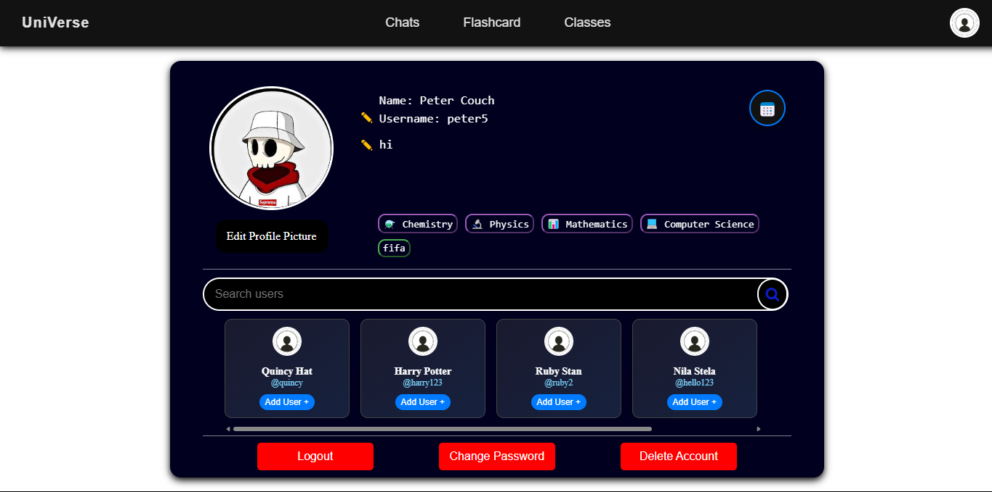

Testing **function** of friend suggestions

**Evidence provided** that friend suggestions displayed : **Test Passed**

|  |  |  |  |  |
| --- | --- | --- | --- | --- |
| No. | Feature | Justification | Input/How to test | Result/Evidence |
| 12 | Displays timetable in user profile page. | Client interview Q4  Stakeholder survey Q3 | Click on timetable button | Pop up with user’s timetable displayed. |

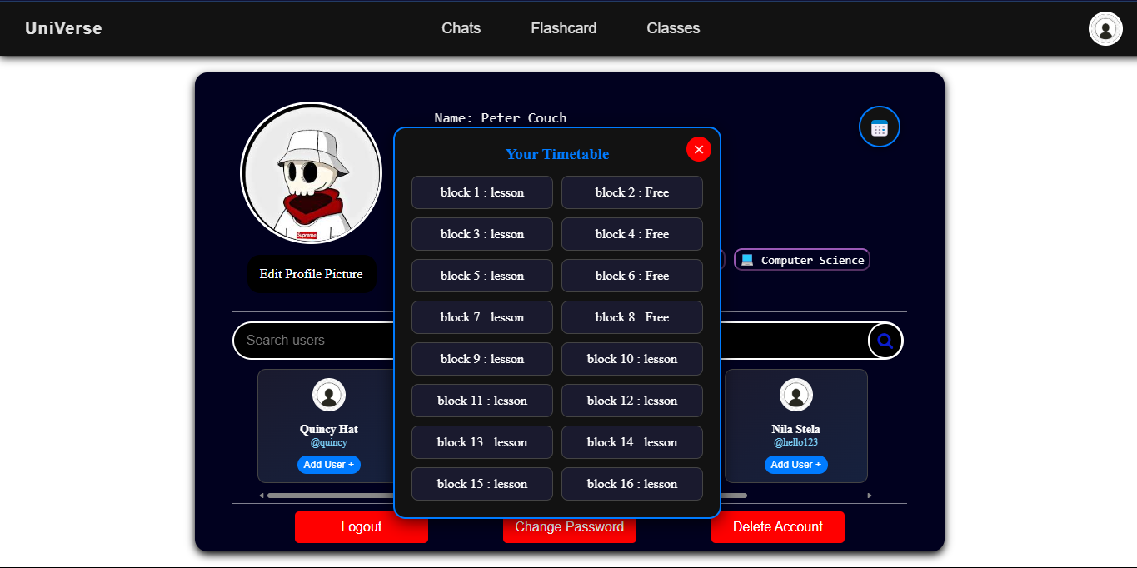

Testing **function** of timetable

**Evidence provided** that timetable displayed : **Test Passed**

|  |  |  |  |  |
| --- | --- | --- | --- | --- |
| No. | Feature | Justification | Input/How to test | Result/Evidence |
| 13 | Allows user to change appearance themes. | Website analysis 1  Stakeholder survey Q4 | Change themes. | Colour scheme of website will change. |

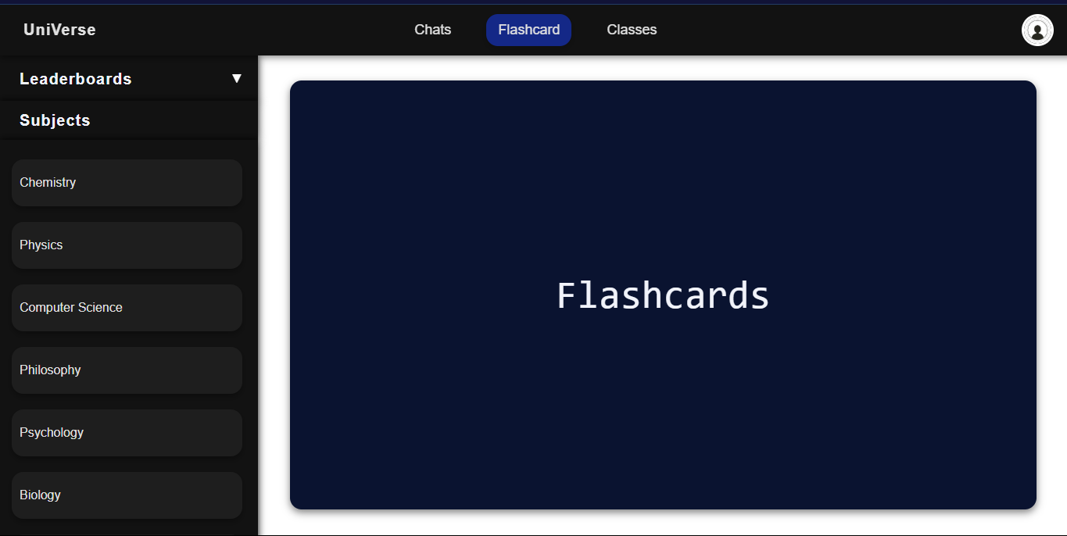

Only one colour theme provided , **test failed.**

|  |  |  |  |  |
| --- | --- | --- | --- | --- |
| No. | Feature | Justification | Input/How to test | Result/Evidence |
| 14 | Navbar at the top of the page for navigation | All website analysis | Click on different navbar links. | User is redirected to corresponding pages. |

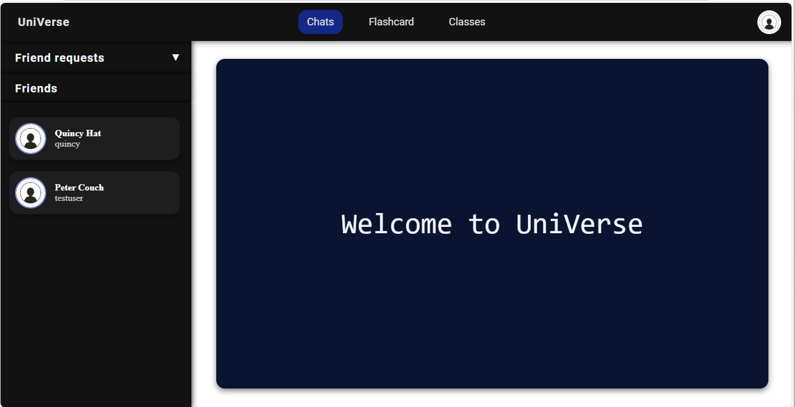

Testing **function** of nav bar

Nav bar displayed

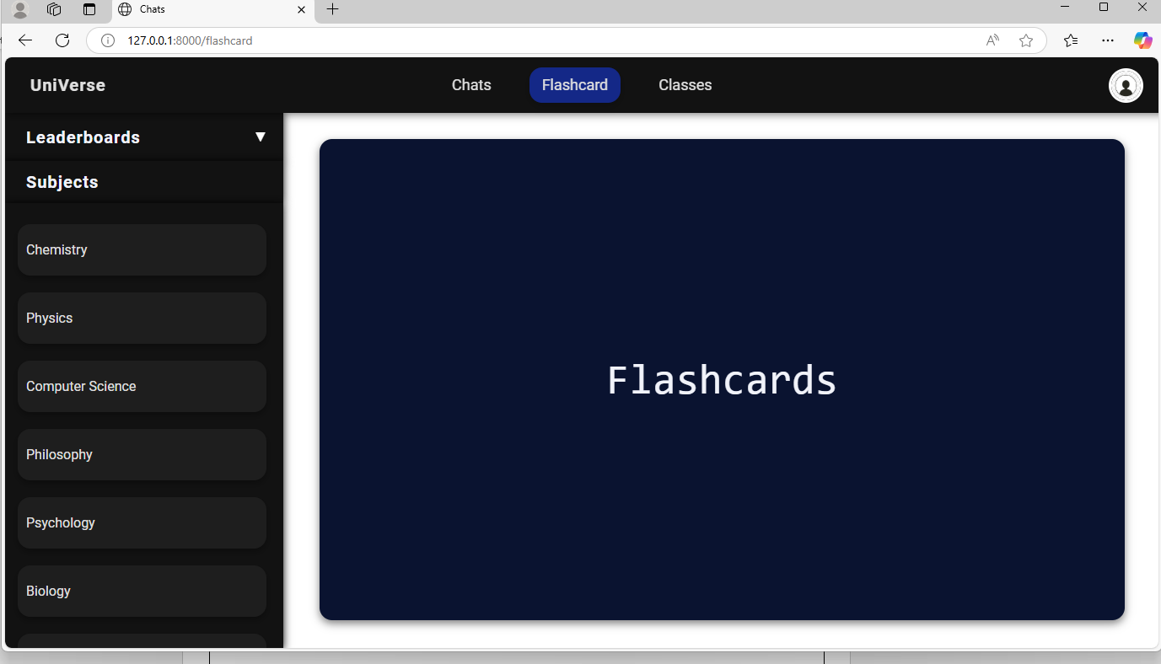

User redirected to flashcard page when flashcard button clicked

**Evidence provided** that nav bar displayed and works: **Test Passed**

|  |  |  |  |  |
| --- | --- | --- | --- | --- |
| No. | Feature | Justification | Input/How to test | Result/Evidence |
| 15 | Allow the user to add friends. | Website analysis 1 & 2  Client interview Q4 | Click add friend button in search bar next to username. | Once friend request accepted user shown in friend list. |

Add friend button clicked to send friend request to jack lodge

User list displayed

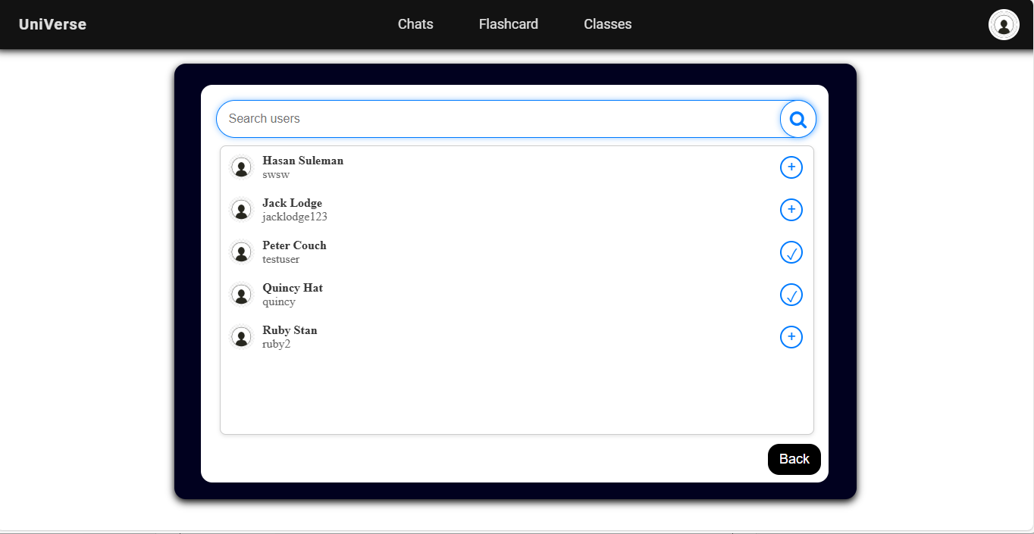

Testing **function** of search users bar

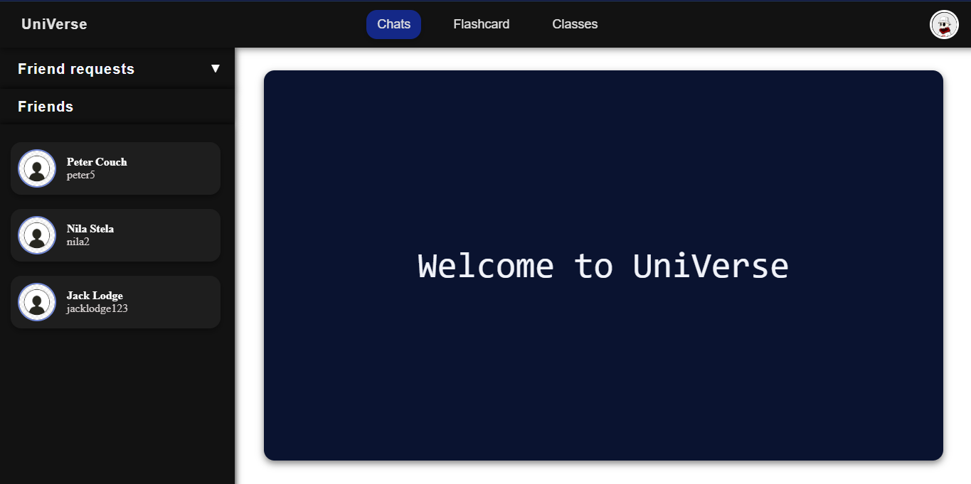

Jack lodge added to friend list when he has accepted the friend request ensuring consistency and providing **robustness**

**Evidence provided** that user can add friends : **Test Passed**

|  |  |  |  |  |
| --- | --- | --- | --- | --- |
| No. | Feature | Justification | Input/How to test | Result/Evidence |
| 16 | Allow user to send files and images in class. | All website analysis | Click files and images button and upload. | Image or file displayed in chat area. |



Testing **function** of sending images

Only images can be sent **test only partially successful**

|  |  |  |  |  |
| --- | --- | --- | --- | --- |
| No. | Feature | Justification | Input/How to test | Result/Evidence |
| 17 | Message seen status updated. | Website analysis 1 & 2 | View message status button. | Should turn blue when friend has viewed your message. |

Testing **function** message seen status

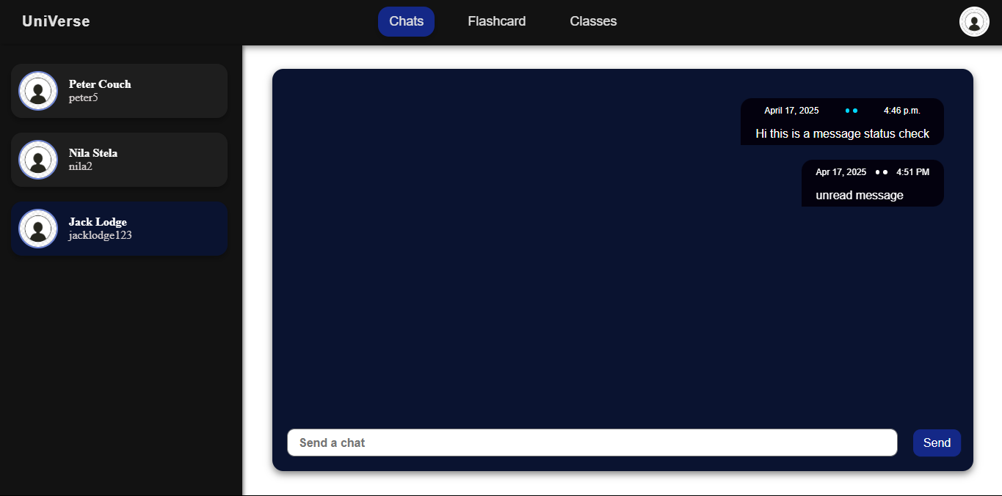

Turned blue as user has viewed message

White as user has not viewed message

**Evidence provided** that message seen status updated : **Test passed**

## STAKEHOLDER SURVEY FOR TESTING USABILTY:

I asked my stakeholders to test the website and then took a survey to get their feedback for how functional and robust the website is.

**Question 1: Did you find the website easy to navigate?**

Overall, the majority of the stakeholders found the website easy to navigate meaning the functionality of the website was efficient so the **test has been passed**.

**Question 2: Was the authentication system straightforward to use and robust?**

Overall, the majority of the stakeholders found the authentication system straightforward to use meaning the clear instructions in bold allowed the users to login and create accounts easily so the **test has been passed.**

**Question 3: Did you like the colour scheme of the website?**

From the survey we can infer that the students liked the colour scheme of the website but would like more options to customise the website. And I did not keep a change theme option so in this case the **test has only been partially successful**.

**Question 4: Were you able to message other users in real time?**

All of the stakeholders were able to do this hence the private messaging system has worked in real time and the **test has been passed.**

**Question 5: Were you able to create and manage group chats?**

All of the stakeholders were able to do this hence the group chat and classes system has worked and the **test has been passed.**

**Question 6: Were there any features in the flashcards that did not work?**

Most of the features worked but some of the stakeholders said the subject list did not work which may be because it did not contain all of the subject the college offers so the **test has been partially passed.**

**Question 7: How well do you agree with the following statement: “The profile page contained all the features necessary and worked with the correct functionality and robustness”?**

Majority of the stakeholders agreed with this and the ones that didn’t was because there was no change theme option however overall the functionality of the features satisfied the stakeholders hence the **test has been passed.**

## EVALUATION OF SOLUTION FROM THE SUCCESS CRITERIA:

Below is a list of all the success criteria, and whether it was successful, partially successful or not met:

|  |  |  |
| --- | --- | --- |
| Feature no. | Feature | Success? |
| 1 | Allow user to login | Success |
| 2 | Allow user to create an account | Success |
| 3 | Allow user to log out | Success |
| 4 | Option to change user details | Success |
| 5 | Option to delete account | Success |
| 6 | Displaying interactive flashcards for each subject | Partially Successful |
| 7 | Displaying interactive questions in quiz mode | Success |
| 8 | Display flashcard points leaderboards | Success |
| 9 | Allow user to message friends in real time | Success |
| 10 | Allow user to create, manage and message in group chats | Success |
| 11 | Displaying friend suggestions to user | Success |
| 12 | Displaying users college timetable | Success |
| 13 | Allow user to change appearance themes | Not Successful |
| 14 | Navbar on every page allowing navigation | Success |
| 15 | Option for the user to add friends | Success |
| 16 | Allowing the user to send files and images in classes | Partially Success |
| 17 | Message seen status is functional | Success |

* **A test evidencing each criteria is in the previous section with matching numbers.**
* **I will address the unsuccessful criteria after the usability features.**

## USABILITY FEATURES:

Below is a screenshot of each page on the website, and the usability features on each page have been highlighted, along with whether they were successful or not. ( Some features may be repeated on pages and I will not be describing them repeatedly ).

**LOGIN PAGE:**

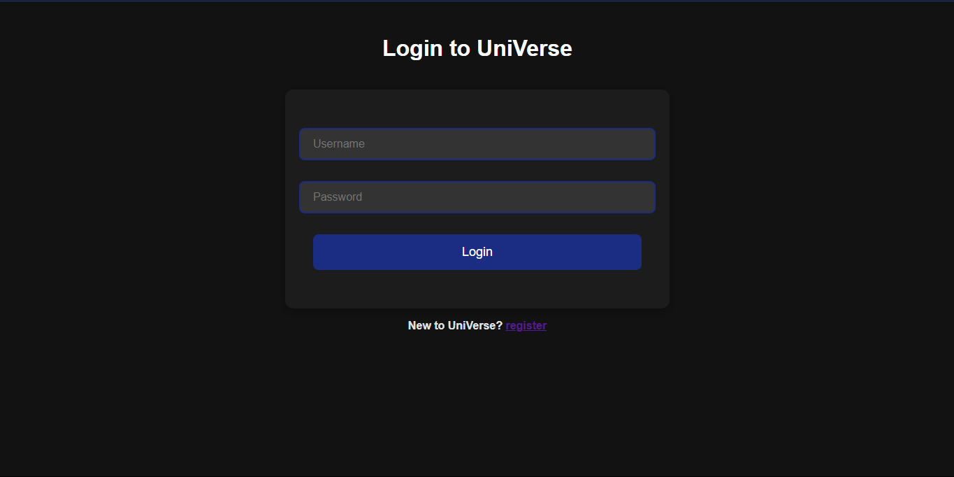

Input boxes to enter user details allowing user to login

**Success**

Large title making it clear to the user what page they are on.

**Success**

Contrast button to make it stand out

**Success**

Link to register page allowing the user to sign up if they don’t have an account

**Success**

**SIGN-UP PAGE:**

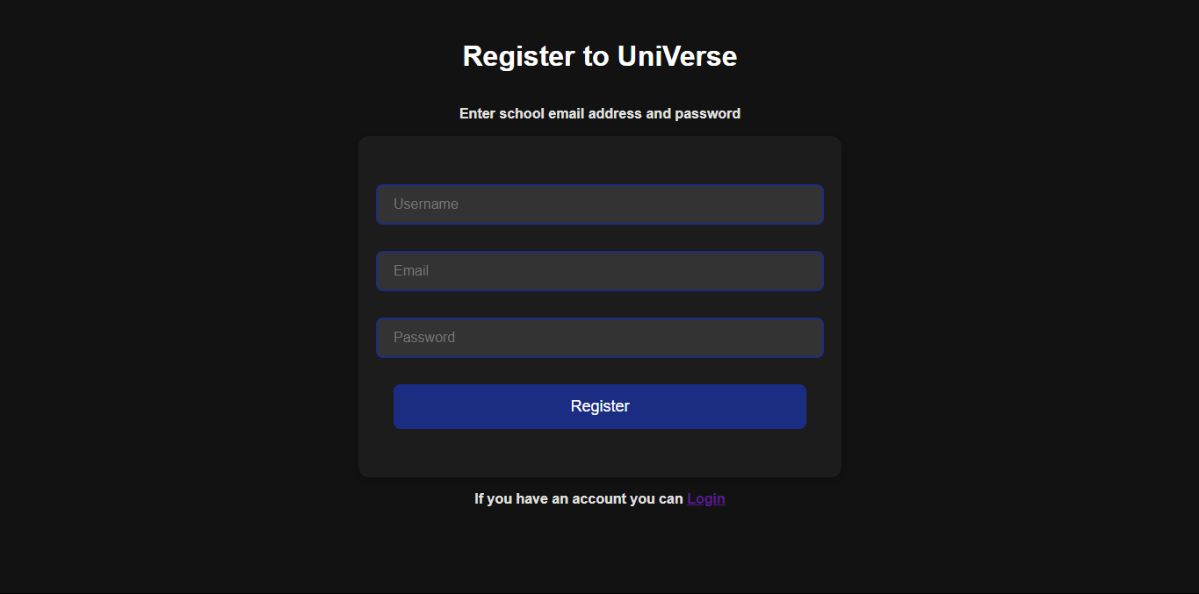

Input boxes to enter user details allowing user to login

**Success**

Instructions specifying user should login with school details as per the clients request

**Success**

Contrast button to make it stand out

**Success**

Link to login page allowing the user to login if they already have an account

**Success**

**INTERESTS PAGE:**

Checkboxes allowing user to select their interests to be displayed on the profile page

**Success**

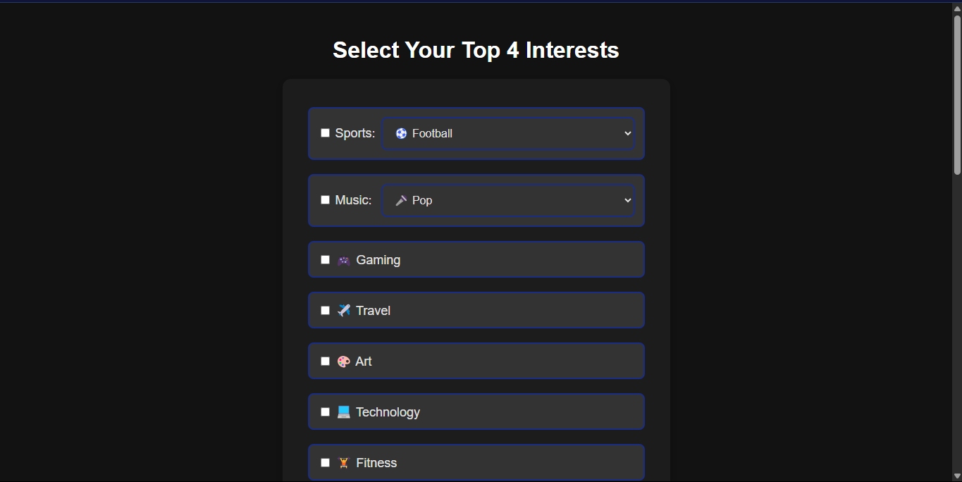

Dropdown menu containing multiple interests

**Success**

Contrast button to make it stand out

**Success**

Other checkbox allowing user to enter other interest not on the list.

**Success**

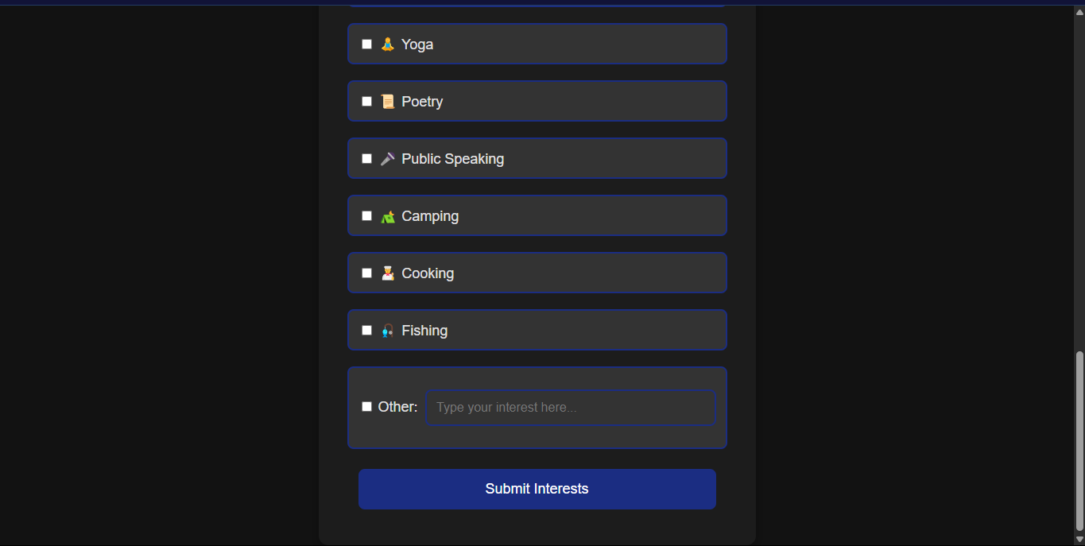

**HOME PAGE:**

Profile picture button linking to profile page

**Success**

Friend request list allowing user to add friends

**Success**

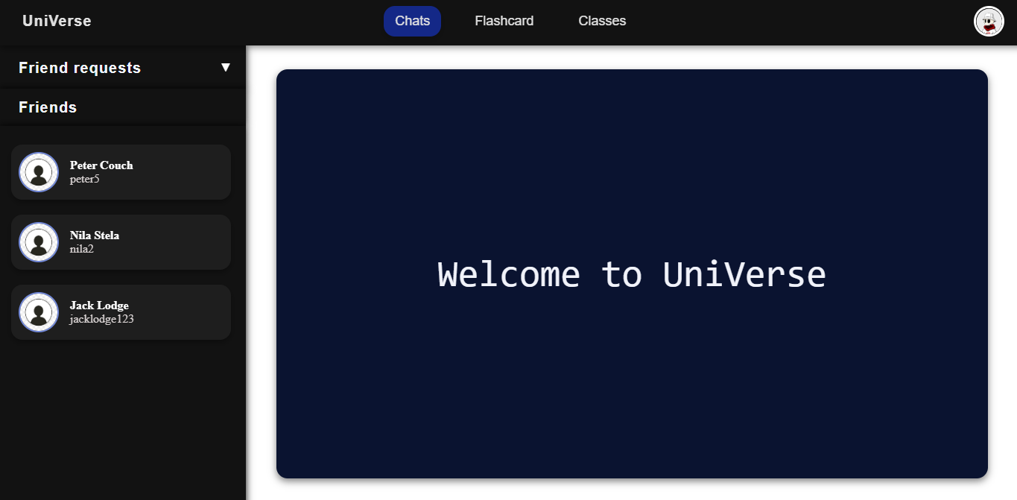

Contrast button to make it stand out

**Success**

Friend list allowing user to message their friends

**Success**

Welcome message to the user after logging in or signing up

**Success**

**CHATS PAGE:**

Time stamp of when message was sent along with message seen status to allow the user to track conversation history

**Success**

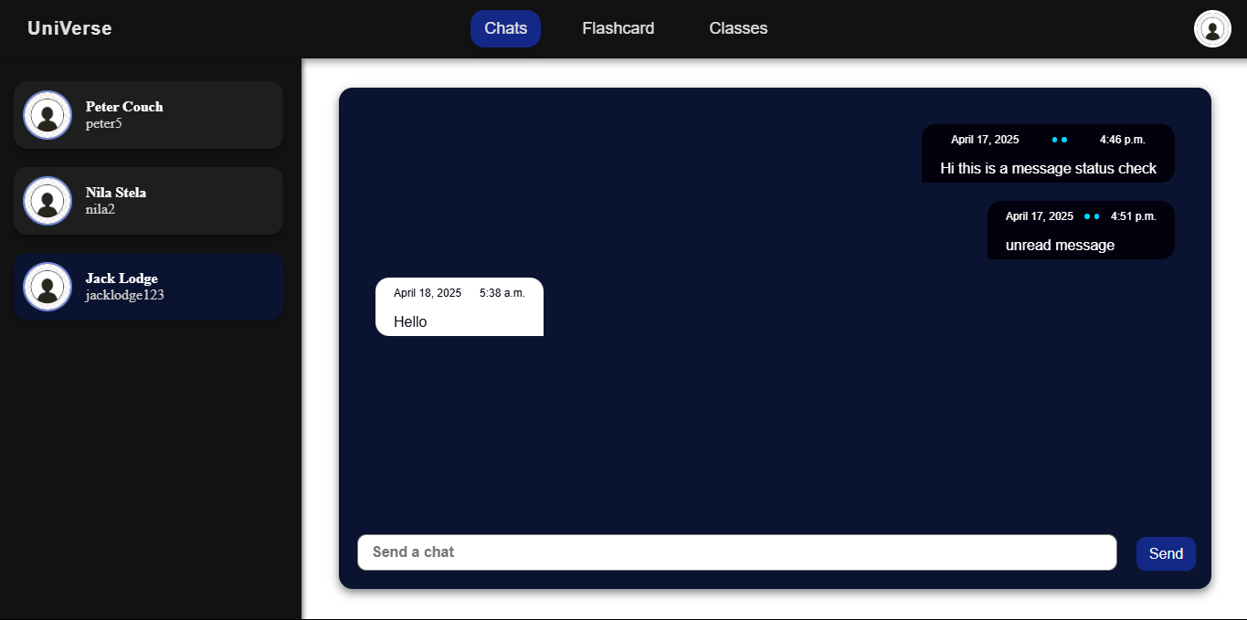

Contrasting text box colours helping user identify who sent message

**Success**

Input and send button allowing user to send the message

**Success**

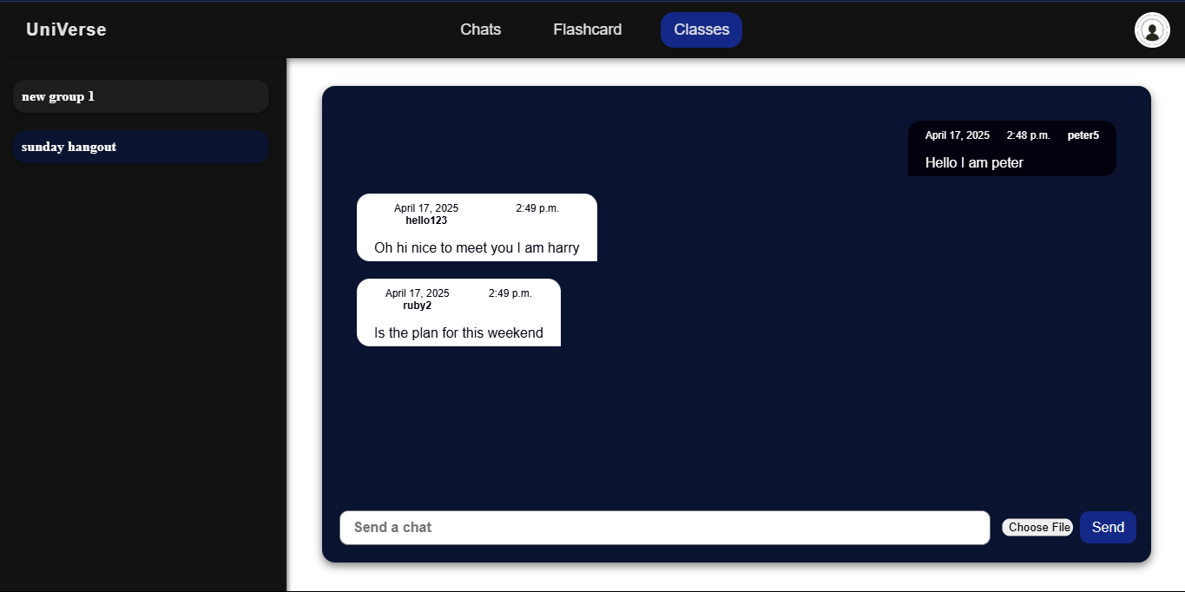**GROUP CHATS AND CLASSES PAGE:**

Choose file button which allows user to send images but not files hence:

**Partially Successful**

Contrasting text box colours helping user identify which group chat user is in

**Success**

Edit group chat and create group chat who’s functionality was shown in post development testing

**Success**

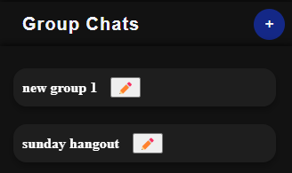

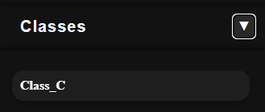

User is automatically joined to class group chat displayed here

**Success**

**FLASHCARDS PAGE:**

Flashcard displayed with question and is interactive as shown in testing

**Success**

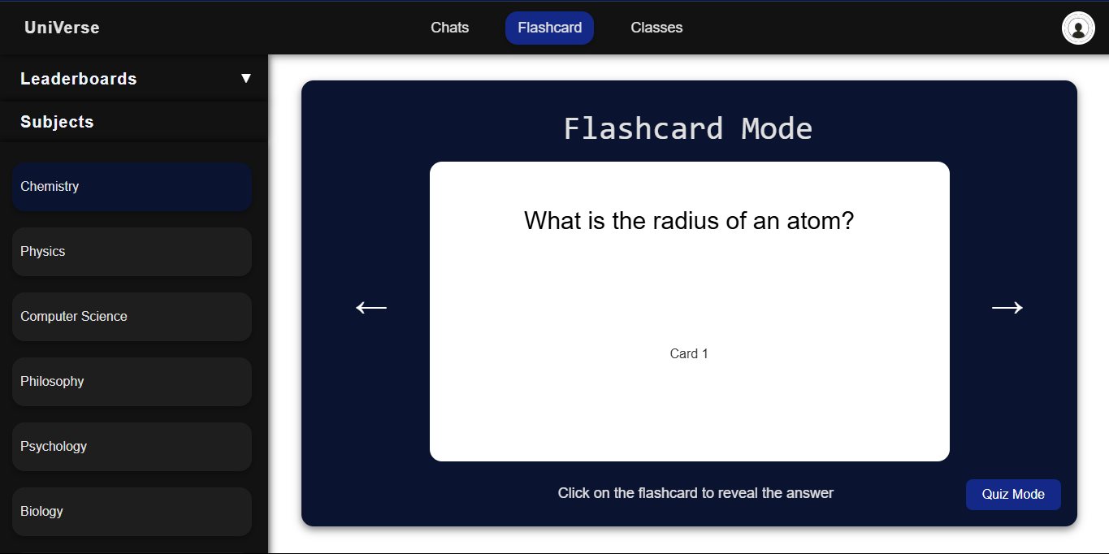

Flashcard list contains only some of the subjects the college offers so **test is only partially successful**

Button linking to quiz mode which works as shown in testing

**Success**

Total user points displayed which will help in keeping the user motivated.

**Success**

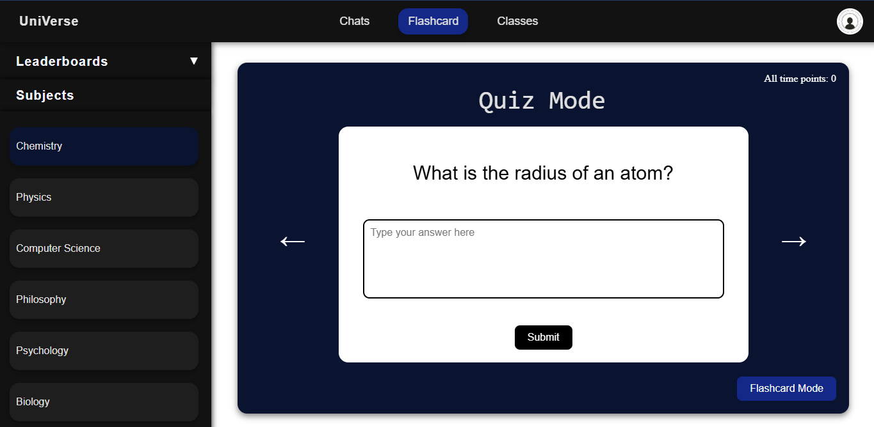

Input box to enter answer which will display if you are correct or not.

**Success**

Button linking to flashcard mode which works as shown in testing

**Success**

**PROFILE PAGE:**

Timetable button which when clicked displays the users timetable as shown in testing.

**Success**

Details displayed with option to edit them allowing user to be control about the details

**Success**

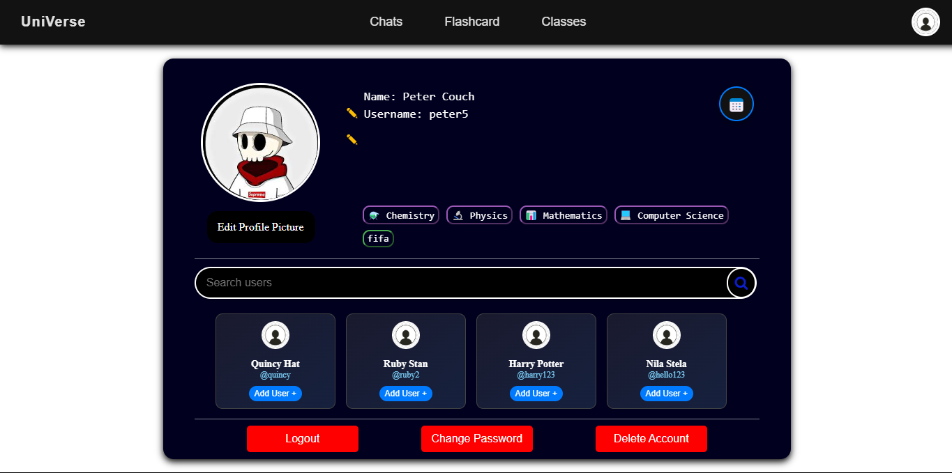

Interests and subjects displayed on profile page for other users to see when they come to this page.

**Success**

User friend suggestions with option to add user or hyperlink to go on their profile page

**Success**

Logout, delete account and change password again allowing user to be in control of their account.

**Success**

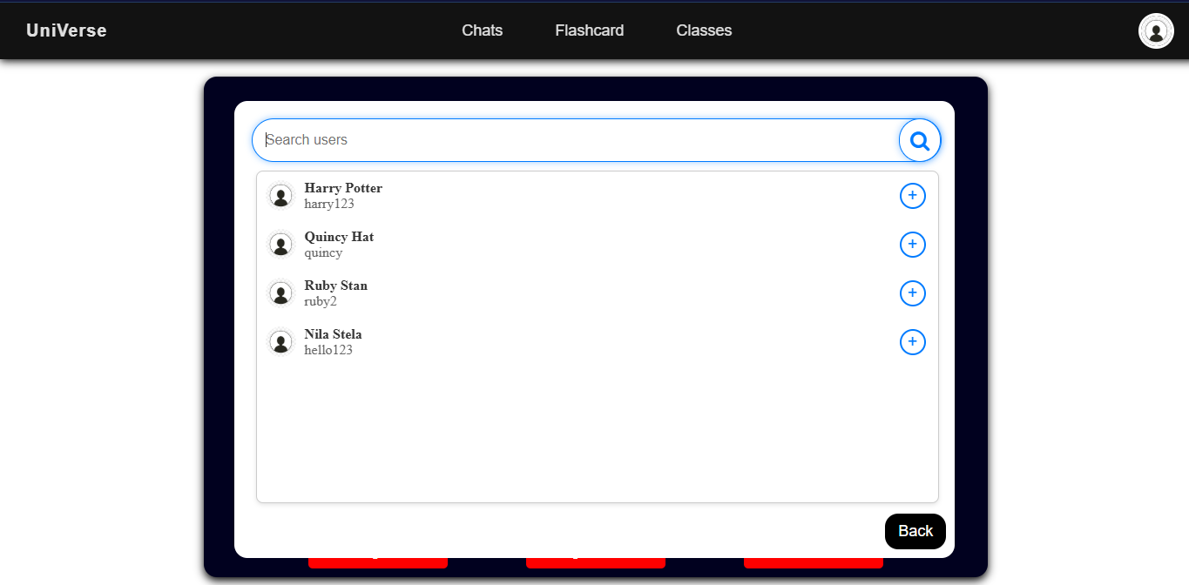

Search bar allowing user to search for users

**Success**

User list displayed with username, profile picture and full name

**Success**

Back button to go close the pop up

**Success**

## UNSUCCESSFUL CRITERIA/USABILITY FEATURES:

**NUMBER 1:**

|  |  |  |
| --- | --- | --- |
| 6 | Displaying interactive flashcards for each subject | Partially Successful |

This was partially unsuccessful according to the stakeholder survey Q6:

**Question 6: Were there any features in the flashcards that did not work?**

Whilst most users had no complaints for any of the features some disagreed and in order to found out the reason why I asked the stakeholders why they disagreed and the summary of most of their arguments where:

Summary of feedback:

*“Some of the subjects I studied where not on the subject list and I could not use the flashcards for them”*

This meant some users felt excluded from using the feature effectively because their subjects were not represented. This limitation stemmed from the fact that I used the norm of subjects rather then asking my client the specific subjects the college offers.

**Further development to address stakeholders needs:**

To improve this system I should contact my client Jack and ask him all the subjects the college offers and adapt the flashcard system to meet those subjects.

Additionally I could have customized the subject list to each student and filtered each students subjects using the subject list to display only the subjects the user does in the subjects list.

**NUMBER 2:**

|  |  |  |
| --- | --- | --- |
| 13 | Allow user to change appearance themes | Not Successful |

This was unsuccessful and was also further addressed in stakeholder survey Q3:

**Question 3: Did you like the colour scheme of the website?**

This shows that the student value customization and that a single fixed theme is not sufficient for the students.

**Further development to address stakeholders needs:**

To address this I will enable a button in the profile page which allows the user to change the appearance of their website which will be based on different colour schemes.

**NUMBER 3:**

|  |  |  |
| --- | --- | --- |
| 16 | Allowing the user to send files and images in classes | Partially Success |

This was partially successful as the user was able to send images but not files as the file upload system was only accepting images. This may be have been because even though the input allowed all files to be uploaded the handling of the file when being sent to other users only worked for images. Furthermore the time limitations during development and the additional complexity of managing and broadcasting files to multiple users in the group chat via Django channels caused this to occur.

**Further development to address stakeholders needs:**

So in order to improve this I would have to extend the backend in consumers.py to be able to handle all types of files. I will also have to store files safely to ensure that all users in the group received the uploaded content in time.

## LIMITATIONS OF THE SOLUTION

### AND HOW THE PROGRAM CAN BE DEVELOPED TO DEAL WITH THEM:

1. **The website only runs on a local server and is not on the internet:**

This limitation is because I have not purchased a domain for the website hence it is not on the internet and the students will not be able to access my website until I put it into a server.

When this happens I will no longer be able to rely on SQLite as my database and I will have to use databases such as MongoDB and make various changes to the backend to make it functional and stable. This will, once again be a challenge as my research tells me that there are multiple factors to take into account with a real deployment.

1. **There isn’t a limit to how many times you can try the password:**

The current JavaScript code doesn’t check how many times a user has inputted username/password when logging in, or when entering school email address and passwords when creating an account. This means a hacker can use a brute force attack to guess the password so they can bypass the log in system and access to the website.

In order to address this I will need to introduce a count variable which record the number of attempts you make in entering the password and if they have tried to many times maybe put them on cool down or suspend their account.

1. **Website is not compatible to all devices:**

At the moment the website is designed for user on laptops and desktop computers only. This is due to the inconsistencies in the HTML and CSS layout which may not render correctly on smaller screens such as mobile phones and tablets. Some elements may appear misaligned or may not function properly due to the lack of responsive design.

To improve this in the future I would like to use responsive design features provided by CSS that would allow the layout to be automatically adjusted based on the size of the screen. I would also test the interface across multiple devices and browsers to ensure that the performance remains consistent.

## MAINTENANCE ISSUES

### AND HOW THE PROGRAM CAN BE DEVELOPED IN THE FUTURE:

The choice of using Django will be very helpful for the client in maintaining the program. My client Jack has complete CRUD control of what is included in the site using Django’s administration system where he can add delete and update user accounts. This is an advantage which makes day-to-day maintenance really easy for him and he should not need any 3rd party intervention to cope with this.

However it will not be easy for Jack to add new pages or make styling adjustments or add functionality to the website; if he wishes to do so he will need to contact someone with experience in Django, HTML and CSS. These two technologies are deeply embedded into my code and require a lot of learning. One thing which will help with any modification is the clear labelling of my work throughout. Another advantage is the consistent nature of my templates with the VIEWS, URLS, APP, TEMPLATE model and the use of database tables (MODELS) within the code.

There was some cases in which I did not carry out standard Django practices, in particular I could have kept the CSS styling in a separate folders under a general STATIC folder as a lot of the styling was repeated for example the navbar. For example, if I had stored all navbar styles in static/css/navbar.css, I could simply update the colour scheme or layout there, rather than editing multiple template files individually. This would also reduce the risk of styling inconsistencies appearing across different pages and help in any maintenance or adjustments required.

Whilst I have used security measures such as using CSRF token to prevent cross-site request forgery, there are still several additional measures I can implement in order to maintain the and protect user data. An example of this would be to use two factor authentication which adds an extra layer of security in the login process. This could be done using Django’s third-party packages like django-otp or django-two-factor-auth, which are relatively easy to integrate with the existing login system. Another important enhancement would be using website verification during the registration process. Currently users can sign up immediately which could increase the risk of fake profiles in case someone accesses a students email address or password. By requiring users to confirm their email address we could prevent this from happening via a verification link before activating their account.

Once the website is deployed live I will need to ensure that the website is compatible with all devices in order to allow users with different devices access. In the future an app based on this website may also be created in order for users to use it on their mobile devices or tablets.